Title: Assessing the Functionality of Mini Dustbins in Khulna City

T. K. Roy¹, M. S. Hossain², S. Rahman¹, M. R. Kabir², M. Mosaib²
¹Assistant Professor, Department of Urban and Regional Planning, Khulna University of Engineering& Technology, Khulna, Bangladesh.
²Urgraduate Student, Department of Urban and Regional Planning, Khulna University of Engineering& Technology, Khulna, Bangladesh.

Keywords: Mini dustbin, assessing functionality, locational suitability, functionality matrix

Abstract
Mini dustbin as strategic instrument plays an important role to manage solid wastes mainly generated from outdoor activities for keeping the city environment neat and clean. Khulna City Corporation (KCC) established around 100 mini dustbins in different places of Khulna City during 2016-17. The places include different educational institutions, offices, parks, river bank recreation areas, markets, important road intersections and medians etc. The aim of the study is to evaluate the functionality of mini dustbins using major four parameters namely functional status, locational suitability, waste collection services and user friendliness. Both qualitative and quantitative methods were used to evaluate the functionality of mini dustbins. A functionality matrix was prepared for multi-level quantitative analysis. Though the overall performance functionality was found moderate, in some cases the study found very poor maintenance and improper locational choices for mini dustbins. On the other hand, there was a very few mini dustbins beside different market places and commercial establishments though there was more demand. In some cases, people are not using mini dustbins for disposal of their generated dry wastes. A large number of general people were found not satisfied regarding collection of wastes from mini dustbins and disposal to Secondary Transfer Stations (STSs). Finally, the study provides some recommendations for improving the overall functionality of KCC provided mini dustbins in Khulna City.


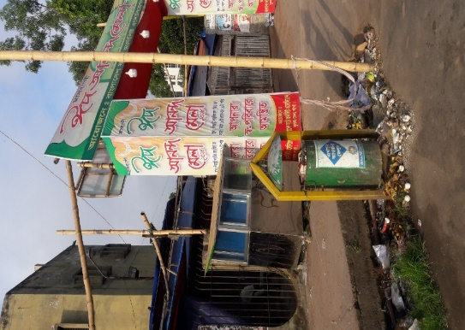
Images
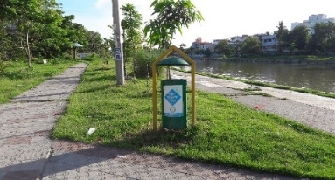

Mini dustbin in KCC Solar Park | Mini dustbin at New Market
Figure 1: Mini dustbins in different places in Khulna city

Reference:
- Regassa, N., D.Sundaraa, R., & Seboka, B. B. (2011). Challenges and Opportunities in Municipal Solid Waste Management:. J Hum Ecol., 33(3), 179-190.
- Ferreira, F., Avelino, C., Bentes, I., Matos, C., & Teixeira, C. A. (2016). Assessment Strategies for Municipal Selective Waste Collection Schemes. Waste Management.
- Roy, T. K. (2013). Management of Park Solid Wastes in Khulna City. International Conference on Solid Waste Management in the Developing Countries, 145, pp. 1-10. Khulna.
- Teixeira, C. A., Avelino, C., Ferreira, F., & Bentes, I. (2014). Statistical Analysis in MSW Collection Performance Assessment. Waste Management, 1584–1594.

Biography:
Tusar Kanti Roy is an Assistant Professor in the Department of Urban & Regional Planning (URP) of Khulna University of Engineering & Technology (KUET), Bangladesh since 2011. He completed his Master of Urban and Rural Planning (MURP) and Bachelor of Urban and Rural Planning (BURP) from Khulna University. He has more than 20 years work experience in teaching, research and development. He has published 30 research papers including 13 papers on solid waste management (SWM) in reputed journals and international conference proceedings. His research areas of interest are waste management, sanitation, urban planning and environment.

Presenting author details

Full Name: Tusar Kanti Roy
Contact number: +8801716717443
Email: tusarkroy@urp.kuet.ac.bd
Session name/number:
Category: Oral presentation
Passport Number: BA0489855

