Title: Incorporating of plastic wastes (PETs) into the manufacturing of unglazed handmade tiles.

FRANCIS ATTA KURANCHIE1, THERESAH AMOAKO NTORI2, DESMOND AGYEMANG2.
1Lecturer, Department of Energy and Environmental Engineering, UENR, Sunyani, Ghana and Adjunct Lecturer, School of Engineering, Edith Cowan University, Australia.
2Department of Energy and Environmental Engineering, UENR, Sunyani, Ghana.

Keywords: Plastic wastes, Environmental problems, Handmade unglazed tiles, European Standards.

- Abstract

Plastics have become one of the most commonly used materials for many purposes domestic, commercial and industrial. The usage of plastics comes with an associated environmental problem - plastic waste generation. Incorporation of plastic waste into tile making was investigated in this study. The study deals with using sand together with plastic waste (polyethylene terephthalate) to fabricate unglazed handmade tiles. Considering the bulk density, water absorption and flexural strength, the final tile products were studied, and results indicated that the bulk density significantly influenced the water absorption, flexural strength and avoidance of cracks in the tiles. The suitable formulation should have greater than 50% wt. of sand and lesser than 50% weight of plastic. The fabricated tiles were compared to the European (EN) standards. They are vitrified as they have very low water absorption rates of 0.313% and 0.332% and low strength of 2.141kg/cm² and 2.447kg/cm² compared to the EN ISO 10545 standard of 225kg/cm². Hence, they can be used as decorative wall tiles in areas where there is low pressure and excessive loads aren’t exerted. The surface quality, rectangularity and straightness of sides also need improvement.

Image:

- Reference:

Biography:
Francis Atta Kuranchie has completed his PhD from Edith Cowan University, Australia. He is a Lecturer at the University of Energy and Natural Resources in Ghana and an Adjunct Lecturer at Edith Cowan University in Australia. He has published more than 15 papers in reputed journals and has been serving as reviewer a number of reputed Journals.

Presenting author details
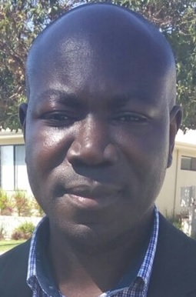

Full Name: Francis Atta Kuranchie
Contact number: +233202508997
Twitter account: Linked In account:
Session name/ number:
Category: (Oral presentation)
Passport Number: PA4318983

