ABSTRACT SUBMISSION FOR ORAL PRESENTATION.

Title : Utility of bronchial brush in diagnosis of carcinoma lung as compared with bronchoscopic biopsy and BAL in a tertiary care rural medical college and hospital.

Dr. Aditi Gupta, Dr Jai kishan, Dr Balinda
Department of Respiratory medicine, MMIMSR, Mullana, Ambala, India

Keywords: Bronchial brush, carcinoma lung, bronchoscopic biopsy

1.Abstract body: Bronchogenic carcinoma is among the leading causes of death across the world. Early diagnosis at a lower stage definately decreases mortality. This study was conducted to demonstrate the utility of bronchial brush in diagnosing bronchogenic ca.
Material and methods: 30 patients of suspected bronchogenic carcinoma underwent fiberoptic videobronchoscopy over 1 year time(Dec 2018 to Dec 2019). BAL, biopsy and brush were planned in all. Brush was taken in all but biopsy was done only if endobronchial lesion was visible. Minimum of 2 wet fixed and 2 dry slides were prepared and sent to pathologist for further evaluation.
Result: 15 were positive for malignancy in brush, 12 in biopsy and 1 in BAL. Endobronchial lesions were observed in 13 patients. Alternate diagnosis was established in 5 cases.
Conclusion: Bronchial brush gives faster and comparable results to biopsy although biopsy remains the gold standard.

2.Image : bronchial brush

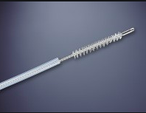

3.Reference: 1.Gaber KA, Goldman JM, Farrell DJ. Cytological examination of the whole endobronchial brush in bronchoscopic diagnosis of lung cancer.Respiratory medicine 2002;96: 259-61
2.Dionisio J,Diagnostic flexible bronchoscopy and accessory techniques.Pneumologia 2012;18:99-106
3.Bandyopadhyay A, Pal M et al.A study of uselfullness of washes and brush cytology with respect to histopatholgy in diagnosis of lung malignancy by using fiberoptic bronchoscopy. CCIJ2016;5(4):293-8.

4. Biography
Dr Aditi completed her MBBS from Government medical college , Faridkot,India in 2009. She did her MD in Pulmonary medicine from Government medical college, Patiala,India in 2014. She worked in the topmost tertiary care research centre of India (AIIMS, New Delhi) for 3 years as senior resident. Currently, she is working as Assistant professor, Respiratory medicine department, MMIMSR, Mullana, India.

5.Presenting author details:

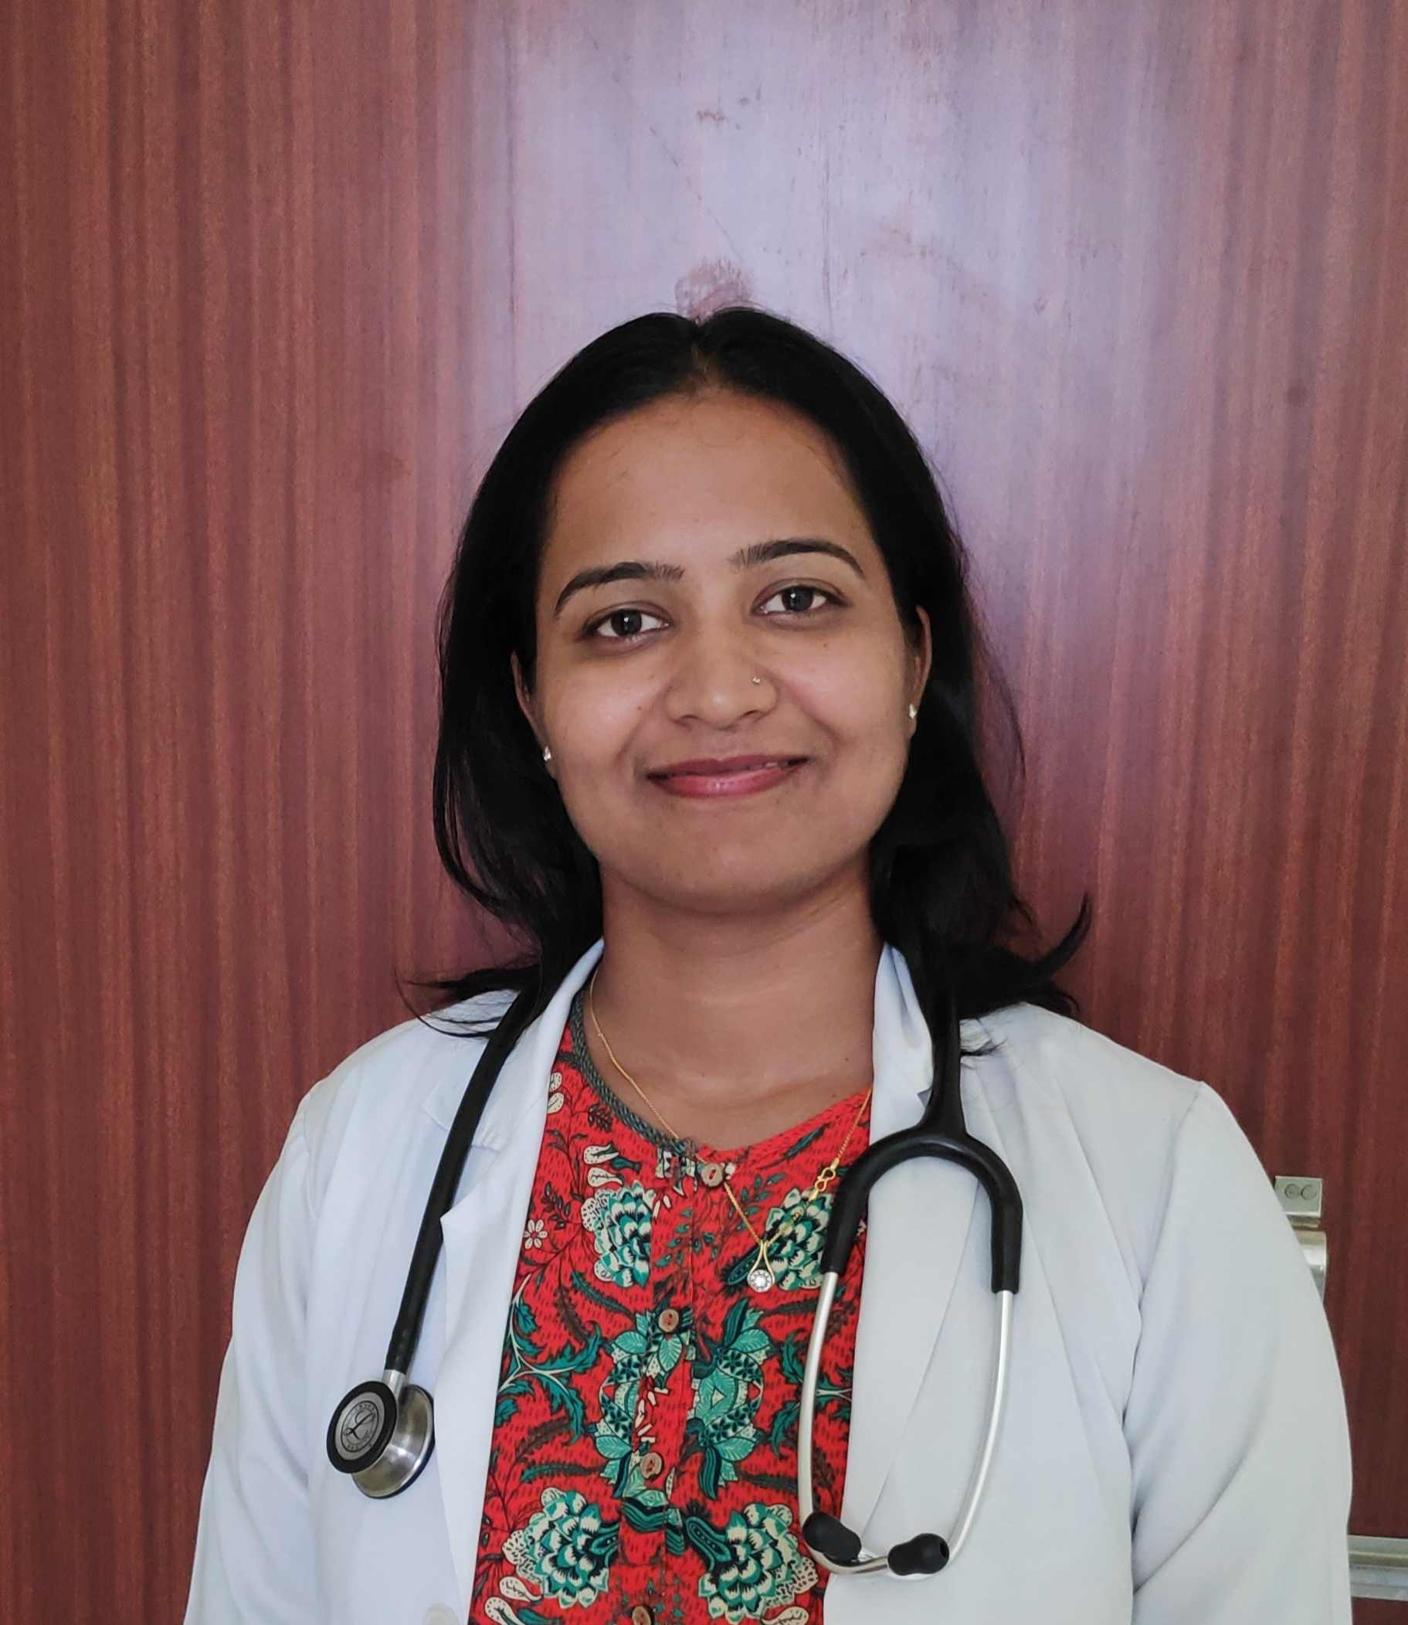

Full name: Dr Aditi Gupta
Contact number: 918195900690
Email: doc.aditigupta@gmail.com
Category :Oral presentation
Passport number:Z2976929, Republic of India

