THE USE OF REMOTE SENSING AND GIS IN PUBLIC HEALTH: A CASE STUDY:
GEO-SPATIAL RISK ANALYSIS FOR SCHISTOSOMIASIS IN A MARGINALIZED COMMUNITY, KENYA

Rolyne Gabby, Muthuka John Kyalo ^{1, 2,} , Michael Hebtu³

¹College of Health Sciences, Institute of Tropical Medicine, Jomo Kenyatta University of Agriculture & Technology, Kenya
²Department of Health Education & Promotion, Kenya Medical Training College, Nairobi, Kenya

³Kenya Medical Research Institute Graduate School, Nairobi, Kenya

Abstract:Schistosomiasis, also known as bilharzia, is a disease caused by parasitic worms.It is prevalent in tropical and subtropical areas, especially in poor communities without access to safe drinking water and adequate sanitation. The field of medical geographic information systems (Medical GIS) has become extremely useful in understanding the bigger picture of public health.GIS has been used to mapping the epidemiological information which includes the burden of disease epidemic transmission, spatial distribution and the determinants of health related states or events in specified population with reference to space and time. Perhaps, remote sensing and GPS has been integrated under the GIS umbrella for disease surveillance, situation analyze and the spatial modeling of disease transmission.GIS tools were used to store, visualize, analyze, and interpret geographic data from the mapped geographical location.These data included factors associated with risk to schistosomiasis.Pertinent data to predict the trends and to portray spatial risk-analysis of the disease was performed.GIS data included attributes, or descriptive information. In this case, the pattern of waters data set that could be mapped as possible areas for the species causing schistosomiasis was done with ArcGis application The descriptive data was searched and display of associated attributes was performed using Raster data set in order to obtain a risk map using a GIS software. Despite of the area not mapped as high risk, the trend seems to have been on a salient change with economic activities being projected towards the use of the lake water for some livelihoods such as fishing, daily chores among women washing clothes and a common habit of children playing with water. Population was projected to be on upsurge and straining the pastoral activity as the main income source, the deviation to other realted economic activities were perceived to be on rise, especially fishing: Results showed a pertinent information compromising the initiative to mitigate the salient schistosomiasis disease, as being the higher rate of HIV transmission.The final conclusions the deficit on PHC centers is mainly related to total number of population.Using Remote Sensing and GIS is a very valuable tool for Public Health Practice and Research, for can be helpful for health decision maker to guide them where to direct health policies and better to visualize health problem and it is Recommended that, Public Health Practitioners and Researchers to consider the use of remote sensing and GIS.

Keywords:Schistosomiasis, marginalized community,GIS, Remote Sensing, Hazard Risk Analysis

Introduction
Schistosomiasis, also known as bilharzia (bill-HAR-zi-a), is a disease caused by parasitic worms. Infection with Schistosoma mansoni, S. haematobium, and S. japonicum causes illness in humans. It is prevalent in tropical and subtropical areas, especially in poor communities without access to safe drinking water and adequate sanitation. It is estimated that at least 90% of those requiring treatment for schistosomiasis live in Africa[1] In Kenya the infection is prevalent in many regions, notably the Lake Victoria Basin, Eastern Province, and the inland coastal strip.The field of medical geographic information systems (Medical GIS) has become extremely useful in understanding the bigger picture of public health. The discipline holds a substantial capacity to understand not only differences, but also similarities in population health all over the world. The main goal of marrying the disciplines of medical geography, public health and informatics is to understand how countless health issues impact populations, and the trends by which these populations are affected. From the 1990s to today, this practical approach has become a valued and progressive system in analyzing medical and epidemiological phenomena ranging from cholera to cancer.[2]
GIS is a combination of several technological and scientific tools that are used in the management of Geographic relationships. The tools can manage the relationships across integrated numerous types of information to get data about an area or even manage a project. GIS can as well help in choosing a delivery route or choosing an ideal site for something you want to implement[3].The applications of remote sensing and geographic information systems (GIS) to vector-borne and helminthic diseases have progressed far beyond the pretty pictures which dominated their early use. As Wood et al. indicate , the number of papers in the area has increased drastically over the last decade, in number and sophistication.Remote sensing and GIS are particularly relevant to emerging infectious diseases.Over time, GIS has been used in several other fields because of the benefits it offers. Though, there are some growing needs to use GIS in Public health. It has been used in Business, economics, and government to analyze data that could otherwise help in decision making.There are several reasons why Public health is turning to GIS applications but research application is at the top of it all. In simple terms, public health is a discipline that studies the health of the general public rather than individuals. This discipline always focuses on prevention rather than treatment[2]. GIS is helpful to a greater extent. It is actually used in research, disease control, and planning. While traditional and assumed application of of GIS in public health and medical practice are on a slow move with insufficient focus for utilization,implementing a space-time approach will be a plus in addressing common areas of neglected tropical diseases in the world and more so, the Sub-Saharan Africa.[6] The outcomes from this study as a review and technology based survey will provide key insights which can be improved from time to time in sub-populations in terms of improving health outcomes and addressing pertinent health risks associated with specific population characteristics, an idea that will employ the use of ecological niche modelling both correlative and mechanistic within and between populations[9].
2. Materials and Methods
- GIS tools were used to store, visualize, analyze, and interpret geographic data from the mapped geographical location. These data included factors associated with risk to schistosomiasis. The aspects of the population as obtained from the demographic charactersistics was used as a pertinent data to predict the trends and to portray spatial risk-analysis of the disease. In this GIS, the data included attributes, or descriptive information. In this case, the pattern of fresh waters data set that could be mapped as possible areas for the species causing schistosomiasis The descriptive data was searched and display of associated attributes was performed. In terms of analysis, spatial data was fed in the GIS, using ArcGis software and transferred to SPSS to answer the research questions. The key data for this mapping was pegged on; Clinic data: from records and field; and Demographic or population data: from census and from local records. This targeted to address For where are schistosomiasis rates higher or lower and how far is it to the nearest health care facility and finally, the best position for health communication centre for continued mitigation. The hall mark was to; evaluate Distribution and locations of government based primary health care locations, generation of vectors layers; Projecting of population at risk;Hazard risk and vulnerability factors data acquired from the survey, records and remotely sensed data were formulated in Raster data set in order to be calculated to obtain a risk map using a GIS software.

Results
Proposed methodology applied step by step. Pre-processing of satellite images carried out to overcome the distortions due to the earth curvature, relief displacement and the acquisition geometry of the satellites (i.e. variations in altitude, aspect, velocity, panoramic distortion). Based on clinic data: from rectified image, records and field. PHC centers provide medical examination and treatment services at different clinics. Vector map has been produced Administration border of the study area and geographical distribution of PHC centers (Fig. 3). Despite of the area not mapped as high risk, the trend seems to have been on a salient change with economic activities being projected towards the use of the lake water for some livelihoods such as fishing, daily chores among women washing clothes and a common habit of children playing with water. Such as depicted in the picture below
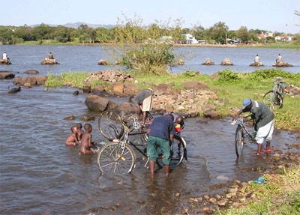

Fig 1: Typical population engagement with water bodies

A risk map showed low risk of Schistosomiasis transmission in term of socioeconomic and environmental suitability, but the projection from the perceived engagement in future predicts are possible surge in the incidence rates of schistomiasis although at a slow phase, but combined with culture and other disease burden, this may be a neglected disease within the region[8].
Primary Health care is under the community health strategy which operates as stipulated under the mandate of universal health care guidelines. The community health assistants beef up the communication in health related forums, and as depicted from the mapping,most of PHCC are located in main road where there was public transportation. Unpaved roads are narrow roads used by citizens to access to their manyatta settings from the water bodies. Access to any health center will be through various ways such as walking, public transportation, and most commonly,cycling.Public transportation move only in main road and there seems to be much of donar/Ngo funded programs to address health related gaps as evidenced from mapped centers on GIS.To access to these centers is by walking, Taxi, mini- three wheel motor car (Toktok), Toktok move in narrow roads as it was identified on mapping range as extracted from rectified image below.
Database was designed and it included attribute data of population distribution, key economic activities involving contact with marginal stagnant waters with a risk of habouring the intermediate host, snail and also,PHC center such as Name, area, address, telephone. Administration borders and serviced area by each PHC center were represented with the polygon. Also, location of PHC center has been presented by point data type in the database .
Population was projected to be on upsurge and straining the pastoral activity as the main income source, the deviation to other realted economic activities were perceived to be on rise, especially fishing: Results showed a pertinent information compromising the initiative to mitigate the salient schistosomiasis disease, as being the higher rate of HIV transmission.The final conclusions the deficit on PHC centers is mainly related to total number of population.
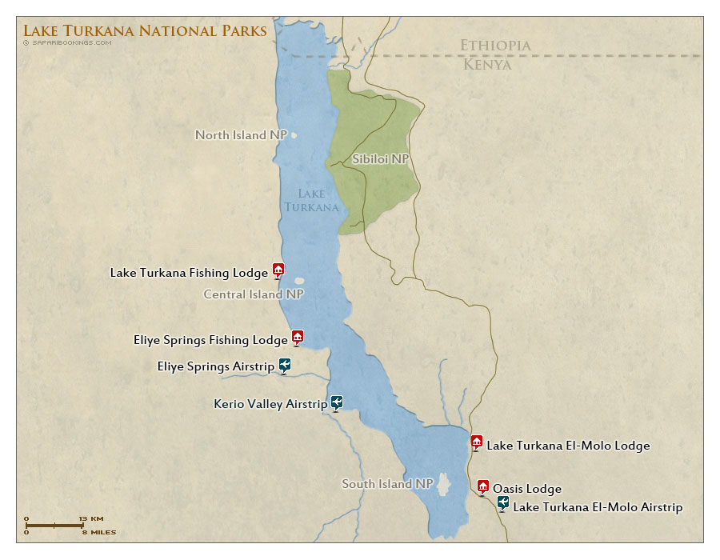

Fig 2: Map of lake Turkana

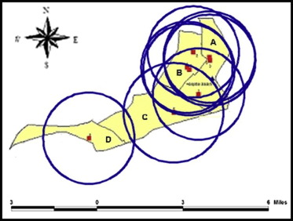
Fig 3. Overlay circle with in km for each PHC centers over relative to proximity to health service/communication centre
Many researches concluded that the use of electronic medical records was functionally aiming to ensure the applicability and convenience of the medical record and optimizing the available data and using the current and projected population dynamics by use of GIS and remote sensing, coupled with application of census statistics on demographic.All mentioned solution should be taken into consideration and studied in details in the next researches.
Conclusions
Traditional method is not capable dynamically to manage and address possible up-surge of schistosomiasis The obtained result showed that health planners and decision makers can use continued advanced fields of knowledge’s such as remote sensing, GIS and computer science in studying, monitoring, mapping, planning, following-up new trends of infectious and vector borne diseases. The salient trend needs a revamp of community health service delivery by the natives within marginalized communities which portray their own peculiar demographic outfits. The study found that the population is considered as the active criteria due to the high population growth. Theoretically, the PHC centers cover the serviced area but it doesn’t cover the serviced population according to the criteria of health care system, an issue which needs re-affirmation through field survey to ascertain if the findings complement at a close precision. Moreover, the study explored that there are many other governmental and private health services that were used by some patients instead of PHC centers. So, this point should be taken into consideration in the next study to fortify rarely mitigation measures as schistosomiasis could affect the already straining health systems in such areas in Sub-Saharan Africa at large. Such predicted was women washing clothes on shores of the lake,being at risk to develop female genital schistosomiasis. Inadequate hygiene and contact with infected water make alos children sub-population vulnerable to the infection
References
- Global Health Estimates 2016: Deaths by Cause, Age, Sex, by Country and by Region, 2000-2016. Geneva, World Health Organization; 2018.https://www.who.int/healthinfo/global_burden_disease/estimates/en/
- Prevention and control of schistosomiasis and soil-transmittedhelminthiasishttp://apps.who.int/iris/bitstream/10665/42588/1/WHO_TRS_912.pdf?ua=1
Geneva, World Health Organization: 2002.

- Murray CJL, Vos T, Lozano R, Naghavi M, Flaxman AD, Michaud C, et al. Disability-adjusted life years (DALYs) for 291 diseases and injuries in 21 regions, 1990–2010: a systematic analysis for the Global Burden of Disease Study 2010. Lancet. 2012;380:2197–223.

- Malone JB. Biology-based mapping of vector-borne parasites by geographic information systems and remote sensing. Parassitologia. 2005;47:27–50.

- Hay SI, Packer MJ, Rogers DJ. The impact of remote sensing on the study and control of invertebrate intermediate hosts and vectors for disease. Int J Remote Sens. 1997;18:2899–930.

- Hay SI, Randolph SE, Rogers DJ. Remote sensing and geographical information systems in epidemiology - guest editors’ preface. Adv Parasitol. 2000;47:xi–xii.

- Brooker S. Schistosomes, snails and satellites. Acta Trop. 2002;82:207–14.

- Kearney M. Habitat, environment and niche: what are we modelling? Oikos. 2006;115:186–91.

- Herbreteau V, Salem G, Souris M, Hugot JP, Gonzalez JP. Thirty years of use and improvement of remote sensing, applied to epidemiology: from early promises to lasting frustration. Health Place. 2007;13:400–3.

