Development of a functional tea and its effect on anthropometrical and biochemical parameters of obese patients
Donald F Molina Chaves, BSc, Nicaragua
Angeles Romano, BSc, Nicaragua
Luis F Maldonado, PhD, Honduras
Adriana Di Iorio, PhD, Spain

Abstract
Central America has had an increase of chronic nontransmissible diseases (NCDs) such as obesity and hypertriglyceridemia. In response to the need of functional foods, a sour tea with mango and betaglucan was prepared. A Completely Randomized Design was used with a factorial arrangement of 2 × 2 × 2, two concentrations of sour tea and mango (50/50 and 75/25), two temperatures (75 and 95 °C) and two times (2 and 5 minutes) of infusion, selecting the treatment with the highest content of total polyphenols (P₂T₂t₂). Different treatments were evaluated: sour tea, sour tea with mango and high dose of betaglucan, and with low dose of betaglucan, associated to normal and controlled diet. Tea intake was evaluated for 28 days, for anthropometrics parameters (weight, height, WHR, BMI, BP, total fat percentage, visceral fat), biochemical (glucose, lipid profile), cardiovascular risk and food intake through a controlled diet. After 28 days of tea intake, a reduction was found in weight (P < 0.009) and WHR (P < 0.024) values in females in T5 treatment. Regarding biochemical analyses, there was significant change in total cholesterol (P < 0.0001), triglycerides (P < 0.003), and HDL (P < 0.003) values in T5 treatment, and cardiovascular risk (P < 0.037) in female sex in T4 treatment. In the alimentary analysis, statistical changes in fat (P < 0.046) and calories intake (P < 0.031) were observed. Overall, the treatment with best results was T5.



Image
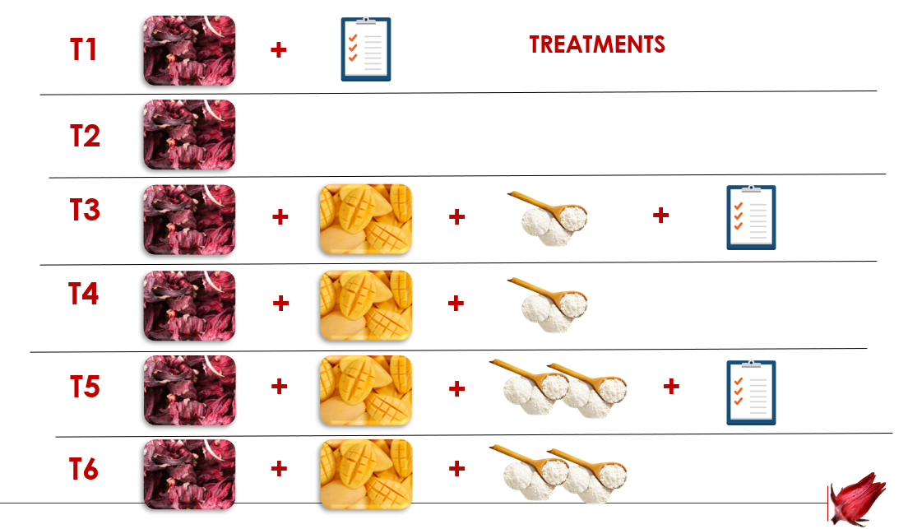
Figure 1 Visual representation of the treatments evaluated during the study.
Recent Publications
- Di Iorio AB, Orozco Beltrán D, Rico JAQ, Carratalá Munuera MC (2020) The Adaptation of the Carbohydrate Counting Method Affects HbA1c and Improves Anthropometric Indicators in Patients with Diabetes Mellitus 2. Front. Nutr. 7:577797. Doi: 10.3389/ftnut.2020.577797.
- Evaluation of the Nutritional Quality of Processed Foods in Honduras: Comparison of Three Nutrient Profiles https://doi.org/10.3390/ijerph17197060.
- Nutrient Assessment and Potential Renal Load of Solutes in Infant Powder Formulas Available on the Honduran Market (ISSN:2582-1423)
- Development and Evaluation of an Infusion of Red Tea (Camellia sinensis) with Blackberry (Rubus ulmifolius) Enriched with β Glucans for the Control Glycemia in Diabetic Persons (ISSN:2582-1423)
5. Agua de coco Fermentado por Lactobacillus plantarum con adición de inulina: Desarrollo de una bebida potencialmente simbiótica (ISSN 2525-8761).

Biography
Adriana Di Iorio has her expertise in clinical nutrition, specialized in gastrointestinal, hepatic, and metabolic pathologies using different methodologies. She has worked in projects associated to fortified foods, functional foods in the treatment of chronic nontransmissible diseases, and nutrient profile evaluation of processed and ultra-processed foods. She has built this model after years of experience in research, evaluation, and teaching both in hospital and education institutions.
Donald Molina has a bachelor’s degree in food science and Technology. He has his expertise in food chemistry, food analysis and human nutrition. He has worked in projects associated to tomato processing and chemical and nutritional changes during manufacturing, and evaluation of the effect of functional foods in anthropometrical and biochemical parameters in obese patients.

Email: adrianadiiorio@gmail.com
donaldmch298@gmail.com

Notes/Comments:

