Obesity, Diabetes and Cancer: A Novel Signal Transduction Pathway
Isao Eto, PhD, University of Alabama at Birmingham, Birmingham, Alabama USA

Abstract (300 word limit)
By 2016, obesity had been known to be associated with at least 13 types of cancer. In 2010, the American Cancer Society and American Diabetes Association issued a joint consensus report on diabetes and cancer. It stated that “type 2 diabetes and cancer share many risk factors, but potential biologic links between the two diseases are incompletely understood.” How might obesity-diabetes affect cancer risk? Today, I am going to present an outline of my experimental evidence that indicates the existence of a novel signaling transduction pathway that integrates other existing hypotheses as well.
It is summarized in one sentence:
“Expression of p27Kip1, a Cell Cycle Repressor Protein, in Human Peripheral Blood Mononuclear Cells Is Inversely Associated with Potential Carcinogenic Risk in Obese Type 2 Diabetic Individuals Relative to Lean Normal Controls”.
You could observe the decrease in the expression of p27Kip1 in the peripheral blood mononuclear cells from the cancer-free obese type 2 diabetic individuals. The decrease in the expression of p27Kip1 could be an earliest indicator of the increase in the cancer risk in obese type 2 diabetic individuals.
Unlike any other cell cycle regulatory proteins, p27Kip1 has two unusual molecular biological properties:
First, a relatively large number of nutritional and chemopreventive anti-cancer agents specifically up-regulate and several pro-cancer agents (including glucose, insulin and other growth factors), specifically down-regulate expression of p27Kip1 without directly affecting the expression of any other G1-to-S phase cell cycle regulatory proteins including p21(Cip1Waf1).
Second, expression of p27Kip1 is regulated primarily at the level of translation, not transcription. At least 4 different upstream signal transduction pathways have been identified so far that either down or up-regulate the translation of p27Kip1; hence the cancer risk in obese type 2 diabetic individuals.

Notes/Comments:

Image
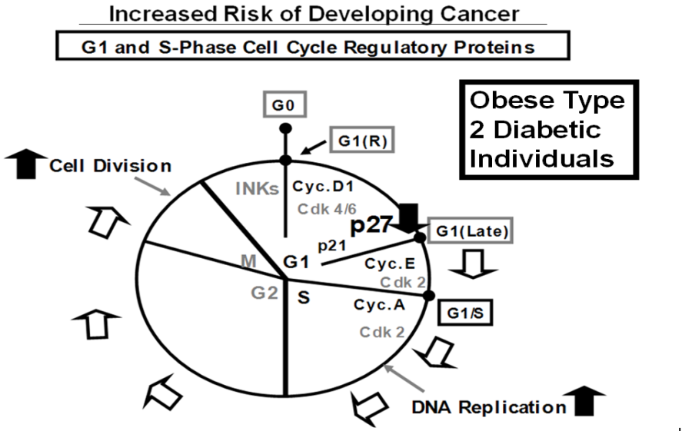

Pro-Cancer Agents

Obese Type 2 Diabetic
Individuals

Recent Publications (minimum 5)
- Eto I (2006) Nutritional and chemopreventive anti-cancer agents up-regulate expression of p27Kip1, a cyclin-dependent kinase inhibitor, in mouse JB6 epidermal and human MCF7, MDA-MB-321 and AU565 breast cancer cells. Cancer Cell International 6: 20-10.1186/1475-2867-6-20. (pp. 1-19)
- Eto I (2010) Upstream molecular signaling pathways of p27(Kip1) expression: Effects of 4-hydroxytamoxifen, dexamethasone, and retinoic acids. Cancer Cell International 10: 3-10.1186/1475-2867-10-3. (pp. 1-19)
- Eto I (2011) Upstream molecular signaling pathways of p27 (Kip1) expression in human breast cancer cells in vitro: differential effects of 4-hydroxytamoxifen and deficiency of either D-(+)-glucose or L-leucine. Cancer Cell International 11:31-10.1186/1475-2867-11-31 (pp. 1-19).
- Eto I (2013) Expression of p27Kip1, a cell cycle repressor protein, is inversely associated with potential carcinogenic risk in the genetic rodent models of obesity and long-lived Ames dwarf mice. Metabolism Clinical and Experimental 62; 873-887.
- Eto I (2014) Expression of p27(Kip1), a cyclin-Dependent Kinase Inhibitor, in Human Peripheral Blood Mononuclear Cells Is Inversely Associated with Potential Carcinogenic Risk in Obese Type 2 Diabetic Individuals Relative to Lean Normal Controls. American Journal of Molecular Biology 4:114-128.

Biography (150 word limit)
Isao Eto, Associate Professor in the Biochemistry Division of the Department of Nutrition Sciences, University of Alabama at Birmingham, USA, grew up in Japan and received his Bachelor's degree in physiological chemistry from the Tokyo Metropolitan University in 1971. After he obtained his Ph.D. degree in the Microbial Biochemistry from the University of Alabama at Birmingham in 1976, he received Postdoctoral training in Cellular Immunology at the University of California San Francisco for one year. Subsequently, he was appointed Research Associate in 1977 and then Adjunct Assistant Professor in 1978 at the Department of Pathology, Showa University School of Medicine in Tokyo, Japan. In 1979, he joined the Biochemistry Division of the Department of Nutrition Sciences at the University of Alabama at Birmingham, USA
Email: drXXXXXXX@xxxmail.com

