Impact Of Food Trays Labelling And Assistance Opening Food And Beverage Packaging On Dietary Intakes of Renal Inpatients: A Pilot Study
Heba Hassanin¹, Karen Walton¹, Alison Bell¹, Kelly Lambert², Jacqueline Chevis² School of Medicine, University of Wollongong, Wollongong, NSW, 2522, Australia and Wollongong hospital.

Abstract
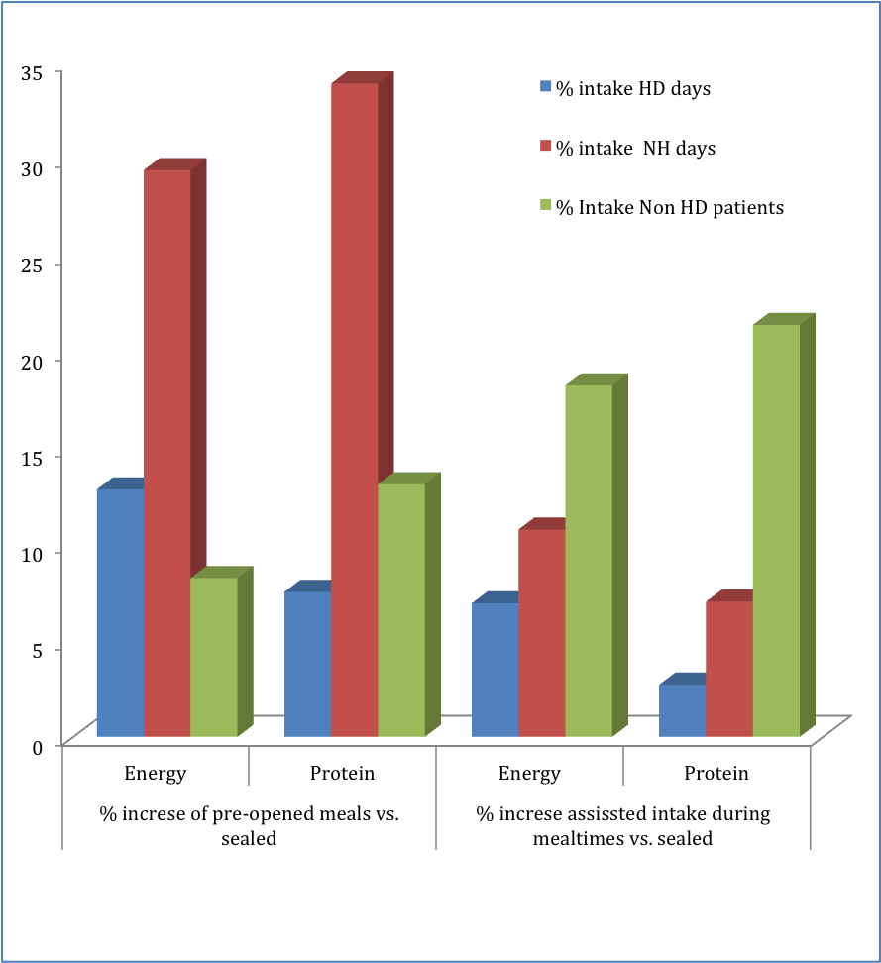
Malnutrition is a common condition in elderly hospitalised patients and is usually associated with increased complications, hospital costs and length of stay. Packaged foods and beverages have been identified as a contributing factor to malnutrition amongst this population. This pilot study aimed to evaluate if assistance to open food and beverage packages is associated with improved dietary intakes by hospitalised chronic renal failure and haemodialysis patients, and to assess the reliability of the currently provided assistance. Dietary intakes and waste audits were conducted to compare differences in intakes between pre-opened and sealed meals on different days. Nurses’ views about the identification of patients needing assistance and the labelling of food trays were explored through focus groups. There was a trend of increased energy and protein intakes when assistance opening packages was provided for haemodialysis patients at the beginning of meals, with significant improvements in energy intakes on the non-haemodialysis days (P: 0.046). However offering assistance during sealed mealtimes showed an evident increase in energy and protein intakes for non-haemodialysis patients reaching significance (P: 0.068 for both). Nurses indicated the unreliability of the tray labelling system. Nutritional status of elderly hospitalised patients can be improved by implementing a patient targeted tray labelling system and raising awareness of nursing and food service staff about timely assistance during mealtimes.

Image

Recent Publications
- Bell AF, Walton KL, Tapsell LC. Easy to open? Exploring the 'openability' of hospital food and beverage packaging by older adults. Appetite. 2016;98:125-32.
- Bell A, Walton, K., Jenkins, E. & Ryman, S. . You have to open it to eat it: does food packaging used in hospitals impede intake in a well older population?. Abstracts of the ICCAS 2015: Opportunities and Challenges for Food and Eating in Society. United States: Montclair State University. 2015;1.
- Bell A, Walton K, Chevis J, Davies K, Manson C, Wypych A, Yoxall A, Kirby J & Alexander N (2013). Accessing packaged food and beverages in hospital: Exploring experiences of patients and staff, Appetite; 60:231-238.
- Walton K, (2012). Improving opportunities for food service and dietetics practice in hospitals and residential care facilities, Nutrition and Dietetics; 69(3):222-225.
- Walton K, Williams P & Tapsell L (2012). Improving food services for elderly, long-stay patients in Australian hospitals: adding food fortification, assistance with packaging and feeding assistance. Nutrition and Dietetics; 69(2):137-144.

 Biography
Heba Hassanin is Passionate Nutrition and Dietetics professional, believes in the critical role nutrition plays in hospitals and community, dedicated to improving dietary habits and long-term health of people of all ages. This research is part of big research programme exploring the open-ability of food and beverages packaging both in hospitals and community settings, conducted by Walton et al, at UOW, after years of experience in research evaluation in this field.
Email: hasah644@uowmail.edu.au

Notes/Comments:

