Abstract

Title: Cross-disciplinary precision occupational and environmental medical services-Remediation of melamine exposure in both workplace and community

Ming-Tsang Wu¹⁻³
¹Department of Public Health, Kaohsiung Medical University, Kaohsiung, TAIWAN
²Department of Family Medicine, Kaohsiung Medical University Hospital, Kaohsiung Medical University, Kaohsiung, TAIWAN
³Research Center for Environmental Medicine, Kaohsiung Medical University, Kaohsiung, TAIWAN

Keywords: Melamine, Environment, Workplace, Kidney, Humans

- Abstract Body
Although the 2008 Chinese toxic milk scandal has wound down, environmental exposure to melamine is still ubiquitously present due to the popular use of melamine-made tableware in day-to-day life. Because a series of human studies have suggested long-term low-dose melamine exposure can increase the risk of renal stones and kidney damage in adults, we assembled one cross-disciplinary medical service team to implement different interventional strategies in the community and in the workplace to mitigate the exposure of melamine chemicals. We found that, in daily melamine exposure from melamine-made tableware, the regular use of stainless steel-made meals boxes to replace melamine tableware can decrease ~68.4% (median) of melamine exposure (ranging from 41.8 % to 91.8 %). In the workplace of melamine tableware manufacturing workers, the installation of ventilation intervention can decrease ~70% of ambient melamine exposure. In this speech, I will present those successful strategies how to reduce melamine exposure in both workplace and community.

- Image:
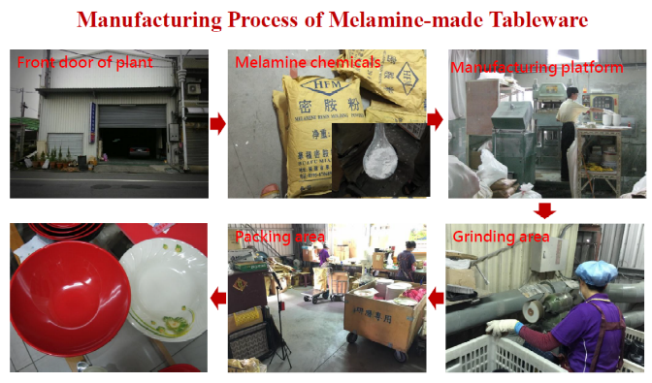

- Reference:
Selected publications
1.Liu CC, .Wu MT*: Low exposure to melamine increases the risk of urolithiasis in adults. Kidney Int. 2011;80:746-52.
2.Wu CF,. Wu MT*: A crossover study of noodle soup consumption in melamine bowls and total melamine excretion in urine. JAMA Intern Med 2013;173:317-9.
3.Wu CF,. Wu MT*: Ambient melamine exposure and urinary biomarkers of early renal injury. J Am Soc Nephrol 2015;26:2821-9.
4.Wu MT*, et al.: Behavioral intervention decreases daily melamine exposure from melamine tableware. Environ Sci Technol. 2015;49:9964-70.
5.Liu CC, .., Wu MT*. Urinary melamine excretion and increased markers of renal tubular injury in patients with calcium urolithiasis: A cross-sectional study. Environ Pollution 2017;231: 1284-90.

- Biography:
Dr. Ming-Tsang Wu has completed his MD from Chung Shan Medical University in Taiwan and PhD from Harvard School of Public Health in the USA. He is a full professor in the Department of Public Health and the Director in Research Center for Environmental Medicine, Kaohsiung Medicine University, Taiwan. His major research interest is on the interactive effects of environmental and occupational exposures, genetic factors, and biomarkers on the health outcomes.

- Presenting author details

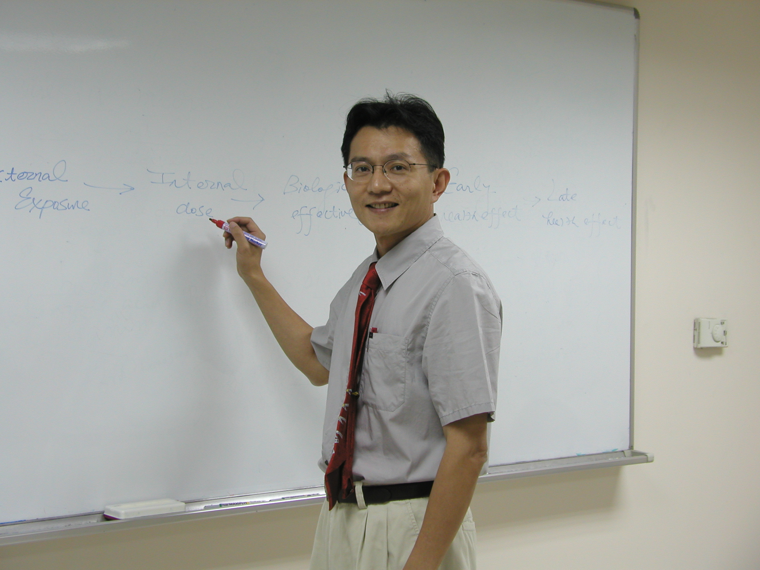
Full Name: Ming-Tsang Wu, MD, ScD
Contact number: 011886-7-3121101 ext. 2141 ext. 55
E-mail: mingtswu@gmail.com
Category: Oral presentation

