Associations of bullying, cyberbullying and depression among adolescent girls
Yo Hyeong KIM, Shanghai American School, China
Yancy SHI, PhD, The Education University of Hong Kong, HK
Chenpeng SUN, The Education University of Hong Kong, HK

Abstract
Statement of the Problem: During and following the epidemic, bullying, particularly cyberbullying, became more prevalent among teenage girls. Concurrently, depression is also emerging as a significantly escalating issue. This study investigated the correlation between bullying, cyberbullying, and depression in a substantial sample of adolescent girls in China.
Methods: A total of 15,577 adolescent girls (10-19 years old) completed surveys online. School bullying (verbal, physical and social/relational bullying) was measured using the Delaware Bullying Victimization Scale-Student. Cyberbullying was measured using the Revised Cyberbullying Inventory. Distress, depression, anxiety, and somatization were measured by the Four-Dimensional Symptom Questionnaire. Linear mixed models were performed for analysis to examine the associations between school bullying and distress, depression, anxiety, and somatization. The associations were adjusted for age, BMI, city level, and school type.
Results: Both school and cyber bullying scores were positively associated with distress, depression, anxiety, and somatization scores. Age was negatively associated with distress, depression, and anxiety. For somatization, the negative association of age was found only among school bullying (verbal, physical and social/relational bullying) but not in cyberbullying.
Conclusions: Verbal, physical, social, and cyberbullying in adolescent girls were associated with higher levels of distress, depression, anxiety, and somatization. Whereas older adolescents experienced lower levels of distress, depression, anxiety, and somatization when encountering verbal, physical, and social bullying at school. Cyberbullying does not discriminate based on age. Subsequent research might address the role of age when exploring the relationship between bullying and depression.

Image
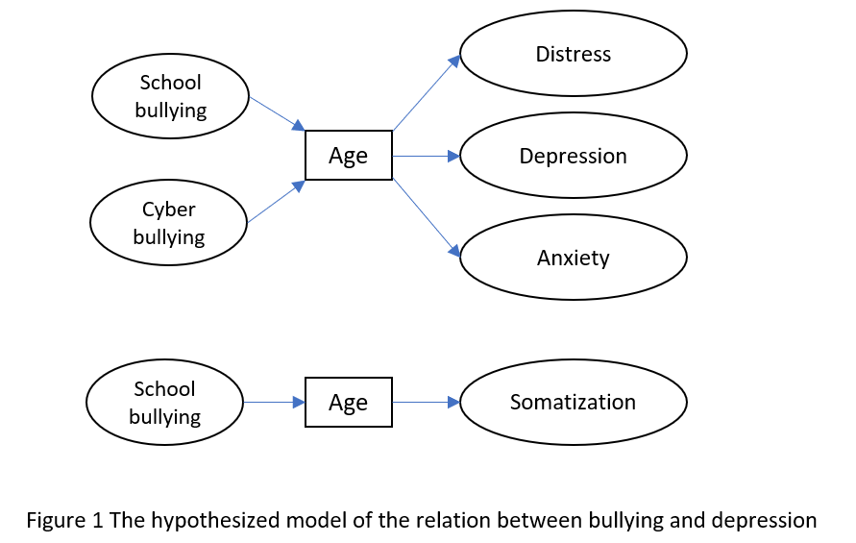
Recent Publications (minimum 5)
1. Shi, Y., Huang, W. Y., Sit, C. H. P., & Wong, S. H. S. (2020). Compliance with the 24-hour Movement Guidelines in Hong Kong Adolescents: Associations with Weight Status. Journal of
Physical Activity and Health. 17(3):287-292
2. Shi, Y., Huang, W. Y., Yu, J. J., Sheridan, S., Sit, C. H. P., & Wong, S. H. S. (2019). Compliance and Practical Utility of Continuous Wearing of activPAL™ in Adolescents. Pediatric Exercise Science, (00), 1-7.
3. Shi, Y., Huang, W. Y., Yu, J. J., & Wong, S. H. S. Compliance With The 24-h Movement Guidelines In Hong Kong Adolescents: Associations With Body Mass Index. Medicine and Science in Sports and Exercise, (2019); Volume 49(5S):S413 Supplement
4. Wong, S. H. S., Shi, Y., & Huang, W. Y., Association between Parenting Styles and Adherence to the 24- Hour Movement Guidelines in Adolescents. Medicine and Science in Sports and Exercise, (2019); Volume 49(5S):S569 Supplement.
5. Shi, Y., Huang, W. Y., Sheridan, S., & Wong, S. H. S. Practical Issues Relating to a 7 Consecutive Days Wear Protocol Using the activPAL™ in Adolescents. Medicine and Science in Sports and Exercise, (2017); Volume 49(5S):174 Supplement.



Yo Hyeong Kim is a young entrepreneur passionate in self-care and bullying issues among adolescents. She has initiated and participated in various service projects, such as co-founded “haf haf,” a self-care brand that donates products to underprivileged communities; “Ni Liu,” an underwater dance piece that advocates for anti-bullying; and Team Treehole, an AI chatbot that supports students who face non-physical bullying. She seeks to bridge the knowledge gap between theory and practice through positive psychology, hoping to improve her capacity for comprehension of people, make wise judgments, and eventually help more youth in developing stronger self-confidence.
Email:bettie01px2026@saschina.org

Notes/Comments:

Presenting author details
Full name: Yo Hyeong KIM
Contact number: +86 13248023017
Twitter account:
Linked In account:
Session name/ number: Stress, Anxiety and Depression
Category: Oral presentation

