
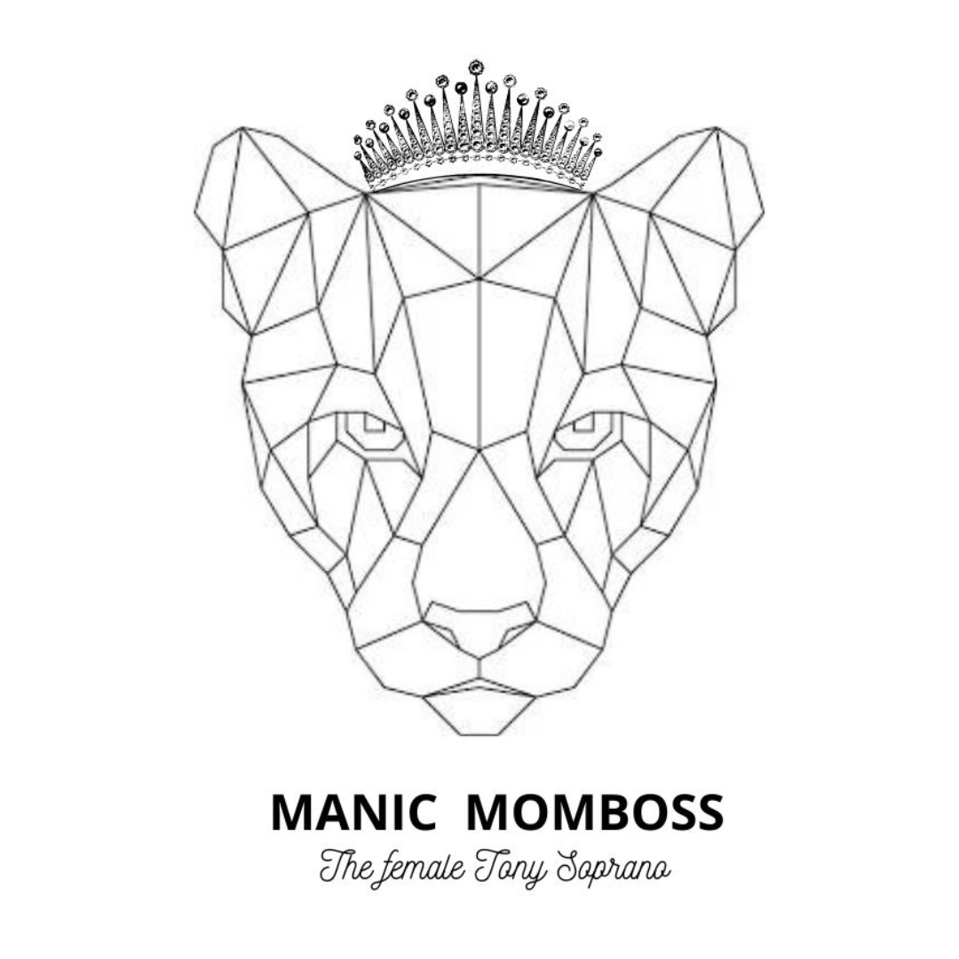

Paste your Logo here

Title: From Living Loss to Manic Momboss
5 steps to mental wellness
Name: Nadya van der Sluis

Abstract
How to be bipolar or mental ill? Something you don’t learn at school. It is something you mostly learn by experience, just like other challenges in live. Even though there are a lot of studies on bipolarity, schizophrenia, borderline, the diagnose itself is very individual, just as living and working with it. Why? Because everyone has their own triggers and tools, like medication or environment. Personally I think that if you search further then only the diagnose and accept that living with it is a living loss, you can reach mental wellness.
The journey in trying to accept a mental illness is familiar with a process of grief. Nadya thinks there are 5 steps to take in this journey and explains her opinion on the psychiatric term ‘living loss’ in her E-book: From Living Loss to Manic Momboss. In 2009 she got diagnosed with a bipolar condition type I after a long manic psychotic episode abroad. Years of self stigma followed, but when she had another relapse in 2015 and 2019 she learned how to be bipolar and how to live, study, work and be a mom without medication, but with her own way of support. She discovered 5 steps needed to make it a part of her and she believes that if every psychologist or psychiatrist would imply this 5 steps with their patient it would help them in their journey of accepting their mental illness faster.

Biography
Nadya van der Sluis has completed her master in criminal law at the age of 28 years from Erasmus University School of Law. She is a lawyer for the Dutch Ministry of Justice & Safety, author and TEDx speaker/consultant on diversity in mental health and birth care. Next to that she is an co-author of the Dutch guidelines for bipolar condition of psychiatrist Ralph Kupka. In 2023 Nadya launched her Lioness Leadership Consultancy programme at the event Talent Night TedxAmsterdamWomen.

