Title : comprehensive study of molecular neuroscience.
Author : Kunal Joon
University : Noida International Institute of Medical Sciences
Corresponding author : Kunal Joon
Email: Kunaljoon37@gmail.com
Abstracts
It deals with the molecular neuroscience, stem cell theory , neuromodulators , flurosence study of nerve and chemical study of neurosignals and even include electrical circuits in the brain
Keyword : neuromodulators , stem cell theory , molecular neuroscience , neurosignals
Structures of neurones
Figure 1
Illustration of neuronal shape and spines: An exemplary pyramidal neuron from the CA1-region of the hippocampus with spine-studded dendritic extensions
A. Top, a CA1-region pyramidal neuron was patched in hippocampal slices from a mouse that had been sparsely infected with a lentivirus encoding EGFP, and was filled with biocytin via the patch pipette (a section stained for biocytin (red) and DAPI to label nuclei (blue). Bottom, expansion of the dendritic field boxed in the neuronal overview image above to illustrate the dense decoration of dendrites with spines.
B. 3D-reconstruction of the pyramidal neuron and its dendritic segment shown in A. In the bottom panel, spine shapes were categorized and color–coded (blue, mushroom; green, thin; pink, stubby). Images courtesy of Dr. Richard Sando.

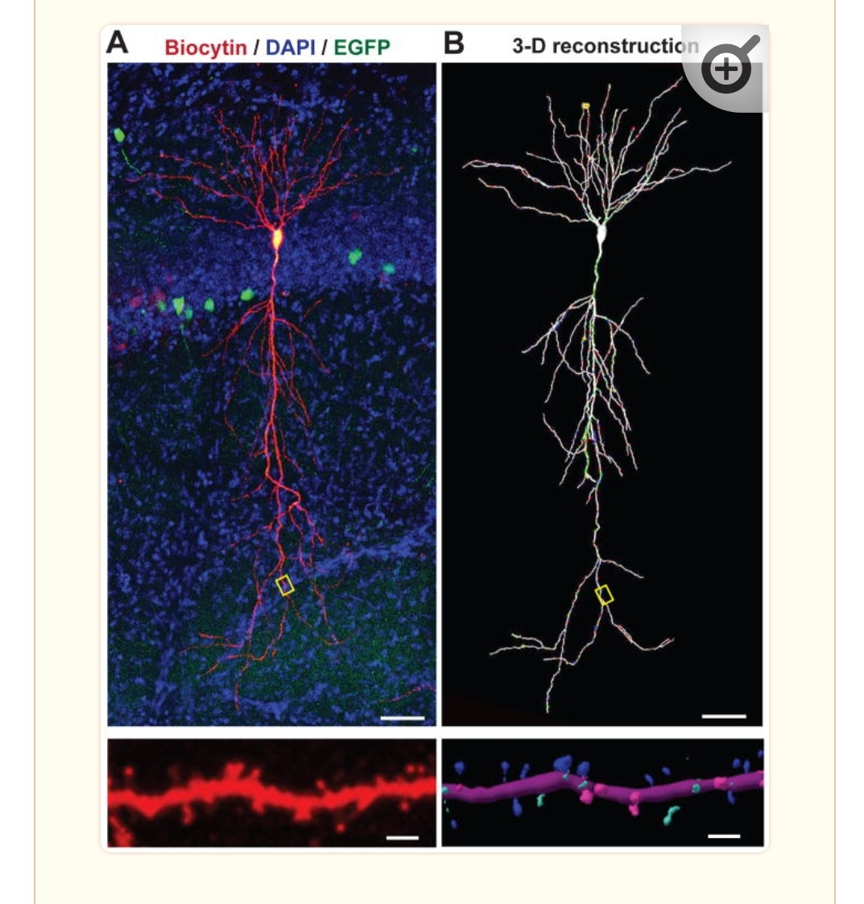
Figure 2
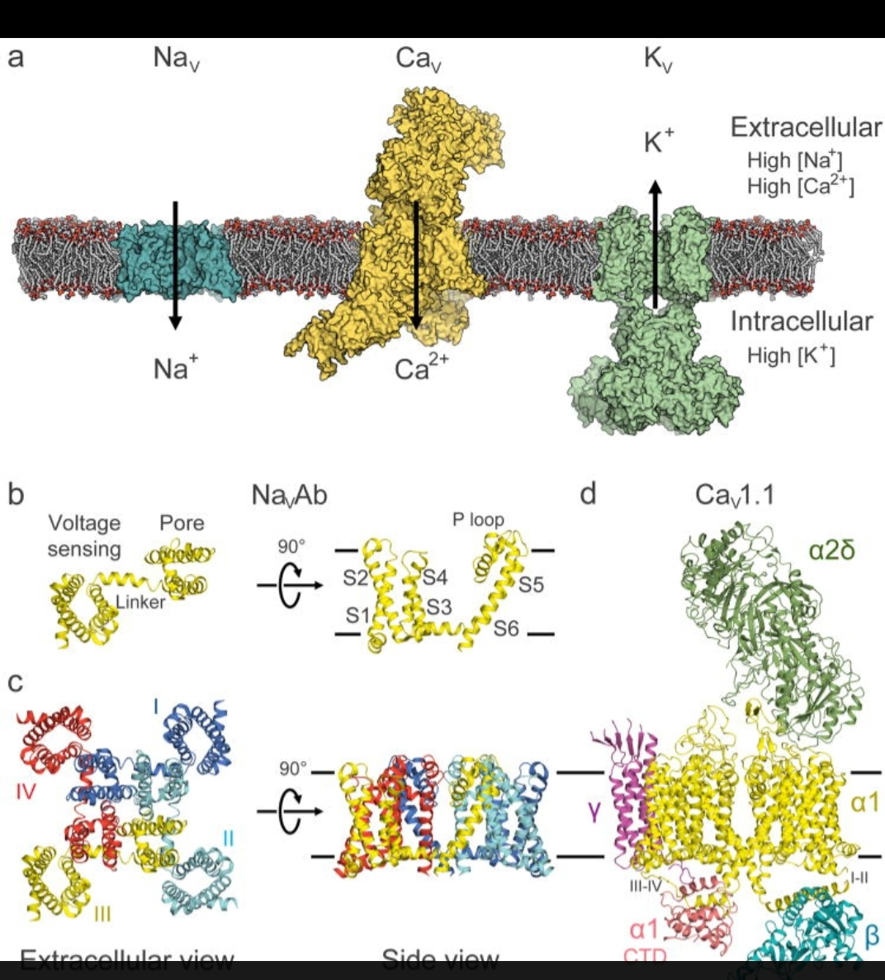
Overall architecture of voltage-gated sodium, calcium, and potassium channels
a, Model of representative NaV, CaV, and KV channels in a lipid membrane. From left to right: bacterial NaVAb (cyan), mammalian CaV1.1 complex with auxiliary subunits (yellow), and mammalian KV1.2/2.1 chimera complex with cytoplasmic β subunits (green)
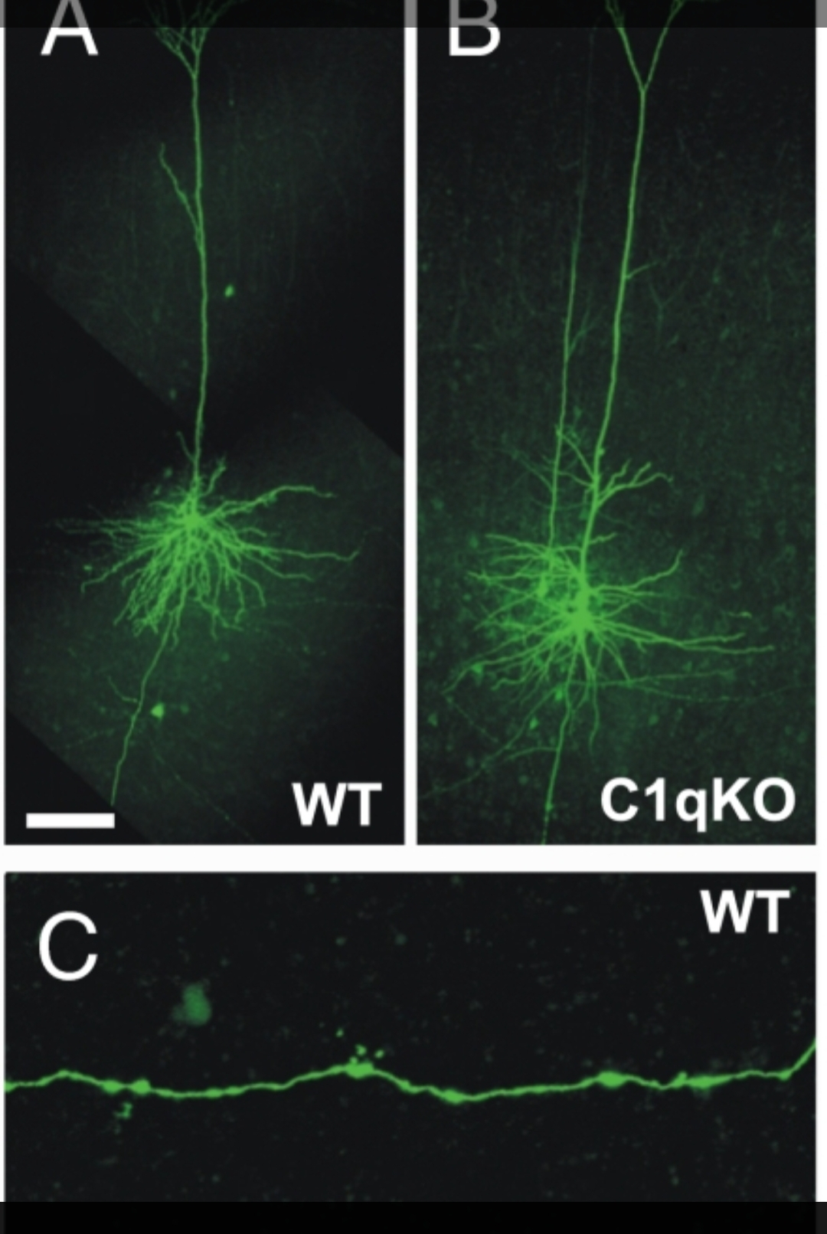
Figure 3 Increased density of axonal boutons in cortical layer V pyramidal neurons of the C1q KO mice. (A and B) Confocal images of biocytin filled layer V pyramidal neurons of C1q KO (A) and WT (B) mice. (C and D) A segment of the axon from the control cell (C) and C1q KO neuron (D). Large and small arrows in D point to examples of large (>1 μm) and small (≤1 μm) boutons, respectively. (Scale bars: A for A and B, 100 μm; D for C and D, 10 μm.)
Discussion
-) molecular neurology
-) molecular neuroscience
-) axon study in mouse
-) flurosence neurons study
Conclusion
Description of molecular neuroscience and flurosecent neuron study are interrelated .
Reference
- https://www.nature.com/subjects/molecular-neuroscience
- https://www.ncbi.nlm.nih.gov/pmc/articles/PMC5689449/
- https://www.sciencedirect.com/journal/molecular-and-cellular-neuroscience
- https://www.feinberg.northwestern.edu/sites/neuroscience/research/research-areas/cellular-molecular-neuroscience.html
- https://www.frontiersin.org/research-topics/38607/new-challenges-and-future-perspectives-in-molecular-neuroscience/magazine
- https://gsbs.rowan.edu/academic-programs/cell-and-molecular-biology/
- https://neuroscience.ucsb.edu/research/molecular-and-cellular-neuroscience
- https://www.dpag.ox.ac.uk/centres/centre-for-cellular-and-molecular-neurobiology
- https://www.nature.com/subjects/molecular-biology
- https://onlinelibrary.wiley.com/journal/10974547

