S.E.R.V.E. Our Youth: Creating An Anti-knife Culture
MJ Maher Group Analyst London UK

Abstract (300 word limit)
Statement of the problem
 !
""#$"%%
&'(
The purpose of the study:)S.E.R.V.E. Our Youth: Creang An An-knife Formula*
 """
%%
Methodology & theorecal orientaon+,""
-.*,"
/**01
"
S"2*The Eecve P.O.R.T.E.R. Strategy3&"
""%
E"2*The State of Survival Strategy*
%%*
4"%&
R25*The Digesble Investment Direcve3
"%%"
"
V2-3The Game Changer Challenge*6"
)"
"
E&2.3The Dig Deep S.P.A.D.E. Soluon3&"
%70"14"
*8"
Statement of the problem: Knife crime is on the rise in the UK. Children as young as 12 years of age are getting caught up in a diverse web of class, race, gender, and cultural differences. Safeguarding institutions often blinded by prejudice, focus on thrusting this live snake out of their back gardens, leaving our children exposed and trapped in the gap. How can we bridge this gap?
The purpose of the study: I created a S.E.R.V.E. Our Youth: Creating An Anti-knife Formula, an on-going research on effective psychotherapeutic interventions that support challenged professionals - therapists, police, teachers, social workers, and youth workers.
Methodology & theoretical orientation: This qualitative research values the multimethod approach to capture some of the reality using several methods: a 45-minute webinar, questionnaires, vignettes, face-to-face interviews, literature research and 12 training videos using psychoanalytic concepts:
Sensitivity: Module 1 - The Effective P.O.R.T.E.R. Strategy – explores personal and organizational barriers to sensitivity and how to improve communication skills.
Emotional: Module 2 -The State of Survival Strategy - addresses common defense mechanisms youths engage to protect themselves but are likely to evoke counter-transference responses from professionals unable to read the youth’s communication of their unspeakable experiences.
Responsibility: Module 3 - The Digestible Investment Directive – discusses what hinders youths from accepting responsibility, how professionals can invest in skills akin to presenting a meal that can be consumed one mouthful at a time.
Victor: Module 4 – The Game Changer Challenge - A commonly held myth is that all victims end up being perpetrators. In this module we aim to change negative outcomes for youth, moving them from victims to victors.
Exclusion: Module 5 – The Dig Deep S.P.A.D.E. Solution – explores some solutions to what perpetuates knife culture; separating mental health diagnosis from Klein’s positions e.g., paranoid-schizoid position from paranoia and schizophrenia.

Image

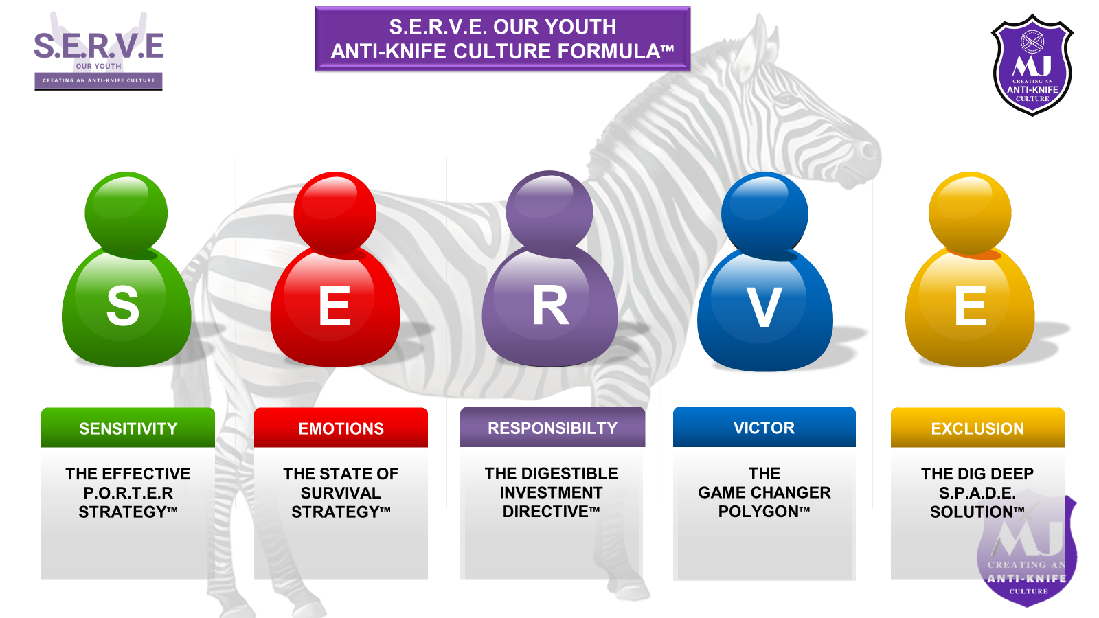
Recent Publications (minimum 5)
- Maher, M.J. (2012) Racism and Cultural Diversity: Cultivating Racial Harmony through Counselling, Group Analysis and Psychotherapy. London: Karnac first now with London & New York: Routledge Taylor & Francis Group
- Maher, M.J. (2018) Response to ‘World in motion- the emotional impact of mass migration’ by Elisabeth Rohr, First published August 14,2018 Group Analysis, London: SAGE
- Maher, M.J. (2015) Rwanda: Hope and Healing published in Once And For All newsletter, London: The Beeches Publication
- Maher, M.J. (2021:195-214), The role of a grandmother in Exploration Depth Psychology and the Female Self: Feminist Themes from Somewhere ed Gardner L & Miller C, London & New York: Routledge Taylor & Francis Group
- Maher, M.J. (2017) Riding the rumbling terror of the mystic hour: Sleep paralysis , to be published , presented at the
Psychoanalytic Society Symposium, Paris - Theme Psychoanalysis & Politics: Anxious Encounters and forces of fear

Biography (150 word limit)
MJ is the creator of S.E.R.V.E. Our Youth: An Anti-knife Culture Formula. She is a group analyst in private practice. MJ teaches trainee counsellors and facilitates groups for doctorate students at Roehampton University. She teaches and facilitates groups on a Foundation Course and an Intermediate Course in Group Analysis in Rwanda. MJ has over 28 years of working in the NHS as a charge nurse, community psychiatric nurse and a group psychotherapist. She worked in a Drug and Alcohol Rehabilitation Unit and Personality Disorder Therapeutic Communities, specializing in racism, sexual abuse and suicide. MJ is an international speaker at psychotherapy symposiums and her response to a keynote address was published. In her book MJ published her research on ‘Can Psychotherapy Penetrate Beyond Skin colour? As a proud grandmother she wrote and published a 5, 264-word poem on The Role of a grandmother comparing social changes between a traditional and colonized grandmother.
Email: mjmaher006@yahoo.com

Notes/Comments:

