The inter-relationship between inflammation and autophagy in schizophrenia:
a new research direction and target
Cai Song, Ling Yan, Yong-Ping Zhang, Li Tian
Research Institute for Marine Drug and Nutrition and Shenzhen Institute, Guangdong Ocean University, PR
China

Abstract (300 word limit)
Inflammatory and autoimmune disorders play an important role in the etiology of schizophrenia. Inflammation and autophagy present two sides of immunity. Over-expression of pro-inflammatory cytokines may inhibit autophagy. For example, downregulated autophagy leads to excessive interleukin (IL)-1β secretion, which in turn, stimulates the autocrine secretion of other pro-inflammatory cytokines and inflammatory response. By contrast, autophagy can remove endogenous inflammasome and negatively regulate the secretion of pro-inflammatory cytokines. The kinase mammalian target of rapamycin (mTOR) is a major regulator of the autophagic process, in which phosphatidylinositol 3-kinase (PI3K/Akt) pathway underlies the upstream of mTOR and modulates its activity. Both mTOR and PI3K/Akt expressions were up-regulated in schizophrenia. However, the inter-relationship between chronic inflammation and autophagy, and whether inflammation suppresses autophagy via PI3K/Akt/mTOR signaling pathway remains unknown in schizophrenia. The aim of current study to determined relationship between inflammation and autophagy, including autophagy regulatory pathway in schizophrenia patients.
66 samples of schizophrenia patients (SZ) and 44 healthy controls (CT) were enrolled. Clinical data as well as blood samples were collected.
The concentration and mRNA expression of IL-1β, IL-6 and INF-γ, as well as mRNA and protein expression of NLRP3, ASC, and CASP1 were increased in SZ. In opposite, the positive rate of MDC staining in autophagic vesicles and mRNA and protein expressions of Beclin 1, LAMP 1, Cathepsin D and LC3 B/LC3 A in lymphocytes were significantly decreased, whereas p62 was significantly increased compared with CT. In SZ lymphocytes, the PI3K/Akt/mTOR pathway was activated at both mRNA and protein levels. Furthermore, IL-1 and IL-6 treatment significantly increased，while IL-10 decreased LC3 B and Beclin 1 expression in SZ lymphocytes. Furthermore, 3-MA, an autophagy inhibitor, increased NLRP3, ASC, Caspase 1 and pro-inflammatory cytokines IL-1β and IL-6.
These results suggest an interaction and imbalance between inflammation and autophagy-lysosome in SZ. The activation of the PI3K-Akt-mTOR signaling pathway may exert inhibited effects on autophagy. Thus, the function of autophagy could be a new target for new treatment for SZ.

Image

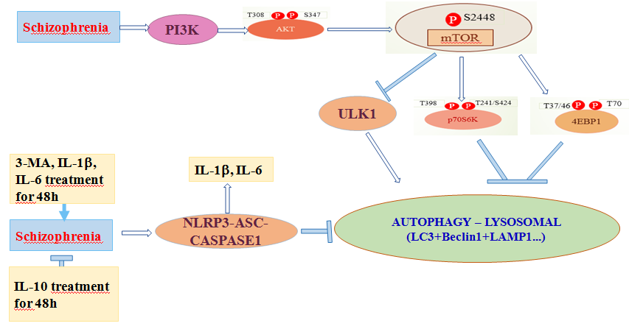

Recent Publications (minimum 5)
- Wang J, Li Y, Lai K, Zhong Q, Demin KA, Kalueff AV, Song C. High-glucose/high-cholesterol diet in zebrafish evokes diabetic and affective pathogenesis: The role of peripheral and central inflammation, microglia and apoptosis. Prog Neuropsychopharmacol Biol Psychiatry. 2019 Aug 22:109752.
- Gu MQ, Li YY, Tang HT, Zhang C, Li W, Zhang YP, Li YJ, Zhao YT, Song C. Endogenous omega (n)-3 fatty acids in Fat-1 mice attenuated depression-like behavior, imbalance between microglial M1 and M2 phenotypes and dysfunction of neurotrophins induced by lipopolysaccharide administration. Nutrients 10(10). Pii E1351, 2018
- Song C, Berridge KC, Kalueff AV. 'Stressing' rodent self-grooming for neuroscience research. Nat Rev Neurosci. 17(9):591, 2016.
- Song C, Luchtman D, Kang Z, Tam EM, Yatham LN, Su KP, Lam RW. Enhanced inflammatory and T-helper-1 type responses but suppressed lymphocyte proliferation in patients with seasonal affective disorder and treated by light therapy. J Affect Disord. 185:90-96, 2015.
- Song C, Phillips AG, Leonard BE, Horrobin DF. Omega-3 fatty acid and RU 486 reverse IL-1-induced memory impairment in rats: a glucocorticoid involved mechanism. Mol. Psychiatry 9: 630-638, 2004.

Notes/Comments:
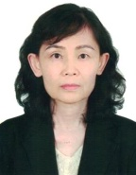 Biography (150 word limit)
Professor Song obtained her PhD in Neuropharmacology from National University of Ireland, and postdoctoral training in McGill and Carleton Univ. Canada. She was an Assi Prof in Psychiatry Dept. UBC, Assoc Prof in UPEI, and Canada Research Chair in Canada NRC and UPEI. Prof. Song published 140 papers (such as Nature Rev Neurosci, Mol Psychitry, Biol Psychiatry, J. Neurosci, Neuropsychopharmacology), 3 books and 14 book chapters. She was invited to give lectures by 60 international conferences, and received many international and national awards, including Pfizer Psychiatry Award, Young Investigator Award from the Society of Psychoneuroendocrinology, Canada Research Chair, “Oversea Famous Professor” of Education Ministry of China and National Leading Scientist awards from Shenzhen Government. Prof. Song is the editor-in-Chief of Curr Res Behav Sci, and serves for 8 international journals. She trained 60 PhD,MSc and PFD, obtained 14 national and local grants and applied 15 patents. Email: cai.song@dal.ca.

