Title: Identification of new alleles in salinity tolerant rice local cultivars t
jjuhyiiyuiiiuihjbhjhjj
XXXX L¹,Ppjhfhfhfjhshghhghghjhuiuiuidhjsdhjsdhjsd XXXXX ES¹, XXXX ALD^{1, 2},
¹Department of Crop Improvement, International Rice Research Institute, Manila, Philippines
²Department of GenePtics and plant Breeding, National Rice Research institute, Osaka, Japan

Keywords: marijuana intoxication, cannabinoids, mean lethal dose (LD₅₀)
PSYCHOLOGICAL SEQUELAE OF MARIJUANA INTOXICATION (AN EXPERIMENTAL STUDY)
- Abstract
This experimental study investigated the psychological and physiological sequelae of marijuana intoxication. Ten Wistar rats (5 females and 5 males) were observed before and after varying dosages of marijuana extract were administered to them, based on their body weights and following LD_{50.} Such psychological parameters as memory, anxiety, sleep/wake behaviour, eating behaviour, social interaction, and motor skills of the rats were observed and recorded. It was hypothesised that marijuana would cause physiological, psychological and physical changes in the rats and that these would vary between female and male rats. Findings indicated that onset of intoxication occurred within 45minutes of ingesting the marijuana orally. Marijuana exerted important changes in all six psychophysiological parameters (memory, anxiety, sleep/wake behaviour, eating behaviour, social interaction, and motor skills). Among other recommendations, subsequent experimental studies should endeavour to account for specific proportions of cannabinoids present in the cannabis strain used.

Image:
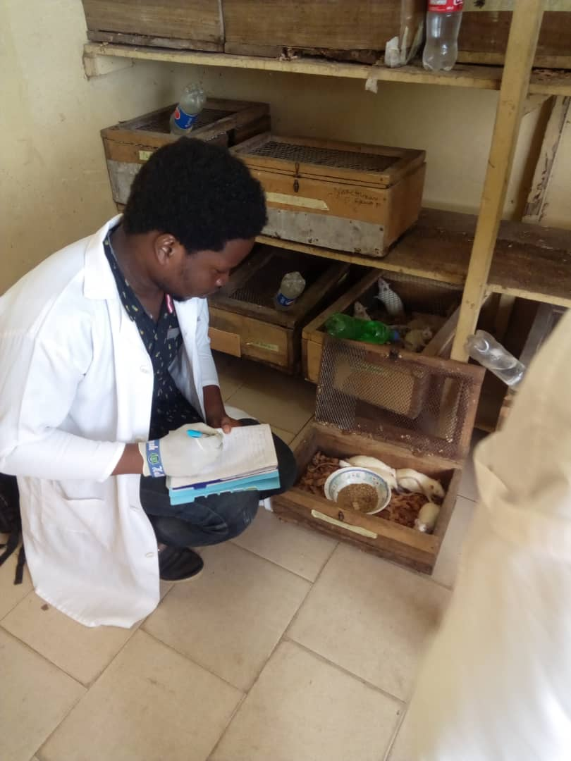

- Reference:
- Tester, M. and R. Davenport, 2003. Na+ tolerance and Na+ transport in higher plants. Ann. Bot., 91; 503–527
- Thomson, M.J., M. de Ocampo, J. Egdane, M.A. Rahman, A.G. Sajise, D.L. Adorada, R.K. Singh, G.B. Gregorio and A.M. Ismail, 2010. Characterizing the saltol quantitative trait locus for salinity tolerance in rice. Rice, 3: 148–160
- Senguttuvel, P., M. Raveendran, C. Vijayalakshmi, K. Thiyagarajan, J.R.K. Bapu and B.C. Viraktamath, 2010. Molecular mechanism of salt tolerance for genetic diversity analysed in association with Na+/K+ ratio through SSR markers in rice (Oryza sativa L.). Int. J. Agric. Res., 5: 708–719
- Biography:
Vine Ikpe has completed his BSc at the age of 26 years from the University of Uyo, Nigeria. He is currently a student member of the International Society for Substance Use Professionals, and was made an alumni of the University of Oldenburg, Germany. He has one publication to his name and looks forwards to pursuing a masters degree programme in Psychopharamacology.
- Presenting author details


Full Name: Ikpe, Vine Matthew
Contact number: 2349024352827, 2348119889716
Twitter account: Vine Ikpe
Linked In account: Vine Ikpe
Session name/ number:
Category: Oral presentation
Passport Number: A10193538

