Comparative Proteomic Analysis of Ganoderma Species during In Vitro Interaction with Oil Palm Root
Siti Nahdatul Isnaini, National Institutes of Biotechnology Malaysia (NIBM), Malaysia

Abstract
Basal Stem Rot (BSR) in oil palm caused by Ganoderma spp. is a deadly disease affecting oil palm plantation yield and global cooking oil supply. A pathogenic species, Ganoderma boninense is claimed as the main causal agent of BSR while Ganoderma tornatum is regarded as non-pathogenic and unable to infect living palms. Insufficient information on the infection mechanism and immature early detection strategy of the pathogen are among the disease control limitations. The existing molecular studies on the oil palm-Ganoderma interaction mainly focused on the response of the plant towards the fungus infection while the information on the pathogen responses is still a scarce. Therefore, in this study, comparative proteomic analyses were conducted to investigate the changes in the dikaryotic mycelial protein expression of the pathogenic G. boninense and non-pathogenic G. tornatum during in vitro interaction with oil palm root. The phenol/ammonium acetate in methanol was shown to be the most effective protein extraction method for 2-DE proteomic studies of Ganoderma spp. mycelia. Scanning Electron Microscope (SEM) images confirmed the hyphae attachment and colonisation of both species on the oil palm root surface after 72 h of inoculation. Comparative proteomic analysis showed that the mycelial proteins from oil palm root exhibited different expression profiles when compared to the mycelia grown on Potato Dextrose Agar (PDA). Proteins differentially expressed in both species may have either direct or indirect link to virulence and pathogenicity, metabolism, growth and maintenance of both Ganoderma species. Identification of these proteins during the interaction with oil palm roots may provide fundamental information for further investigation on specific roles of the identified proteins towards Ganoderma infection mechanism and facilitate selection of potential markers for early detection of BSR in the future.

Image

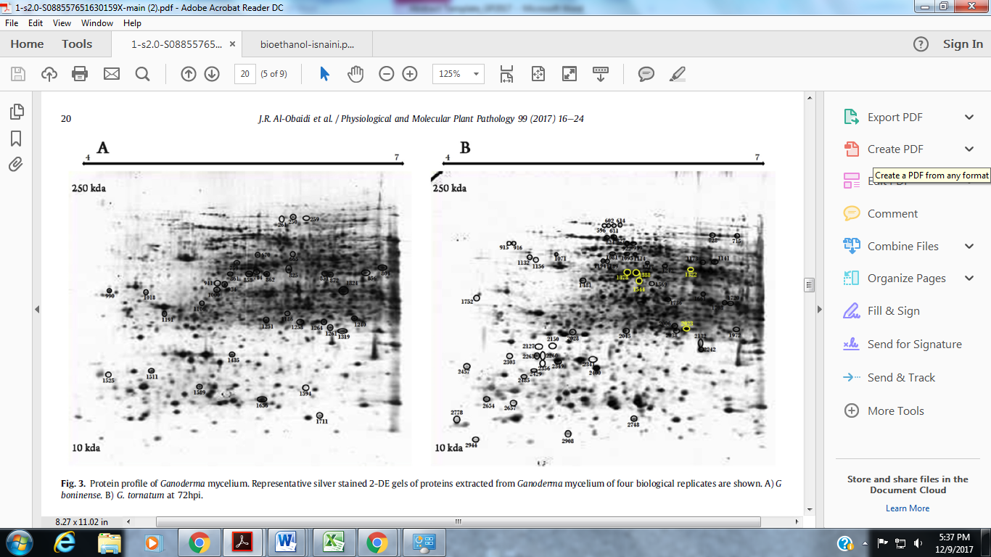

Recent Publications
- Al-Obaidi, J. R., Hussin, S. N., Saidi, N. B., Rahmad, N., and Idris, A. S. (2017). Comparative proteomic analysis of Ganoderma species during in vitro interaction with oil palm root. Physiological and Molecular Plant Pathology. 99 (2017):16-24.
- Siti Rokhiyah Ahmad Usuldin, Al-Obaidi, J.R. , Razali, N. Mat Junit, S., Ajang, M.J., Hussin, S.N., Hamid, S.S., Hanafi, N.M., Mat Roni, A.N. and Saleh, N.M. (2017). Molecular investigation of carrageenan production in Kappaphycus alvarezii in different culture conditions: a proteomic approach. Journal of Applied Phycology, 29 (4): 1989–2001.
- Al-Obaidi, J. R., Saidi, N. B., Usuldin, S. R., Hussin, S. N., Yusoff, N. M. and Idris, A. S. (2016). Comparison of different protein extraction methods for gel-based proteomic analysis of Ganoderma spp. The Protein Journal, 35(2): 100-106.
- Alam, M.Z., Kabbashi, N.A. and Hussin, S.N. (2009). Production of bioethanol by direct bioconversion of oil-palm industrial effluent in a stirred-tank bioreactor. Journal of Industrial Microbiol Biotechnology, 36(6):801-8.

 Biography
Siti Nahdatul Isnaini Said Hussin is currently a scientist in Plant Biotechnology Division of Agro-Biotechnology Institute (ABI), National Institutes of Biotechnology Malaysia (NIBM). Her working experience was on proteomics, algae tissue culture and bioprocess system. She is a member of Malaysian Agricultural Proteomics Society (MAPS) and her current research interests are on the molecular interaction between plant pathogenic fungi and host plants and fungal virulence-related proteins. Email: isnaini@abi-nibm.my

Presenting author details
Full name: Siti Nahdatul Isnaini Binti Said HUssin
Contact number: +60192783606
Linked In account:
Session name/ number:
Category: (Oral presentation/ Poster presentation)
Notes/Comments:

