Precision MetabolomicsTM for Precision Medicine:

From Population Health to Scientific Wellness
Martin P. Hornshaw, PhD, Metabolon Inc., USA




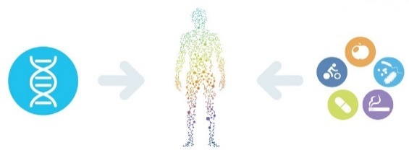
Abstract (300 word limit)
GENOMICS
Our genes suggest what diseases we might be predisposed to
LIFESTYLE / ENVIRONMENT
External factors such as diet, exercise & other lifestyle choices, medications, microbiota, etc influence our health
PHENOTYPE
A complete status of health assessed with metabolomics that can be used to prevent, diagnose & treat disease
We have heard much about genomic medicine but genotype does not equate to phenotype. A potential future of effective precision medicine requires not only estimates of lifetime risk of disease but also accurate measurement of phenotype: molecular phenotype. This will enable assessment of disease risk in the near term, disease progress, effect of intervention on disease progression and so on. Precision MetabolomicsTM enables measurement of molecular phenotype in the form of the assessment of an individual’s overall metabolism and changes to metabolism, not just specific, discrete metabolite measurements, in samples such as plasma, urine and tissue. When utilized in a ‘Systems Medicine’ approach metabolomics becomes a powerful indicator of health and disease. A pragmatic systems medicine approach would be to merge genomics data with large scale phenotypic measurements such as metabolomics, proteomics and imaging. The global metabolomics platform developed over the last15 years by Metabolon and its use in recent years in population health studies and applying knowledge of metabolism to precision medicine research will be discussed. These areas include diagnosis of inherited metabolic disease, undiagnosed illness, assessment of penetrance, drug toxicity and ‘scientific wellness’.

Image

Recent Publications (minimum 5)
- Long, T et al. (2017) Whole genome sequencing identifies common to rare variants associated with human blood metabolites. Nat Genet. 49, 568-578
- Guo, L et al. (2015) Plasma metabolomics profiles enhance precision medicine for volunteers of normal health Proc. Natl. Acad. Sci. USA 112, E4901-E4910.
- Price ND et al, (2017) A wellness study of 108 individuals using personal, dense, dynamic data clouds Nat. Biotechnol. Jul 17 doi 10.1038/nbt.3870 [epub ahead of print]

Biography (150 word limit)
Dr Hornshaw is the Director of Scientific Marketing at Metabolon. Before joining Metabolon he worked for Thermo Fisher Scientific and Applied Biosystems-MDS Sciex in roles ranging from a scientist working at the bench through to leading a large team of scientists supporting customers in the field using mass spectrometry. At Metabolon Dr Hornshaw’s goal is to educate the public in general as well as scientists specifically as to the power of mass spectrometry based metabolomics to identify underlying mechanisms in biology affecting health and disease such as how the microbiome communicates with its host, in biomarker discovery and validation, as a tool to enable both precision and personalized medicine and more. Dr Hornshaw has many years of experience as a scientist and of managing scientists working with the ‘mass spec OMICS’ of metabolomics, lipidomics and proteomics as well as clinical and diagnostic applications of mass spectrometry.
Email: mhornshaw@metabolon.com

Notes/Comments:

