Biomarker and therapeutic target discovery in DOCK8
Deficiency

Minnie Jacob, MSc, Department of Genetics, King Faisal Specialist Hospital and Research Center (KFSHRC), Riyadh, Saudi Arabia. Department of Molecular & Cell Biology, Australian Institute of Tropical Health and Medicine, James Cook University, Townsville, QLD, Australia
Andreas Lopata, PhD, Department of Molecular & Cell Biology, Australian Institute of Tropical Health and Medicine, James Cook University, Townsville, QLD, Australia
Majed Dasouki, MD, Department of Genetics, King Faisal Specialist Hospital and Research Center (KFSHRC), Riyadh, Saudi Arabia.
Anas M. Abdel Rahman, PhD Department of Genetics, King Faisal Specialist Hospital and Research Center (KFSHRC), Riyadh, Saudi Arabia. College of Medicine, Al Faisal University, Riyadh, Saudi Arabia. Department of Chemistry, Memorial University of Newfoundland, St. John's, NL, Canada

Abstract
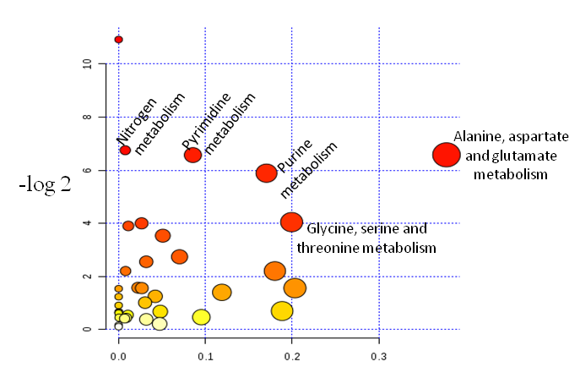
Primary Immunodeficiency (PID), a rare group of genetic disorders, is characterized by increased susceptibility to various infections, growth failure, eczema and malignancy. Hyper-IgE Syndromes (HIES) are a heterogeneous group of heritable inborn errors of immune function and include deficiencies in DOCK8, PGM3, STAT3 and severe atopic dermatitis.
Lymphoblastoid cell lines were established from patients with HIES. Comprehensive “multi-OMICs” profiling using LC-MS/MS (metabolomics, proteomics), and RNA-Seq (transcriptomics) were performed on these cell lines. Multi-OMICs data was analyzed using differential expression, Ingenuity Pathway Analysis (IPA) as well as the Genomatix Pathway system tool which creates a network functionally related genes.
Figure: Significant changes in several pathways connected to DOCK8 deficiency
Multiple canonical pathways, especially EIF2 signaling, P13/AKT signaling, epithelial adherens junction signaling & its remodeling, protein ubiquitination pathway, glycolysis as well as pathways of pyrimidine ribonucleotides were significantly perturbed with an impact on cellular growth and proliferation; amino Acid metabolism; DNA replication, recombination, and repair. Adenosine and homocysteine were most upregulated while acetyl-L-carnitine, glutathione and several pyrimidine ribonucleotides. Infectious diseases and cancer were the top diseases identified by IPA analysis with MYC, 5-FU and sirolimus as the upstream regulators. Several interacting immune-modulators including IL6,7, 17 and IFNG. DOCK8, STAT3 and ARHGEF2 isoforms were differentially expressed and appeared to be disease specific.
Combined “multi-OMICs” analysis in DOCK8 deficiency identified “apparently” unique perturbations in multiple cellular processes and pathways leading to predisposition to infection and cancer.

Recent Publications
- Alfadhel M,Al Othaim A, Alsaif S, El MutairI F, Alsayed M,Rahbeeni Z, Jacob M, Alahadib L,Al-Odaib A et.al ,2017: Expanded Newborn Screening Program in Saudi Arabia: Incidence of screened disorders.J Paediatr Child Health Epub 2017 March 4..

- Yumi Mizano,Yuichi Ninomiya,Yutaka Nakachi,Mioko Iseki, Minnie Jacob, Fowzan S Alkuraya,et.al :Tysnd1 Deficiency in mice interferes with the peroxisomal localization of PTS2 enzymes, causing lipid metabolic abnormalities and male infertility. PLOS, Genet.2013:9(2):e1003286.Epub 2013 Feb 14
Osama Y Al-Dirbashi, Mohamed Rashed, Minnie Jacob, Lujane Y Al-Ahaideb.
- Improved method to determine succinylacetone in dried blood spots for the diagnosis of tyrosinemia type 1 using UPLS-MS/MS. Biomed chromatgr.2008 Nov:22 (11):1181-5

- Al- Dirbashi OY, Santa T, Rashed MS, Al-Hassnan Z, Shimozawa N, Chedrawi A, Jacob M, Al-Mokhadab M : Rapid UPLC-MS/MS method for routine analysis of plasma pristanic, phytanic, and very long chain fatty acid markers of perozimal disorders.J Lipid Res.2008 Aug:49(8):1855-52.Epub 2008 Apr 25.

- Al- Dirbashi, Jacob M, Hassan Y Aboul-Enein, Mohamed S.Rashed. Rapid liquid chromatography-tandem mass spectrometry method for quantification of ziprasidone in human plasma.Biomedical chromatography. Biography
Ms Minnie Jacob, works at the Newborn Screening and Biochemical Genetics Lab (NSBGL).Ms Minnie is also doing her PhD at James Cook University, Australia. She is interested in metabolomics biomarker discovery in several Hyper IgE Syndromes and in the Inborn Error of Metabolism (IEM). Ms Minnie has several publications related to this field


minnie@kfshrc.edu.sa
Presenting author details
Full name: Minnie Jacob
Contact number: +966501831828
Linked In account: mjparampil
Session name/ number:
Category: Oral presentation
Notes/Comments:

