Effects of boron supplementation on peripartum dairy cows’ health: a metabolomics and transcriptomics approach

Abdullah Basoglu, Prof.Dr. Selcuk University Turkey
Nuri Baspinar, Prof.Dr. Selcuk University Turkey
Leonardo Tenori, Dr. University of Florence, CERM, Italy
Alessia Vignoli, University of Florence, CERM, Italy
Erdem Gulersoy, Selcuk University Turkey

Abstract
Although many different dietary studies on the prevention of negative energy balance related diseases are often encountered, this is the first study investigating the effects of boron supplementation on peripartum dairy cows’ health in the light of an omics approach. Twenty-eight healthy cows (1 control and 3 experimental groups) were enrolled from 2 months before predicted calving until 2 months after calving. Experimental groups were assigned to receive boron at increasing doses as an oral bolus. Production parameters, biochemical profile, Nuclear Magnetic Resonance based metabolomics profile, and mRNA abundance of gluconeogenic enzymes and lipid oxidation genes were determined. Pivotal knowledge was obtained on boron distribution in the body. Production parameters and mRNA abundance of the genes were not affected by the treatments. Postpartum nonesterified fatty acids, β-hydroxybutyrate, and triglyceride concentrations were significantly decreased in experimentals. The primary differences among groups were in lipid-soluble metabolites. There were significant differences in metabolites including postpartum valine, β-hydroxybutyrate, polyunsaturated fatty acid and citrate, propionate, isobutyrate, choline metabolites (betaine, phosphatidylcholine, and sphingomyelin), and some types of fatty acids and cholesterol in experimentals. Boron appears to be effective in minimizing negative energy balance and improving health of postpartum dairy cows..

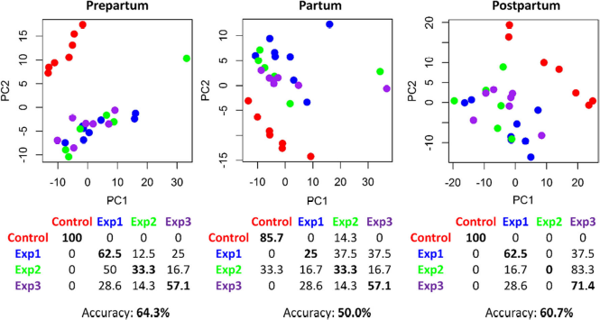

Fig. 1. PCA-CA score plots of lipid-soluble extracts, discrimination among control group (C) (red dots), experimental group 1 (Exp 1) fed with diet containing 60 ppmboron (blue dots), experimental group 2 (Exp 2) fed with diet containing 120 ppm boron (green dots), and experimental group 3 (Exp 3) fed with diet containing 180 ppm boron (purple dots) at three different times: prepartum, partum, and postpartum. The confusion matrix and the accuracy of each comparison are also reported.

Recent Publications
- Xu C, Sun LW, Xia C, Zhang HY, Zheng JS, Wang JS (2016) 1Hnuclear magnetic resonance-based plasma metabolic profiling of dairy cows with fatty liver. Asian-Australas J Anim Sci 29:219–229
- Tatone EH, Gordon JL, Hubbs J, LeBlanc SJ, DeVries TJ, Duffield TF (2016) A systematic review and meta-analysis of the diagnostic accuracy of point-of-care tests for the detection of hyperketonemia in dairy cows. Prev Vet Med 130:18–32.
- Ingvartsen KL, Moyes K (2013) Nutrition, immune function and health of dairy cattle. Animal 7(Suppl 1):112–122.
- Basoglu A, Baspinar N, Tenori L, Vignoli A, Yildiz R (2016) Plasma metabolomics in calves with acute bronchopneumonia. Metabolomics 12:1–10.
- Imhasly S, Bieli C, Naegeli H, Nyström L, Ruetten M, Gerspach C (2015) Blood plasma lipidome profile of dairy cows during the transition period. BMC Vet Res 11:252

Biography
Abdullah Basoglu has been working at Selcuk University as an academic staff. He is interested in boron metabolism, omics and metabolic diseases in animals.
Email: abbasoglu@selcuk.edu.tr

Notes/Comments:

