Discovering anti-kinases moleucles from a desktop computer
Turki Sobahy, Msc, KFSH&RC, Saudi Arabia

Abstract
Introduction: The emergence of informatics (data-driven sciences) revolutionized the fields of pharmacology and drug discovery on applied and theoretical levels (1, 2). Instead of performing high cost experiments, in silico environment enables conducting the work in high throughput and cost-effective manner, for instance. The most popular computational tool for estimating molecules affinity towards a target protein is molecular docking. However, using the mentioned tool on large datasets of freely available molecules requires sophisticated or specialized computers. This effort is to develop a robust tool that suited for common hardware that is easily available and accessible.
Purpose: The original study aim is to discover potential inhibitors for a kinase target. In our facility, regular office workloads PCs are available (4G of RAM, 3.33G for total physical memory & 4 cores). We want to pass millions of compounds through a high throughput filter. Then, molecular docking can be applied with reasonable molecules count against the target of interest. This to showcase an example of what researchers or students can accomplish with no financial concerns.
Method: Predictive models are widely applied in the field of chemoinformatics (3, 4, 5). We employed ligand-based approach, using machine learning (ML) methods, to predict compounds anti-kinases activity aiming to remove ligands that are likely to show no affinity towards the kinase family. ML methods are robust and suite normal hardware. The free autodock vina docking tool was used. The target protein was prepared using AutoDockTools, while ligands prepared and docked through in house pipeline. The pipeline, written in python, includes file format conversion (via Obable), ligands preparation by AutoDockTools and results reformatting for downstream analysis.
Conclusion: Our approach is an effort to show the valuable outcomes of informatics-based methods using regular hardware. We hope this attempt enlightens young generations on the inestimable tools at their disposal.

Image
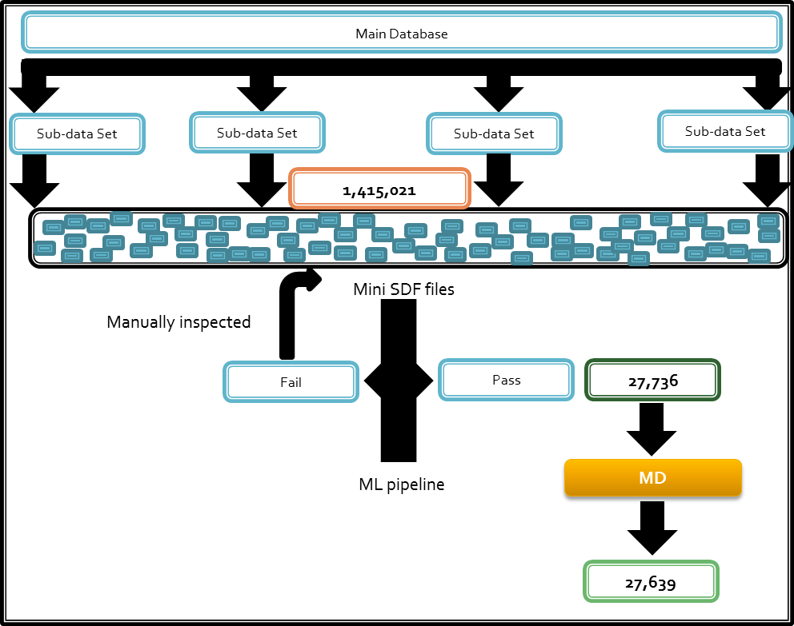
Figure: A display example of our pipeline including the breaking down a main database into smaller components twice to accommodate the limited computational infrastructure. The main dataset contains 1,415,021 compounds and the ML pipeline is able to filter out ~ 98 % of the molecules (only predicting 27,736 to have anti-kinases activity).

References
- Sliwoski, Gregory, Sandeepkumar Kothiwale, Jens Meiler, and Edward W. Lowe. "Computational Methods in Drug Discovery." Pharmacological Reviews. The American Society for Pharmacology and Experimental Therapeutics, Jan. 2014.
- Leelananda, Sumudu P., and Steffen Lindert. "Computational Methods in Drug Discovery." Beilstein Journal of Organic Chemistry. Beilstein-Institut, 2016.
- Xia, X., E. G. Maliski, P. Gallant, and D. Rogers. "Classification of Kinase Inhibitors Using a Bayesian Model." Journal of Medicinal Chemistry. U.S. National Library of Medicine, 26 Aug. 2004.
- Briem, H., and J. Günther. "Classifying "kinase Inhibitor-likeness" by Using Machine-learning Methods." Chembiochem : A European Journal of Chemical Biology. U.S. National Library of Medicine, Mar. 2005.
- Mitchell, John B O. "Machine Learning Methods in Chemoinformatics." Wiley Interdisciplinary Reviews. Computational Molecular Science. Wiley Periodicals, Inc., Sept. 2014.

 Biography
Turki Sobahy is a research associate at King Faisal Specialist Hospital & Research Center (KFSHRC). He had his bachelors’ degree in laboratory medicine and masters’ degree in bioinformatics. His research interests include developing pipelines for NGS data analysis, SNPs annotations and chemoinformatics predictive models.
Email: tsobahy@kfshrc.edu.sa

