Could chameleon brain structure studies help the treatment of neurofibromatosis?
Cemil Koyunoğlu, Energy Systems Engineering Department, Central Campus, Cinarcik Road 5th km, Yalova University, Yalova, 77200, Turkey
cemil.koyunoglu@yalova.edu.tr

Abstract

If our eyes had the eye system of a chameleon, perhaps sunglasses technology would have a hard time keeping up with us. This article actually aimed to show how important it is to provide a standard of living that will not change the normal life of every living creature in nature, and how much it offers solutions to the great problems of human beings. In this editorial article, I tried to explain which genetic dependent skin disease (neurofibromatosis) causes the natural nervous systems of chameleons, which change the mechanism on the skin.

Image
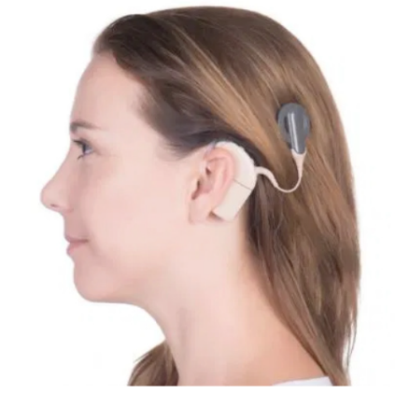
Recent Publications (minimum 5)
[1] Koyunoğlu C. Use Chou’s 5-Steps Rule to Reveal Why SARS + MERS = COVID-19? Journal of Biochemistry and Analytical studies 2020;4(2).
[2] Koyunoğlu C. The Vital Importance of the Extracorporeal Membrane Oxygenation (ECMO) Device on COVID-19 Patients. International Journal of Clinical & Medical Informatics 2020;3(1).
[3] Koyunoğlu C. How to Act with the Fact that the COVID-19 Virus is Derived from Bats? ACTA Scientific Biotechnology (ASBT) 2020;1(7):1-2.
[4] Koyunoğlu C. Bats: One of the Key Animals for Humanity; A Case Study for COVID 19. Biomedical Research and Clinical Reviews 2020;1(1).
[5] Koyunoğlu C. Collecting Bio Information against COVID-19 with Pse-in-One Software. Journal of Environmental and Soil Sciences 2020;5(3).
[6] Koyunoğlu C. To Understand Well on the Source of COVID-19: Rhinolophus affinis-1. International Journal of Biochemistry & Physiology 2020;5(2).
[7] Koyunoğlu C. To understand well on the source of COVID-19: Rhinolophus affinis-2. Clinical Medical Reviews and Reports 2020;3(2).
[8] Koyunoğlu C. Which is more accurate SARS-CoV + MERS-CoV = SARS-CoV2 or SARS-CoV + MERS-CoV = MERS-CoV2? Clinical Medical Reviews and Reports 2020;3(1).

Biography (150 word limit)
Cemil Koyunoğlu born in Malatya 1980. And his moved from Malatya to Antalya when he finished his 1st preliminary school. He finished his followed classes in Anltalya and he graduated Chemical Engineering in Malatya, Inonu University. He was one of the main person who established Inonu-Pal accredited fuel-oil laboratory with his willingness after his bachelor’s degree graduation. Then, he graduated from his Master of science degree position at the same department during his proficiency testing connection between SGS Netherland and Inonu-Pal. After the fuel-oil laboratory first accepting as an accredited laboratory. He accepted as a research assistant in Yalova University Energy Systems Engineering Department. Email: cemil.koyunoglu@yalova.edu.tr

