WE CAN MAKE A DIFFERENCE
PHYSICIAN; A HUMANITARIAN LINK BETWEEN PEOPLE AND NATIONS

Everyday somewhere or other in the world someone; most likely a woman is being victimized by a brutal acid attack, often by someone known to the victim. India is among a handful of countries that witness the maximum number of horrific acid attacks on women. The male perpetrators disfigure women as a form of revenge. They get hold of the corrosive chemical without difficulty, and have little fear of the law. With limited access to reconstructive surgery and rehabilitation, survivors are physically and emotionally scarred for life.

THE VICTIM DIES “A HUNDRED DEATHS”

Acid attacks completely spoils and mutilates the face of the victim and sometimes even the eyesight is lost. If the victim is the only earning member in the family, it becomes difficult for the victim and other members of the family to survive.

As a lead Reconstructive Plastic Surgeon and as an expression of social responsibility to the community to extend the benefit of scientific advancement in the field of Reconstructive Plastic Surgery, it is proposed to offer the benefits of the Reconstructive Plastic Surgery to the needy at certain designated medical institutions.

Often these victims need multiple stages of painstaking reconstructive surgeries over and above a prolonged professional, personal and social rehabilitation program and need continuous financial support. Insufficient infrastructural support at most of the remote and non metropolitan cities, does not allow the victims of acid attack to get the quality expertise, which otherwise would reduce not only the complexities of deformities and help save some of the vital structure like vision, etc. as well as improve the quality of life. It is an attempt to stress upon the importance of suitable primary treatment as well providing voluntary definitive reconstructive procedure. The laxity of certain sections of the law, allow the offenders to walk away with minimal punishment.

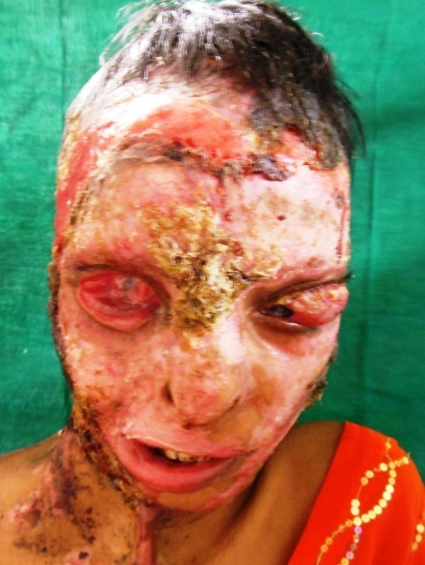
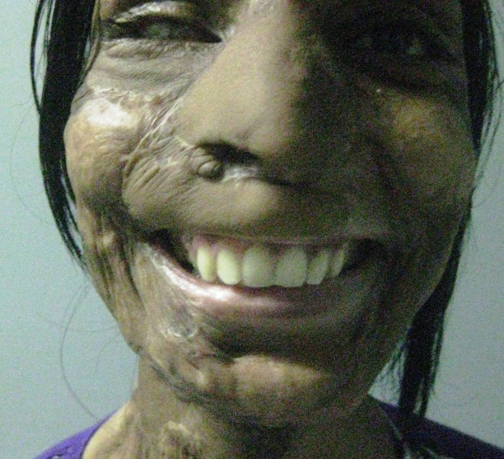
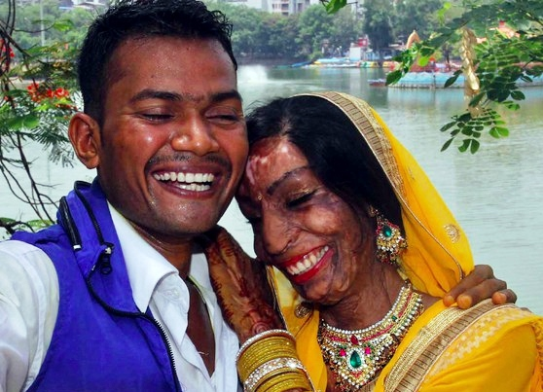

“A MINUTE MAY BE A VERY SHORT TIME”;
“TAKES JUST A MINUTE TO DAMAGE LIFE / FACE”.

“VITRIOLAGE IS A FORM OF VIOLENTASSAULT”

Spirituality / Social Services had a deep-rooted connection in India.
The link between the ‘KARMA’ as espoused by sacred Indian texts and initiatives anchoring corporates as responsible citizens has been amply evident in India since early days. Karma is an universal law of cause and effect. The importance accorded to respect for elders, relationships and family values are the pillars upholding the symbiotic relationship between the community and businesses in India, breaking across the barriers of culture, religion and language. The Indian ritual of touching the feet of elders is a good example of how respect manifests itself in everyday life.

“Any country’s progress depends on its growing economy, but at the same time the citizens / caregivers should have an ethical value system, that’s where philanthropy and altruism comes into play". The essence of altruism is self-sacrifice; an individual committing a selfless act with no benefit to themselves. Every individual with the little or some resources and know-how has an obligation to help his / her fellow countrymen. Reaching out and transforming lives of others who deserve it most.

As a lead Reconstructive Plastic Surgeon and as an expression of social responsibility to the community to extend the benefit of scientific advancement in the field of Reconstructive Plastic Surgery, it is proposed to offer the benefits of the Reconstructive Plastic Surgery to the needy at certain designated medical institutions. Highly experienced surgeon in the fields of Reconstructive Surgery across the country would be happy to extend these benefits to the Acid Burn Victims.

Often these victims need multiple stages of painstaking reconstructive surgeries over and above a prolonged professional, personal and social rehabilitation program and need continuous financial support. Insufficient infrastructural support at most of the remote and non-metropolitan cities, does not allow the victims of acid attack to get the quality expertise, which otherwise would reduce not only the complexities of deformities and help save some of the vital structure like vision, etc. as well as improve the quality of life. It is an attempt to stress upon the importance of suitable primary treatment as well providing voluntary definitive reconstructive procedure. The laxity of certain sections of the law, allow the offenders to walk away with minimal punishment.

HOW DISGUSTING!!

WITH JUST A FEW PENNY, ANYONE CAN BUY A WEAPON
THAT CAN RUIN PERSON'S LIFE IN A FEW SECONDS

