Successful penile replantation following self mutilation

Ismaliza I, Normala B, Mohammad Ali
Plastic and Reconstructive Department Hospital Kuala Lumpur Malaysia
Unit Science Reconstructive, Universiti Sains Malaysia, Kubang Kerian, Kelantan

Abstract
41 years old Chinese Man, with history of drug abuse presented to our center after traumatic penile self amputation. We performed microvascular replantation of amputated penis with approximation of the dorsal artery and dorsal vein, however the dorsal sensory nerves was unable to locate. After microvascular replantation, adequate Doppler arterial flow and color were noted in the distal end of the anastomosis. Total ischaemic time was 15 hours. Penis viable. The penis developed significant oedema and swelling at the distal penile shaft. Postoperative day seven we went in again for penile skin refashioning and delayed skin closure . He was referred to Psychiatry team and he was started on antipsychotic drug. At 4 weeks postoperatively, the patient was evaluated in plastic clinic with good Doppler flow and excellent skin preservation and adequate wound healing.

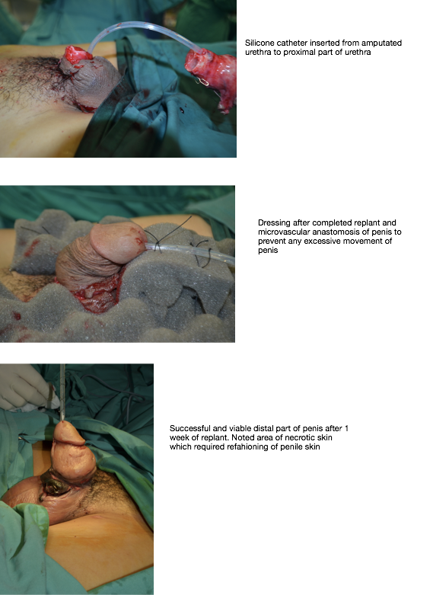
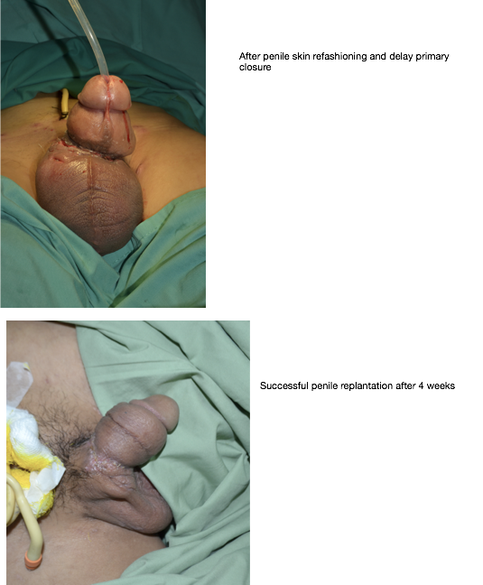

References
- Reconstruction of male genital defects Stan Monstrey, Peter Ceulemans, Nathalie Roche, Philippe Houtmeyers, Nicolas Lumen, and Piet Hoebeke
- Genital Trauma by E. Plas, I. Berger (urology textbook)
- Reconstruction of an Amputated Glans Penis With a Buccal Mucosal Graft: Case Report of a Novel Technique
- Peyronie’s Disease surgical therapy Gerald H.Jordan
- Penile Implants Steven K. Wilson,MD and John Mulcachy
- Reconstruction of Scrotal Defects by Anterolateral Thigh flap, original paper from Urology Department of Shanghai University, July 2014
- Scrotal reconstruction: a review and an proposed algorithm, Europena Journal Plastic Surgery from Department of Plastic & Reconstructive Surgery, Royal Perth Australia
- Trauma To External Genitalia from Urological emergencies by George W. Jabren & Wayne J.G Hellstrom
- Gender Reassignment by Milton T. Edgerton Jr & Margaretha Willemina Langman in Plastic Reconstructive and Maxillofacial Surgery Georgide 3rd edition
- Chapter 97 Recontruction of genitalia by Leslie T. McQuiston & Anthony A. Caldmen form Plastic Surgery Secret Plus 2nd edition Key Notes
- Jezior JR, Brady JD, Schlossberg SM. Management of penile amputation injuries. World J Surg 2001;25:1602–9.

Presenting author details

Name: Dr Ismaliza Bt Ismail
Contact Number: 0123962608
Category: Poster Presntatiion

