Computer-Assisted Planning and 3D Printing-Assisted Modeling for Chin Augmentation

Po-Chuan Chang, MD, Taiwan

Abstract (300 word limit)
We report the use of three-dimensional (3D) imaging and printing to design custom fit porous polyethylene chin implants. Patients requesting chin augmentation received 3D computed tomography (CT) imaging of the facial area. Patients were able to select the chin contour they desired by viewing 3D images of their face and chin. A 3D mandible replicate was printed from the CT data, and used to sculpt the inner surface of the implant to match the shape of the mandible, and the outer surface to match the contour the patient desired. Implants were placed with a 2 cm mucosal incision. The primary outcome was patient satisfaction with the cosmetic result at 6 months postoperatively. From April 2014 to March 2015, 107 females and 22 males (average age, 29.7 years) received chin augmentation using 3D imaging and printing to create a custom fit porous polyethylene implant. No major complications (e.g., infection, nerve injury) occurred. At 1 month, 5 of the 124 patients who returned for follow-up were not satisfied; however, became satisfied after a minor adjustment procedure. All of the 78 patients that returned for the 6 month follow-up were satisfied with the cosmetic result. No implant displacement, skin numbness, or infection was noted during the 6 months of follow-up. In conclusions: 3D imaging and printing can be used to produce custom fit porous polyethylene chin implants that results in minimal complications and a very high satisfaction rate.

Image
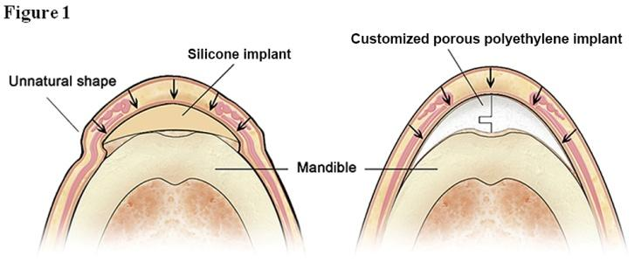
Recent Publications (minimum 5)
- Po-Chuan C (2017) Computer-Assisted Planning and 3D Printing-Assisted Modeling for Chin Augmentation. Aesthetic Surgery J, 38:1-10.

Biography (150 word limit)
Chang, Po-Chuan has devoted himself to the chin surgery for many years, and he is good at hand carving. The clinical experience shows that the shape of most original implants cannot achieve the natural appearance. So he choose porous polyethylene as material, with a variety of 3D technology to achieve customized outcome. Clinical results over the years more confirmed his ideas and practices.
Email: changpochuan@gmail.com

Notes/Comments:

