Superdry liposuction 4D in the treatment of lipohypertrophy and lipoedema

Karacalar A, Turkey

Statement of the Problem: Lipohypertophy and lipoedema are a fat distribution disorder causing massive, bilaterally symmetrical enlargement of the lower extremities particularly in women.It is known that the leg has only one layer of subcutaneous tissue, leaving little margin for error. This peculiarity calls for a different approach than that of the other regions. Liposuction under a tourniquet allows the surgery to be performed conscientiously and safely. The author published this approach as the superdry technique for the kneecap area previously, which evolved into the superdry liposuction 4D by the influence of accumulating experience. This approach goes one step further in the process of leg sculpting. Methodology & Theoretical Orientation:Over 100 patients between 19 and 54 years of age with lipohypertophy or lipoedema were consecutively treated by a single surgeon. In six patients, selective neurectomy of the gastrocnemius and/or gastrocnemius muscle shaving were used in conjunction with the superdry liposuction 4D. Findings:There was significant improvement in the form, proportion and diameters of the extremities as well as a dramatic improvement of symptoms including pain, swelling.Patients showed significant reductions in spontaneous pain, sensitivity to pressure, feeling of tension, bruising, cosmetic impairment, and general impairment to quality of life. Mean volume of aspirate was 3000 mL (range 750-6000 mL). None of the serious complications associated with liposuction were observed in this series. Minor complications including localized residual fat deposits in 4 patients that required revision under local anaesthesia and hyper pigmented scar in 4 patients were observed. Conclusion & Significance: The superdry 4d liposuction is capable of becoming a gold standard in the treatment of lower extremity lipohypertrophy and lipoedema. However, it is a complicated procedure requiring an artistic eye and a good judgment of leg curvatures that is appropriate only for highly experienced surgeons.

Recent Publications
The Amazons and an analysis of breast mutilation from a plastic surgeon's perspective.
Karacalar A.
Plast Reconstr Surg. 2007 Mar;119(3):810-8.

Botulinum toxin for the treatment of temporomandibular joint disk disfigurement: clinical experience.
Karacalar A, Yilmaz N, Bilgici A, Baş B, Akan H.
J Craniofac Surg. 2005 May;16(3):476-81.

A perichondrial flap for functional purposes in rhinoplasty.
Karacalar A, Korkmaz A, Içten N.
Aesthetic Plast Surg. 2005 Jul-Aug;29(4):256-60.
PMID: 10987500

Compensatory brow asymmetry: anatomic study and clinical experience.
Karacalar A, Korkmaz A, Kale A, Kopuz C.
Aesthetic Plast Surg. 2005 Mar-Apr;29(2):119-23. Epub 2005 Apr 21.

Spontaneous recanalization of the divided lactiferous duct in the rat.
Karacalar A, Orak I, Aydýn O, Yaln T.
Ann Plast Surg. 2005 Feb;54(2):196-200.

A pedicle-lengthening technique for free latissimus dorsi muscle flaps: the "Y-V-I" principle.
Karacalar A, Demir A, Güneren E.
J Reconstr Microsurg. 2005 Apr;21(3):173-8.

Subcision surgery for the correction of ear deformities.
Karacalar A, Demir A, Yildiz L.
Aesthetic Plast Surg. 2004 Jul-Aug;28(4):239-44.

No-touch technique for autologous fat harvesting.
Karacalar A, Orak I, Kaplan S, Yildirim S.
Aesthetic Plast Surg. 2004 May-Jun;28(3):158-64.

Liposuction of the kneecap area under tourniquet: a superdry procedure.
Karacalar A, Ozcan M.
Aesthetic Plast Surg. 1998 Nov-Dec;22(6):408-11

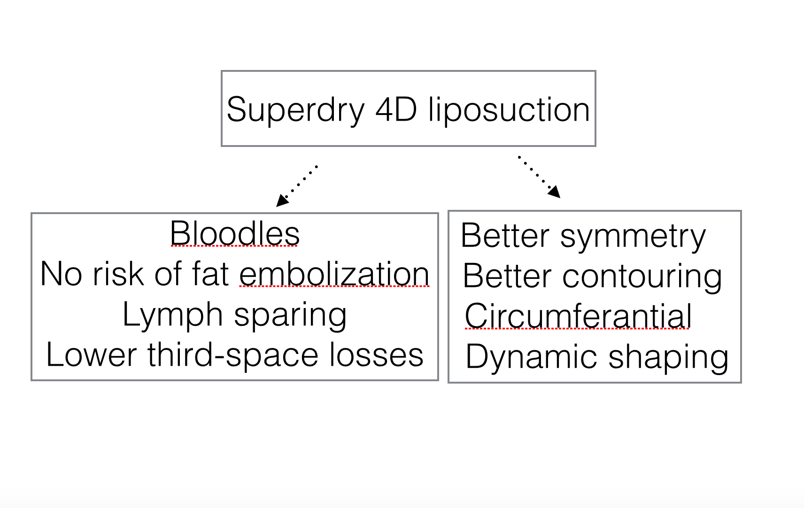

Biography
Dr. Karacalar has over 20 years of experience as a plastic & aesthetic surgeon specializing in body and lower extremity contouring surgery. He has extensive experience with lipoedema treatment. He uses various art fields to develop his aesthetic sense and judgment , including painting, sculpture and photography.

e-mail:drkaracalar@gmail.com

