Local Anesthetics for Neuroprotection Prior to Nerve Transection
Nicole L Miller BS, Florida International University Herbert Wertheim College of Medicine, USA
Harvey W. Chim MD, University of Florida School of Medicine, USA
Christopher J. Salgado MD, University of Miami School of Medicine, USA

Abstract
Following coaptation of peripheral nerves in reconstruction, multiple limitations exist in the regeneration process. Lidocaine may serve as a neuroprotectant prior to nerve transection through inhibition of calcium influx and thus preservation of donor axons. The usefulness of this local anesthetic as a neuroprotective agent was investigated in a rat sciatic nerve model. The sciatic nerves of 41 Sprague-Dawley rats were injected with normal saline (n = 9), 1% Lidocaine (n = 11), 1% Lidocaine w/ 10% calcium gluconate (CG) (n = 11), and 10% calcium gluconate (n = 10). Following injections, the sciatic nerves were transected, labeled with Fluorogold nerve tracer and microsurgically anastomosed. Animals underwent behavioral testing preoperatively and postoperatively at 8 or 12 weeks. Walking track analysis and gridwalk testing demonstrated enhanced recovery of locomotion in rats that were administered Lidocaine prior to nerve transection compared to other groups. At 8 weeks, Lidocaine and Lidocaine w/ CG-treated rats had significantly improved Sciatic Functional Index (SFI) scores compared to saline-treated rats (p < 0.05). At 12 weeks, Lidocaine and Lidocaine w/ CG-treated rats had significantly improved SFI scores compared to saline and CG-treated rats (p < 0.05). Gridwalk analysis of foot slip errors indicated Lidocaine-treated rats had significantly lower mean foot slips compared to saline-treated rats (p < 0.05), and Lidocaine w/ CG rats had significantly lower mean foot slips compared to saline, CG, and Lidocaine-treated rats (p < 0.05). At 12 weeks, Lidocaine-treated rats had the lowest level of mean foot slips, which was significantly less than that of Lidocaine w/ CG-treated rats (p < 0.05).
This study affirms that administration of Lidocaine prior to nerve transection is an effective intervention to preserve

Image
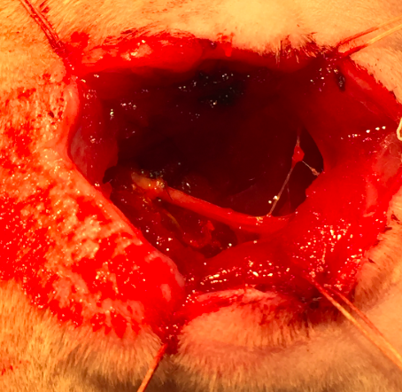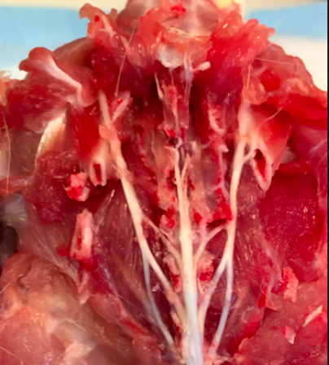
Figure 1: Exposed right sciatic nerve of Sprague-Dawley rat prior to transection. Figure 2: Exposed bilateral sciatic nerves during tissue
Harvest following transcardial perfusion.
Recent Publications (minimum 5)
- Salgado CJ, Chim H, Chen HC, et al. (2016) Immediated pedicled gracilis flap in radial forearm flap phalloplasty for transgender male patients to reduce urinary fistulas. J Plast Reconstr Aesthet Surg. 69 (11):1551-1557.
- Salgado CJ, Romanelli P, Chim H, et al. (2016) A staging system for gluteal foreign body reaction to injectables. J Plast Reconstr Aesthet Surg. 69 (8):e174-9.
- Chim H, Chieng LO, Salgado CJ, et al. (2015) Reconstruction of open wounds as a complication of spinal surgery with flaps: a systematic review. Neurosurg Focus 39 (4):E17.
- Chim H, Salgado CJ, Ng ZY, et al. (2015) Soft tissue coverage of the mangled upper extremity. Semin Plast Surg. 29(1)48-54.
5. Salgado CJ, Chim H, Wei FC, et al. (2013) Challenges in replantation of complex amputations. Semin Plast Surg. 27 (4):182-9.

donor axons for planned nerve transfers and may have
potentially beneficial clinical applications that warrant
further studies.

 Biography
Nicole L. Miller is a medical student at the Florida International University Herbert Wertheim College of Medicine. She dedicated a full year at the Lois Pope Life Center at the University of Miami School of Medicine to study a new method to improve the viability of nerve transfers. The approach is clinically applicable and cost efficient for microsurgical reconstruction with donor nerves for peripheral nerve injuries.
Email: nmill058@fiu.edu

