Experience of 6866 cases on Lip reduction surgery in Thailand
Pusit Jittilaongwong, MD
Punisa lip and plastic surgery clinic
Bangkok, Thailand

Abstract
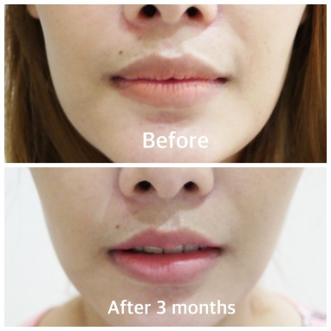
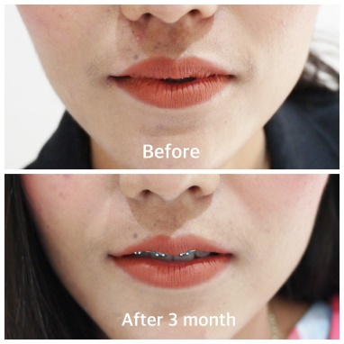
The purpose of this report is to present my personal experiences over the last 7 years in lip reduction surgery.
A method of evaluating the results of lip reduction surgery was performed on 6866 consecutive patients from 1 January 2011
to 30 September 2016 at Punisa Clinic lip surgery clinic. Patients who have undergone a lip reduction surgery by Dr. Pusit technique,
“Bird wing incision” can expect more desired shape & size of their lips and even an improved smile, abnormality. Results of my patients included 4943 cases underwent upper lip surgery, 272 cases for lower lip surgery and 1651 cases for both upper-lower lip surgery. Patients who underwent lip reduction surgery reported an overall of high satisfaction rate with their surgical outcome. In conclusion ,Lip reduction surgery tend to be more popular in Asian countries from past until now.
Lip surgery can improve patients lip shape ,size and smile.
The minor complication were reported with asymmetry, scarring (Keloid) and lip tightness.

Keywords: lip reduction , cosmetic lip reduction, lip surgery

Image

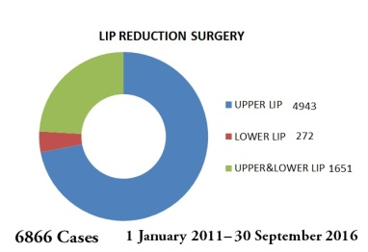
Image

Recent Publications (minimum 5)
1. Stucker FJ., Jr Reduction cheiloplasty. An adjunctive procedure in the black rhinoplasty patient. Arch Otolaryngol Head Neck Surg. 1988;114:779–80. [PubMed]
2. Field LM. Macrocheiloplasty. Principles and techniques. J Dermatol Surg Oncol. 1992;18:503–7.[PubMed]

3. Rey R, Carreau JP, Gola R, Berbis P. Melkersson-Rosenthal syndrome. Value of reduction cheiloplasty. Ann Dermatol Venereol. 1996;123:325– [PubMed]
4. Botti G, Botti C, Cella A. A simple surgical remedy for iatrogenic excessively thick lips Plast Reconstr Surg 20021101329–34.(Discussion in 2002;110:1335–6) [PubMed]
5. Fanous N, Brousseau VJ, Yoskovitch A. The bikini lip reduction: An approach to oversize lips Plast Reconstr SurgAccepted for publication August 2006. [PubMed]

Biography
Dr.Pusit, the founder of Punisa lip and plastic surgery clinic. He is a Broad certified plastic surgeon graduated from Surgery Department, Siriraj Hospital Medical.
Dr Pusit’s name is one of the most sought-after plastic surgeons for lip surgery. He is also well known as the pioneer lip reduction “Krachap lip” surgery in Bangkok, Thailand.He was invited to speak in conferences 27 th Annual meeting of The Society of Aesthetic Plastic Surgeons of Thailand 2017.He also contributed to many articles published in newspapers as well as appeared in social media.Dr. Pusit has since worked in private practice actively improving the appearance of patient’s lips by reducing their size and abnormality for thousands of patients for the past 7 years

To contact Dr.Pusit please email doctorphusit@gmail.com or visit website www.punisaclinic.com

Email: doctorphusit@gmail.com

Notes/Comments:

