Rehabilitation post liposuction surgeries
By: Kerelous George
CLT, PT
Abstract:
About 40% of final and patient satisfaction of any liposuction surgery depends on rehabilitation that supposed to be done 3rd day post to the liposuction surgeries,
The rehabilitation supposed to be done by a certified lymphedema therapist and manual lymphatic drainage massage therapist under the supervision of the surgeon himself.
In this presentation we will discuss together a 6 weeks protocol for rehabilitation post liposuction surgeries from certified lymphedema therapists view and what they can offer for the patients and what they need from the surgeons.
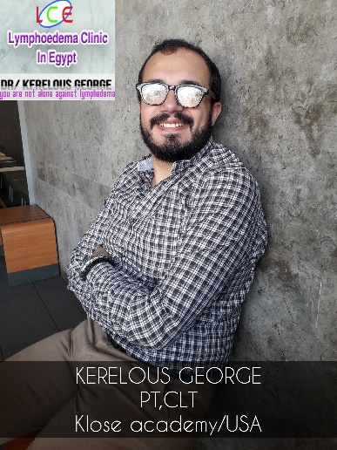
Biography:

Kerelous George a certified lymphedema therapist from klose training, USA and Physical therapist from Egypt equivalent from NY, USA and he is the Founder of Lymph Clinic in Egypt (LCE) since 2012 with a great experience in Lymphedema, rehabilitation post liposuction surgeries and lipoedema with over than 1000 patients and he is world wide lecturer in many conferences.

Author details:
Full name: kerelous George
Phone number: +201066391989
Email: kerelousgeorge@gmail.com

