Abstract Template

Title: The day after tomorrow: How to market your practice post-pandemic

Sam Peek
Keywords: Practice Management, Plastic Surgery, Agency

Introduction: COVID-19 has altered how we communicate, interact, travel, make purchases, buy homes and in just 12 months, it has affected most facets of our lives. Still, even once we reach a level of widespread vaccinations, how we adapted to meet the needs of a pandemic world will not be so easy to revert from. When we need to accomplish something, people generally choose the path of least resistance to achieve our goal, and if you believe that people are going to be waiting in line to drive to consultations again, then 2021 is going to be rough. The pandemic has shown us that distance is subjective and that we have the resources available to facilitate most business from the comfort of our homes. That presents a new and unique challenge to modern companies to either evolve and adapt to fit the patient's needs or fall behind and hope to catch up later. Marketing and advertising has to happen, and the businesses that adapt will be the ones that come out on the other side confident their message is going to be seen.

METHOD: In this presentation, The Day After Tomorrow: How to Market Your Practice Post Pandemic, we will illustrate how to optimize your plastic surgery services and digital footprint to create meaningful ROI for your business in a post-COVID world.

This presentation will explain how to leverage the following four tools:
1) Telehealth - Telemedicine is here to stay
2) Google New Initiatives - Are you a trusted source of information to Google?
3) Websites - Your most important marketing tool
4) Social Media - Leverage the power of information

RESULTS: By leveraging these four resources to their full potential, you can create an ecosystem that nourishes and educates existing patients while portraying a welcoming environment for new patients too. COVID has forced us to reevaluate how we conduct business and although not every change benefits us, we cannot escape or ignore the.
CONCLUSION: With maskless grocery trips and large-scale gatherings still on the horizon, adapting your business to cater to the needs of a distanced society will set your business up for success whether in the office or behind a screen. You will not only attract new patients, but your loyal clients will appreciate your efforts in being a practical/visible resource.
Biography: An entrepreneur at heart, and an Internet nerd by choice. Over his professional career, Sam has worked in the fields of law, technology, real estate management, market research and now Internet marketing. Boasting a diverse background that allows him to understand what makes businesses thrive, and do so quickly.
Sam launched Incredible Marketing in Orange County, California, along with several team members that were just as fed up with the status quo as he was. A polarizing figure with a knack for saying all the right things at the wrong time, Mr. Peek has a diverse background that gives him a distinct advantage to understanding what makes the medical aesthetic industry thrive and the foresight to ensure you’re always thinking in a proactive way, not reactive.
With nothing more than a decade of industry leadership and a few pairs of basketball shorts, he has become a trusted figure in the healthcare marketing space for his results-oriented and no-nonsense approach to digital communication strategies. Sam frequently speaks at industry meetings in the United States, Australia, and around the world.
Presenting author details
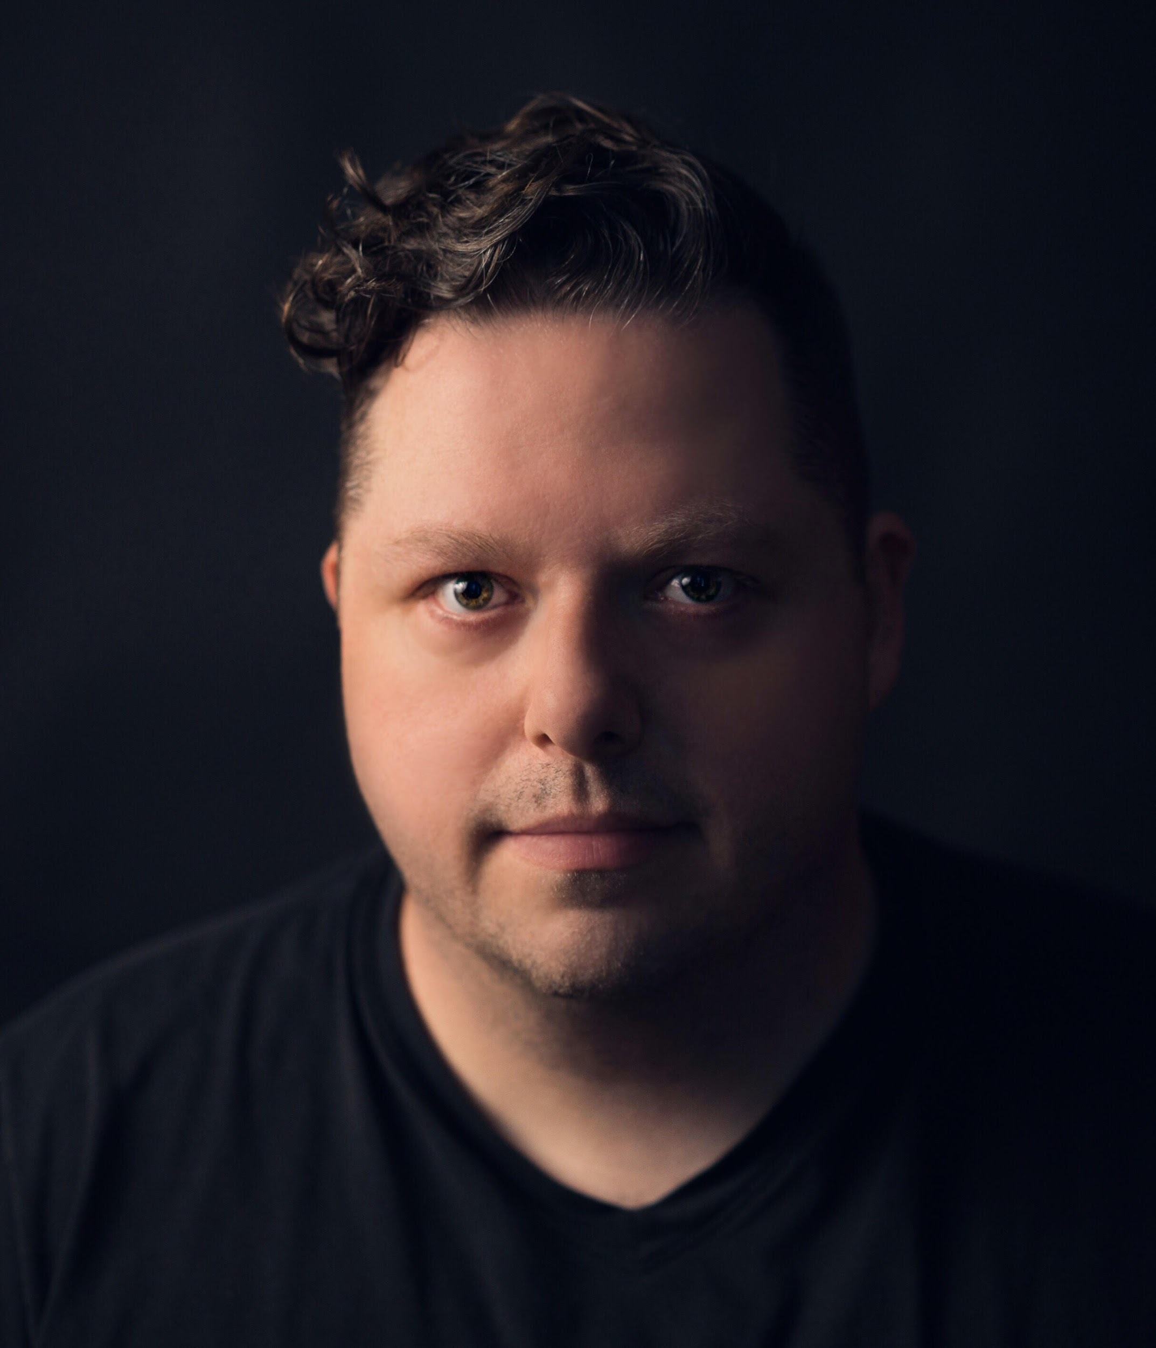
Full Name: Samuel Peek
Contact number: 714-425-7950
Twitter account: https://twitter.com/sampeek?lang=en
Linked In account: https://www.linkedin.com/in/samuelpeek/
Session name/number: Plastic Surgery, Cosmetic Surgery
Category: Speaker

