Abstract Template

Title: Evaluation of the treatment success of distal third of lower leg and foot soft tissue defects using distally based fasciocutaneous flaps

Stevanović G^{1,2}, Paravina J², Vujčić J², Adamović D^{1,2}, Milinković A^{1,2}, Momčilović S^{1,2}
¹Department of Plastic Surgery, Faculty of Medicine, University of Nis, Nis, Serbia
²Clinic for Plastic, Reconstructive and Aesthetic Surgery, Clinical Center Nis, Nis, Serbia

Keywords: Soft tissue defects, Reconstruction, Lower leg injury, Foot injury, Complications

- Abstract Body
The present study included 67 patients (62 males and 5 females) from Serbia with soft tissue defects of the distal third of the lower leg and foot who were treated surgically using the distally based fasciocutaneous flaps. The operations were performed at the Clinic for Plastic and Reconstructive Surgery and the Orthopedic and Traumatology Clinic of the Clinical Center in Nis from 2008 to 2015. The research was conducted according to the ethical guidelines of the 1975 Helsinki Declaration and approved by the Ethics Committee of the Faculty of Medicine, University of Niš, Niš, Serbia. Evaluation of the treatment success was performed by monitoring early and long-term results. Early results included assessment of flap viability, presence of infection, presence of haematoma and the presence of epidermolysis. Long-term results were assessed through functional and aesthetic performances. In 22 patients, reconstruction was performed using the medially based flaps (MBF) and in 45 patients with laterally based flaps (LBF). Major complications in the form of partial or complete flap necrosis were statistically significantly more noted in patients with MBF (6/22) than in patients with LBF (4/45) (p=0.047), while minor complications (infections, haematomas and epidermolysis) were not recorded. Although there were significantly more men included in the study (p<0.01), there was no difference between the genders in terms of flap localization (p=0.661). In studies conducted by other authors, high survival rates of fasciocutaneous flaps were also noted if used in appropriate condition. In low-resource settings, these flaps represent a valuable method for post-traumatic reconstructions.

- Image:

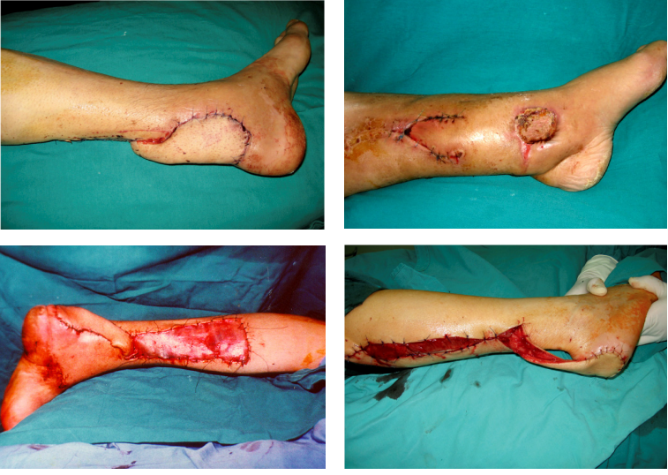

- Reference:
- Tajsic, N., R. Winkel and H. Husum, 2014. Distally based perforator flaps for reconstruction of post-traumatic defects of the lower leg and foot. A review of the anatomy and clinical outcomes. Injury., 45: 469-77
- Park, J.S, S.G. Roh, N.H. Lee and K.M. Yang, 2013. Versatility of the distally-based sural artery fasciocutaneous flap on the lower leg and foot in patients with chronic disease. Arch Plast Surg., 40: 220-225
- Parodi, P.C., F. De Biasio, E. Rampino Cordaro, G.F. Guarneri, N. Panizzo and C. Riberti, 2010. Distally-based superficial sural flap: advantages of the adipofascial over the fasciocutaneous flap. Scand J Plast Reconstr Surg Hand Surg., 44: 37-43
- Biography:
Goran Stevanovic has completed his PhD at the age of 33 years from Faculty of Medicine, Universityof Nis, Serbia. He is a member of national (SRBPRAS) and international associations of plastic and reconstructive surgeons (BAPRAS). He has published several papers in reputed journals and has been serving as an editorial board member of repute.
- Presenting author details


Full Name: Goran Stevanović
Contact number:+38163530464
Twitter account:
Linked In account:
Session name/ number:
Category: (Oral presentation/ Poster presentation)
Passport Number:

