
HOW TO KEEP YOUR SKIN WITHOUT SURGERY?

By M.D Elizabeth Aguilar
How many times have we thought about keeping our skin young as long as possible? However, we are afraid of surgery, so we are currently looking for alternatives to this end. Currently cosmetic products have been developed for this purpose under the highest quality standards and this is what leads us to talk about Younique.
Younique begins by looking at Mother Nature in search of the inspiration behind our cosmetics. Our internal scientific team formulates a product that honors that inspiration while offering cutting-edge cosmetics. Our goal is to provide healthy, clean and pure cosmetics.
Younique's cosmetic development processes use scientific research to ensure that our products contain high quality ingredients that enrich and nourish the skin. The result is a wonderfully effective product that is safely compatible with virtually any type of skin.
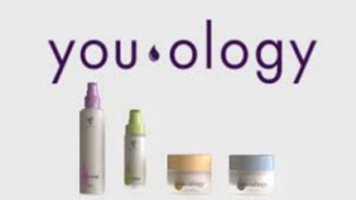
Youology is a fully customizable skin care solution that creates, with up to 40,000 possible combinations, skin care unique in its kind.
For example, each product mentioned below has 3 reinforcement options that are chosen according to the specific problem of each person, be it acne, lack of luminosity, dryness, etc.
Cleaner. Imbued with the replenishing properties of aloe leaf and other nutritious ingredients, this customizable cleansing base will surely refresh your face and prepare your skin for a new personal skin care routine. Formulated with: safflower oil, coconut fatty acids, aloe leaf juice.
Serum. Formulated to absorb quickly, this highly concentrated serum is full of nourishing ingredients for the skin such as vitamin E, niacinamide and olive oil to hydrate the skin.
Day moisturizer Personalized for the skin, this moisturizer moisturizes and nourishes this day, helping to overcome the daily stress that is applied every day. Formulated with trehalose and other natural products that help improve the skin.
Night cream The night cream base includes nourishing ingredients that hydrate your skin and complete your personalized skin care regimen. Formulate with: Niacinamide, Echium seed oil, olive oil, shea butter, trehalose.
Each of our products takes full advantage of the antioxidant benefits of essential oils, in combination with vitamins and substances that in recent years have been revolutionary in the field of aesthetic medicine, as is the case with coenzyme 10.
They can be used for safety because they are hypoallergenic without parabens and are an excellent maintenance option after surgery or as a preventive treatment for premature aging.

