Title
Supratip Refinement Suture to Adjust the Supratip Contour in Aesthetic Asian Rhinoplasty

Author
Ju Yun Jang
[sprezzatura@hamail.net]

Affiliation
QiaoJiaRen Plastic Surgery Hospital

Purpose
Supratip fullness, which leads to aesthetically unpleasing nasal tip, is a common problem in rhinoplasty. The convexity of cartilaginous framework on supratip area accounts for substantial part of the etiology. In this presentation, the author describes the technique for surgical correction of convexity of supratip area and controlling the degree of concavity of supratip.

Methods
A retrospective chart and intraoperative photo review was conducted for 91 consecutive patients (22 primary rhinoplasty and 69 secondary rhinoplasty). In all cases the author used columellar strut and shield graft or onlay graft for tip projection and derotation graft for controlling tip rotation. Supratip refinement suture was performed in 49 patients who presented undesirable supratip contour or supratip convexity.

Results
The supratip refinement suture allowed the desirable supratip contour achieved in all cases with no evidence of infection, bleeding, hematoma and deformity.

Conclusion
The author’s suture technique is a simple and reliable procedure for adjusting the degree of the supratip concavity, with the original cartilage preserved.

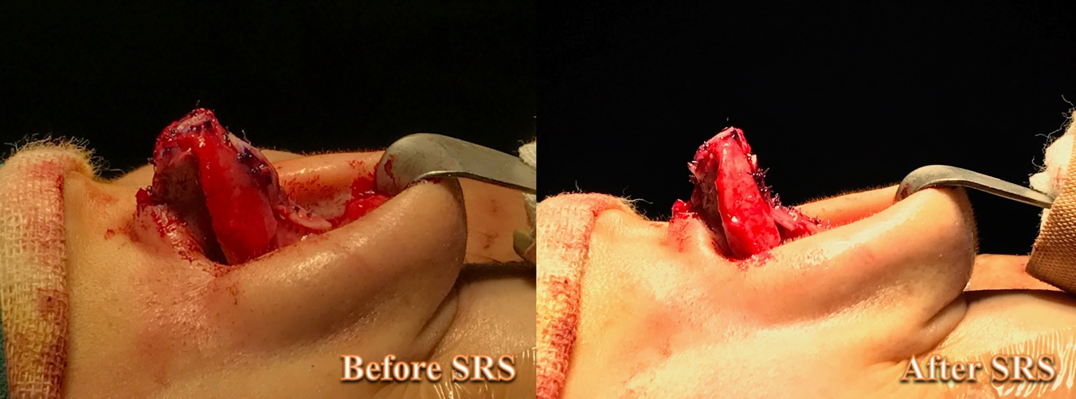
Fig. 1. Intraoperative photos show that the desirable concave supratip contour is achieved after supratip refinement suture.

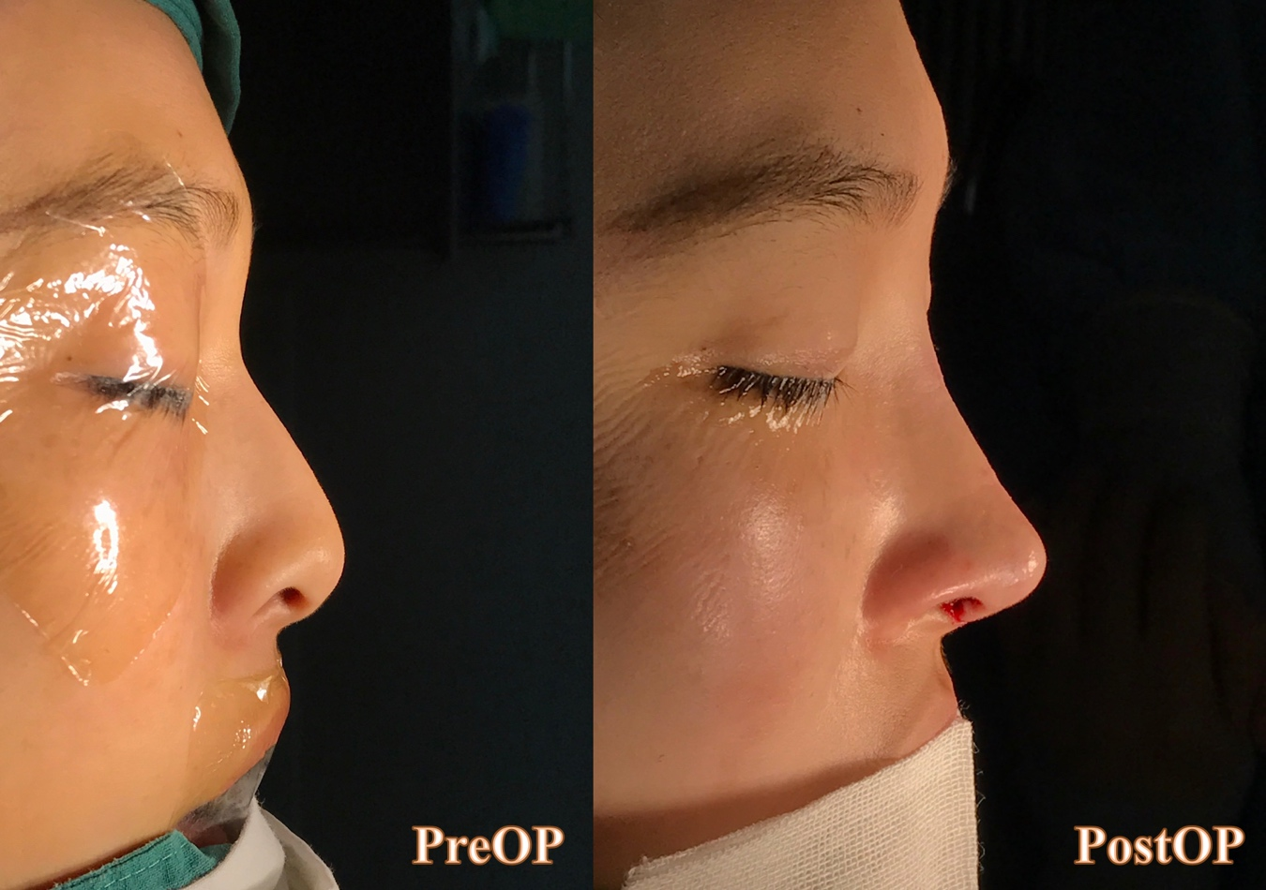
Fig. 2. Preoperative (Lt) and postoperative (Rt) photos

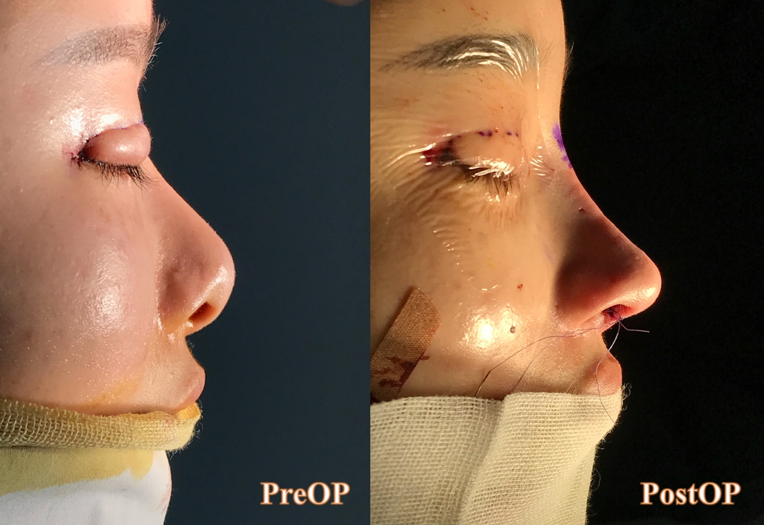
Fig. 3. Preoperative (Lt) and postoperative (Rt) photos

