Treatment of Occipital Migraine with Minimally Invasive Surgical Techinique: Our 7 Years’ Experience

Raposio E.¹, Lago G.¹, Bertozzi N.¹, Fante C.¹, Sanese G.²
- Plastic Surgery Unit, Department of Medicine and Surgery, University of Parma , Italy
- Plastic Surgery Unit, Tor Vergata University, Rome, Italy

Abstract
Introduction/Statement of the Problem: Migraine Headache (MH) is a very common disorder affecting up to 4% of the world’s adult population. Patient are usually treated with conservative treatments, both pharmacological and non-pharmacological (biofeedback, behavioural and life style changes, etc...). However some patients remain refractory to conservative options and might be successfully treated with surgical procedures. In these subjects migraine is usually caused by extracranial nerve compression due vascular, fascial or muscular structures nearby. The aim of migraine surgery is to relieve such compression at specific trigger points located in the occipital, temporal and frontal regions. In occipital headache the nerve compression is usually due to the presence of dilated or kinky occipitalis arteries running in close proximity to the greater and lesser occipitalis nerves.
Methodology & Theoretical Orientation: From 2011, in our Plastic Surgery Unit at the University of Parma, Italy, we performed 125 surgical procedures in patients suffering from occipital headache (87 bilateral, 20 right and 18 left procedures). In this group of patients nerve decompression was achieved by occipital artery ligation or cauterization. Vessels were previously localized by mean of portable Doppler device.All patients have been hospitalized and discharged the day after the procedure.
Findings: Among patient suffering from occipital migraine, 95% of them observed significant improvement of their condition at 3 months post-op, with 86% reporting complete relief. In some patients reporting partial relief, migraine symptoms were still present due to nerve compression in other trigger sites, usually located in the temporal or frontal areas.
Conclusion & Significance: Migraine is a common and debilitating condition that can be treated successfully with minimally invasive surgical procedures. Our results suggest that vascular compression is the main causative agent in occipital migraine.

Biography

Prof. Edoardo Raposio, MD, PhD, graduated at the University of Genoa, is specialized in Plastic and Reconstructive Surgery and in Hand Surgery. He has obtained a PhD at the University of Tromso, Norway, and is currently the Director of the Chair and Residency Program in Plastic Surgery at the University of Parma, Italy. During his academic career, he gained international experience as visiting professor in several Plastic Surgery Departments, both in Europe and USA. His clinical activities are mainly focused on the surgical treatment of migraine headache and primary hyperhidrosis with minimally invasive techniques.

Email: edoardo.raposio@unipr.it

Recent Publications:

- Raposio E, Caruana G. Tips for the surgical treatment of occipital nerve-triggered headaches. Eur J Plast Surg. 2017:40;3:177-182.
- Raposio E, Bertozzi N, Bordin C, Simonacci F. Surgical therapy of migraine and tension-type headache. In: Current Perspectives on Less-Known Aspects of Headache. (Turker H. ed.). InTech, London, UK. pp.: 93-114.
- Polotto S, Simonacci F, Grignaffini E, Grieco MP, Raposio E. Surgical Treatment of Frontal and Occipital Migraines: A Comparison of Results. Plast Reconstr Surg Glob Open. 2016;18;4(3):e653.
- Raposio E, Caruana G. Minimally Invasive Endoscopic Surgical Treatment of Headache. In: Atlas of Endoscopic Plastic Surgery. (Raposio E., ed.). Springer, New York, USA, 2015; pp.: 17-23.
- Raposio E, Caruana G. Frontal endoscopic myotomies for chronic headache. J Craniofac Surg. 2015;26;3:E201-203.
- Caruana G, Grignaffini E, Raposio E. Endoscopic forehead muscle resection for nerve decompression: A modified procedure. Plast Reconstr Surg Glob Open. 2015;7;3:e342.
- Caruana G, Bertozzi N, Boschi E, Pio Grieco M, Grignaffini E, Raposio E. Endoscopic forehead surgery for migraine therapy Personal technique. Ann Ital Chir. 2014;85:583-586
- Raposio E, Bertozzi N, Bordin C, Simonacci F. Surgical Therapy of Headaches: Minimally Invasive Approaches. In: “Clinical Advances in Head & Neck Surgery”. Openaccess eBooks, Las Vegas, USA. 1-23, 2018.
- Gfrerer L, Raposio E, Ortiz R, Austen WG Jr. Surgical Treatment of Migraine Headache: Back to the Future. Plast Reconstr Surg. 2018 Oct;142(4):1036-1045.
Image:
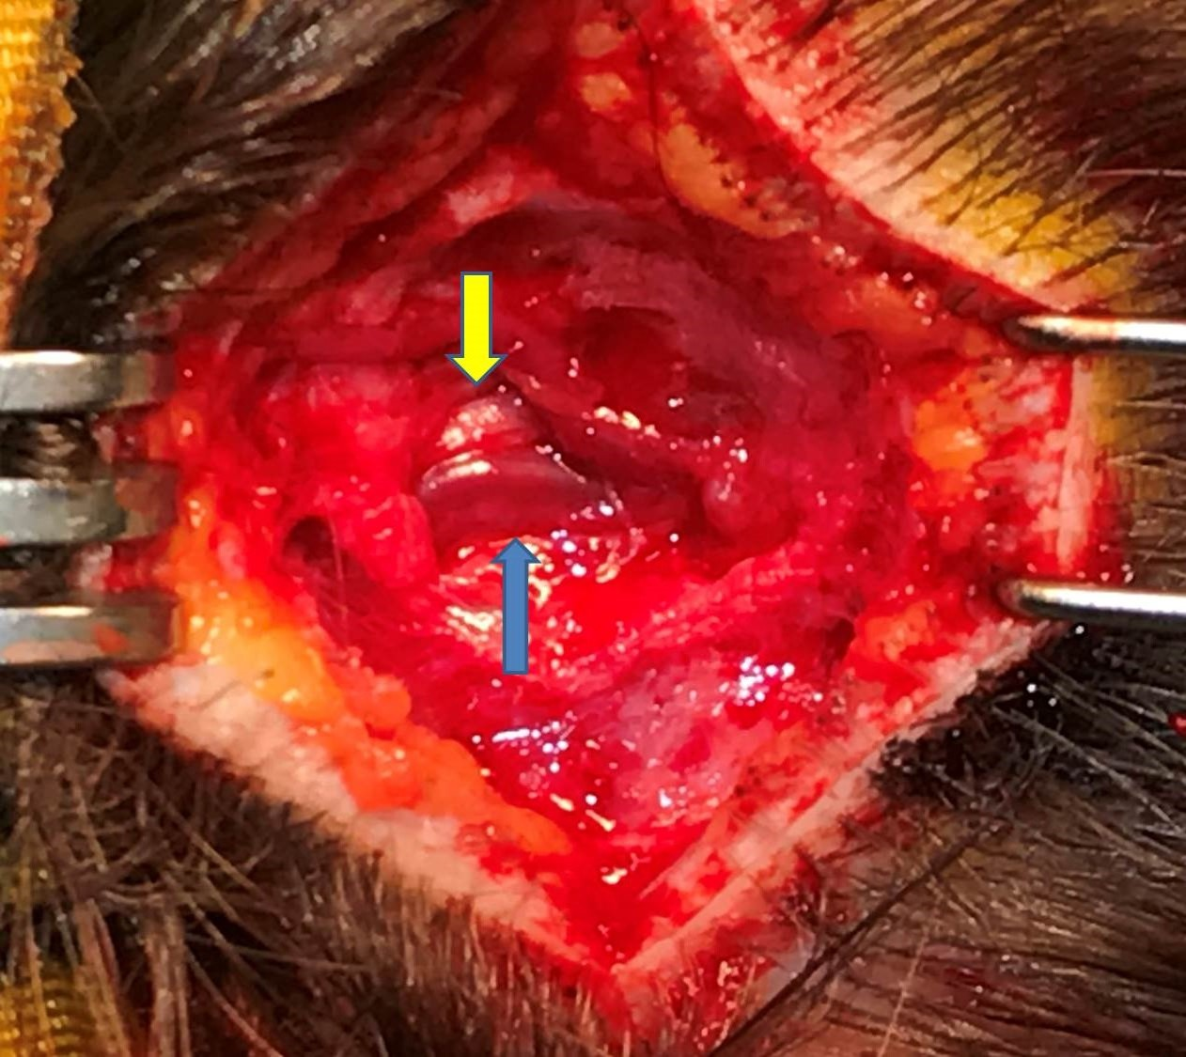

Figure legend: Dilated right occipital artery (blue arrow) running in close proximity to the right Great Occipital nerve (yellow arrow).

