Title: Reconstruction of Large Radical Vulvectomy and Perineal Defects Using Bilateral Gracilis Myocutaneous Flaps: A Case Report

Authors:
Myra Alexandra Pahilan-Firaza, M.D.
Maria Redencion Bukid-Abella, M.D., FPCS, FPAPRAS

Abstract
Objective of the Sudy: This study discusses the applicability of the bilateral gracilis myocutaneous flaps in the reconstruction of an uncommonly large defect following a radical vulvectomy with wide perineal excision. Methods / Technique: We present a case of a 68 year-old, female, who was diagnosed with Invasive Squamous Cell Carcinoma, Non-Keratinizing type. She underwent radical vulvectomy with wide excision of the perineal area, bilateral inguinal lymph node dissection, protective transverse loop colostomy. Post-excision defect was 30 x 10 cm. Our reconstruction utilized the bilateral gracilis myocutaneous flaps. Skin paddles were estimated to be 32 x 7 cm (from the proximal to mid-thigh). The medial circumflex femoral arteries were identified and secured with a vessel loop. The muscle was divided from the insertion and origin. The distal portion of the flap was secured to the anterior aspect of the defect, the proximal to the posterior. The urethra, vagina and anal canal were all circumferentially sutured to the medial aspects of the flaps. Results: Post-operatively, distal flap necrosis developed left (measuring 0.5 x 2 cm) and right (measuring 0.3 x 1 cm). Debridement and primary closure were done on day 10 post-operatively. Post-debridement recovery was unremarkable. The patient was freely voiding and ambulatory, and was eventually discharged. Conclusion: This case report establishes that it is possible to use the bilateral gracilis myocutaneous flaps for extensive vulvar and perineal defects. It is associated with acceptable anatomic, functional and aesthetic outcomes, a minor post-operative complication (minimal distal flap necrosis), no further secondary delayed complications, and does not result in difficulties of urination. This allows for an aggressive oncological resection in selected group of patients to achieve tumor-free margins.

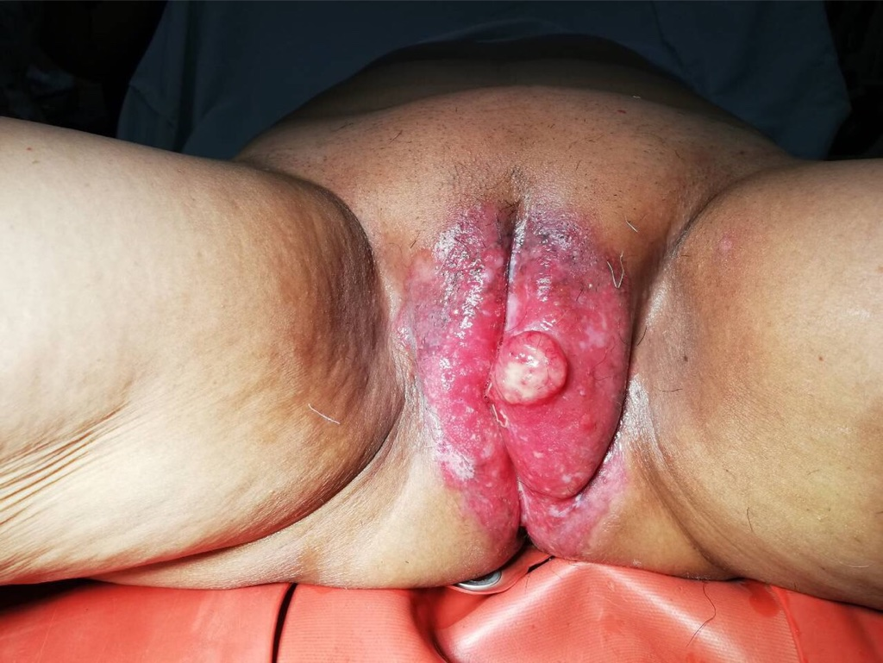

Figure 1. Lesion prior to excision.

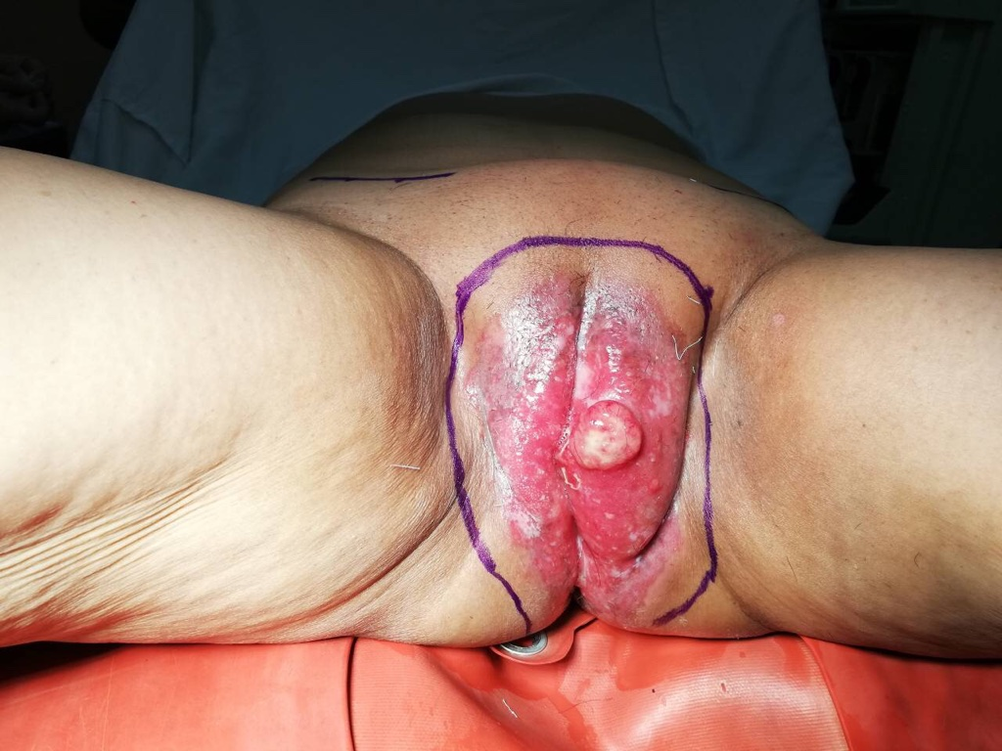

Figure 2. Markings prior to radical vulvectom and wide excision
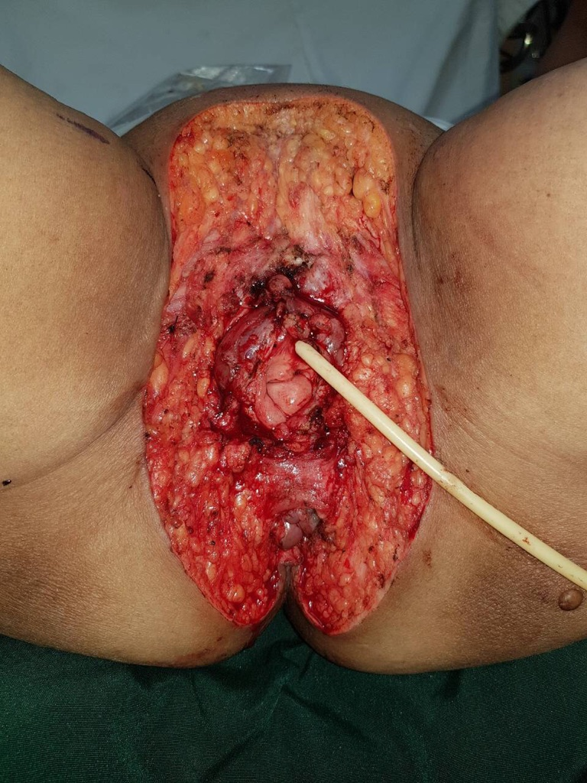

Figure 3. Post-vuvectomy and wide excision defect.

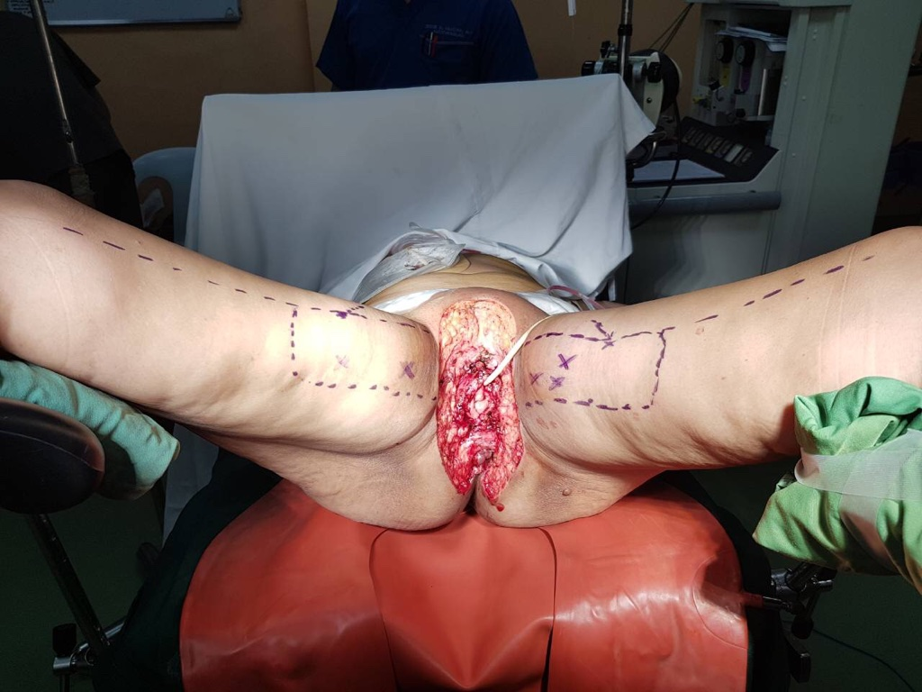

Figure 4. Defect with markings. Multiple “X” indicate perforators detected on Doppler

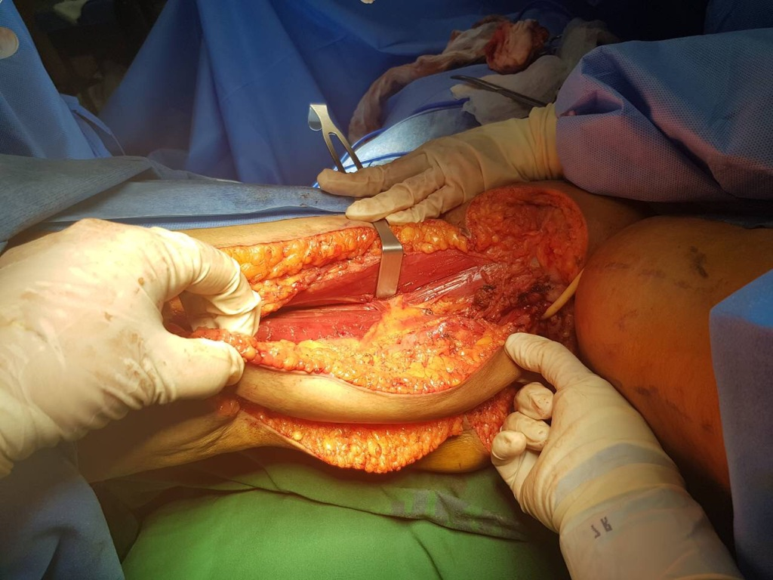

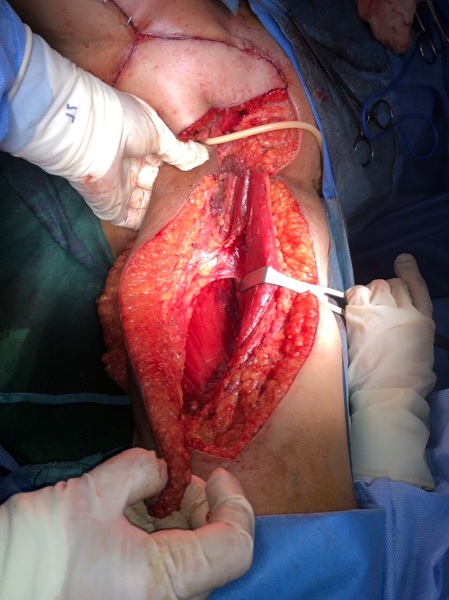
Figure 5. Right gracilis myocutaneous flap prior to inset.

Figure 6. Left gracilis myocutaneous flap before inset.

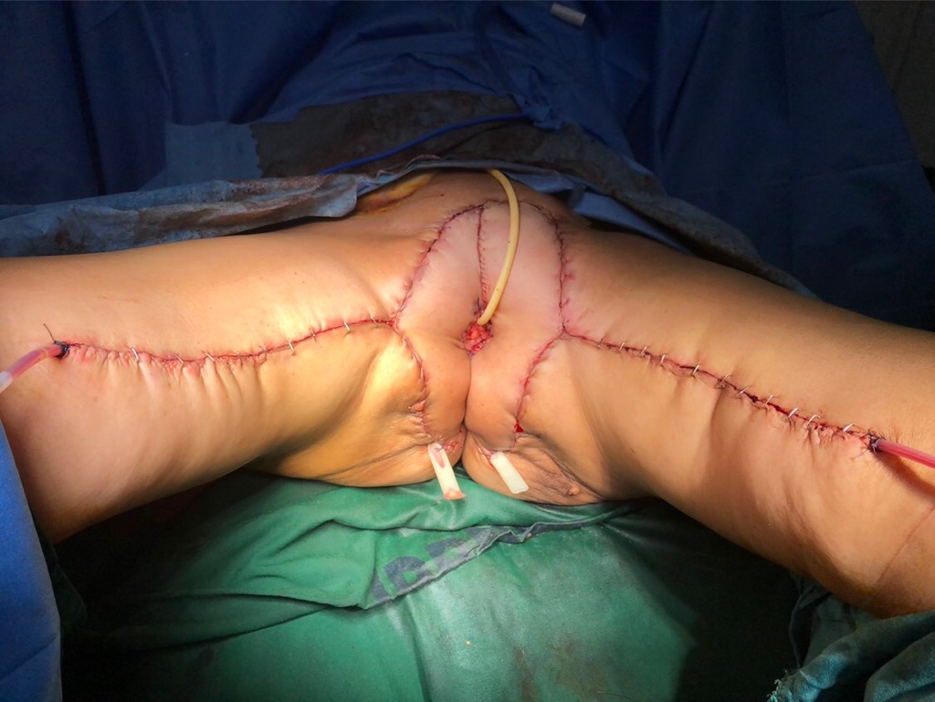

Figure 7. Inset of flaps done. Donor sites sutured. Immediately post-operative.

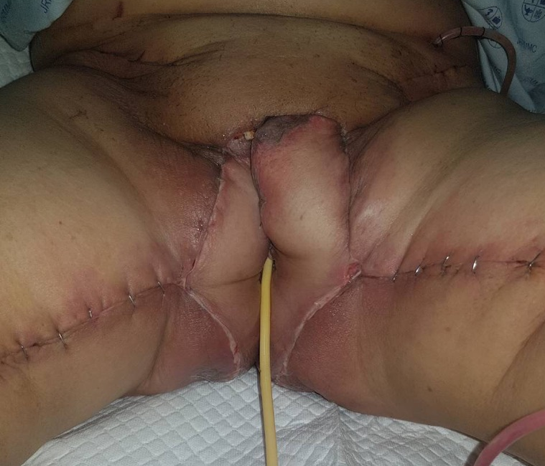

Figure 8. Day 8 post-operatively showing minimal distal flap necrosis.

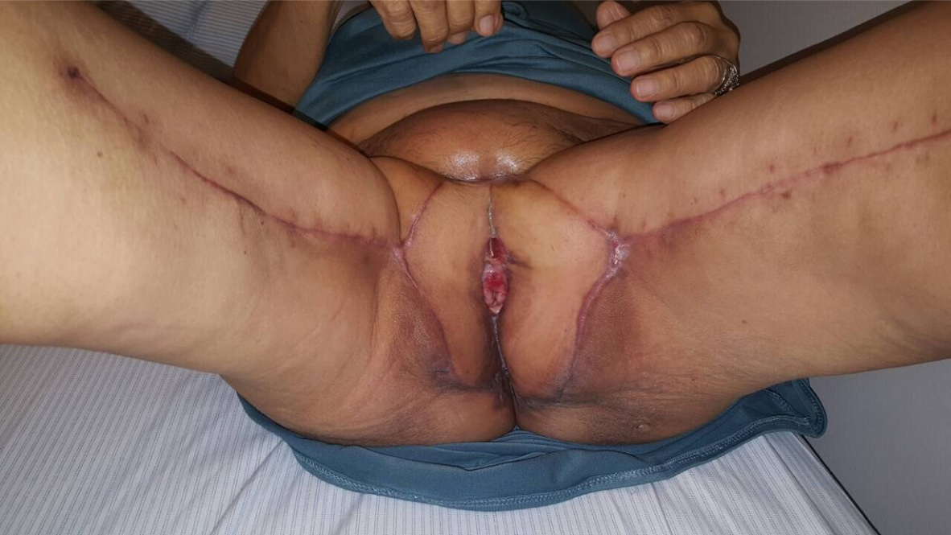

Figure 9. Post-debridement. 2 months post-operatively, with good aesthetic and functional outcomes.

Recent Publications:
- Chong TW, Balch GC, Kehoe SM, Margulis V, Saint-Cyr M. Reconstruction of Large Perineal and Pelvic Wounds Using Gracilis Muscle Flaps. Ann Surg Oncol. 2015 Oct;22(11):3738-44. doi: 10.1245/s10434-015-4435-1. Epub 2015 Feb 24.
- Kaartinen IS, Vuento MH, Hyöty MK, Kallio J, Kuokkanen HO. Reconstruction of the pelvic floor and the vagina after total pelvic exenteration using the transverse musculocutaneous gracilis flap. J Plast Reconstr Aesthet Surg. 2015 Jan;68(1):93-7. doi: 10.1016/j.bjps.2014.08.059. Epub 2014 Sep 16.
- Heath PM, Woods JE, Podratz KC, Arnold PG, Irons GB Jr. Gracilis myocutaneous vaginal reconstruction. Mayo Clin Proc. 1984 Jan;59(1):21-4.
- Devulapalli C, Jia Wei AT, DiBiagio JR, Baez ML, Baltodano PA, Seal SM, Sacks JM, Cooney CM, Rosson GD. Primary versus Flap Closure of Perineal Defects following Oncologic Resection: A Systematic Review and Meta-Analysis. Plast Reconstr Surg. 2016 May;137(5):1602-13.
- Burke TW, Morris M, Roh MS, Levenback C, Gershenson DM. Perineal reconstruction using single gracilis myocutaneous flaps. Gynecol Oncol. 1995 May;57(2):221-5.

Biography:

Myra Alexandra Pahilan-Firaza, M.D. is currently a Plastic, Reconstructive and Aestheric Surgery Fellow-in-Training. She graduated in medical school in the University of the Philippines-Manila, College of Medicine. She completed her 5 years of residency training in General Surgery in Jose R. Reyes Memorial Medical Center. She had her clinical clerkship in NewYork Presbyterian-Weill Cornell Medical College in Dermatology; and Cardiac and Thoracic Surgery programs in York Avenue, New York City. She had previous research works during her residency training in Surgery. As a Plastic Surgery fellow-in-training, she aspires to build her research experience, as well as, her knowledge and skills in the field, to further improve the practice of Plastic Surgery in her country. She believes that continuing education through updates and research, as shared by the colleagues in their respective expertise, can strengthen the global camaraderie and broaden the perspective of each Plastic Surgeon.

Email: myraalexandramd@gmail.com

Notes/Comments:

