Title: Large Gluteoperineal Defect Reconstruction Using a Vertical Rectus Abdominis Myocutaneous Flap: A Case Report

Authors:
Myra Alexandra Pahilan-Firaza, M.D.
Maria Redencion Bukid-Abella, M.D., FPCS, FPAPRAS

Abstract
Purpose of the Study: This study aims to discuss the feasibility of the vertical rectus abdominis myocutaneous flap in the reconstruction of an unusually large gluteoperineal defect following an abdominoperineal resection, wide gluteal mass excision. Methods/Technique: We present a case of a 65 year-old, male, diagnosed with rectal adenocarcinoma with right gluteal extension, who underwent an abdominoperineal resection with wide excision of the gluteal mass. The defect was 30 x 12 cm post-resection. For reconstruction, we chose an inferiorly-based vertical rectus abdominis myocutaneous (VRAM) flap. The elliptical skin paddle was from the subcostal area to the symphysis, and medial to lateral of the rectus muscle borders. The muscle was then divided from its superior portion. The flap was tunneled intraabdominally, with careful rotation to avoid kinking of the inferior epigastric artery. The inferior aspect of the skin paddle tunneled intraperitoneally was de-epithelialized. The remaining skin paddle was exteriorized and positioned to cover the gluteoperineal defect. An intraperitoneal drain was placed, and the peritoneum was closed with a composite mesh. The flap was then sutured around the defect. The donor site was closed primarily. Results/Complications: Post-operatively, the patient’s recovery was unremarkable. The flap was viable without any complications. The patient was able to ambulate on post-operative day 2, drain was removed on day 4 and was sent home. Conclusion: This case report demonstrates that the VRAM flap for a large gluteoperineal post-excision defect is possible without complications. The technique is associated with good anatomic, functional and aesthetic outcomes. This reconstruction technique permits an aggressive surgical resection in a select group of patients in order to achieve tumor-free margins.

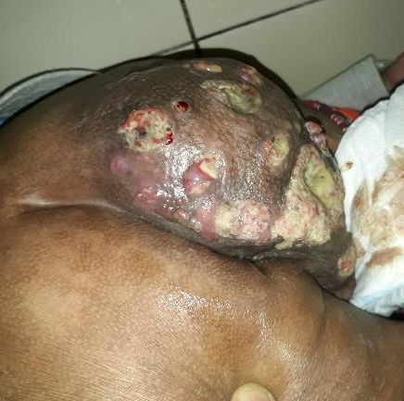

Figure 1. Right gluteal mass pre-operatively.

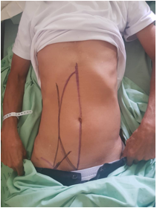

Figure 2. Markings for the VRAM donor site.

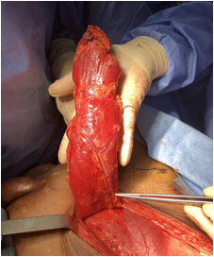
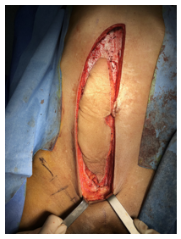

Figure 3. VRAM harvest.

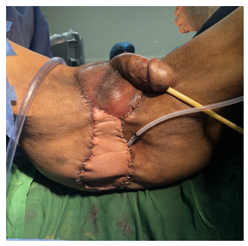

Figure 4. Post-operatively after flap inset.

Recent Publications:

- Hollenbeck ST, Toranto JD, Taylor BJ, et al. Perineal and lower extremity reconstruction. Plast Reconstr Surg. 2011;128(5):551e–63e.
- Touny, A, Othman H, Maamoon S, Ramzy S, Elmarakby H. Perineal reconstruction using pedicled vertical rectus abdominis myocutaneous flap (VRAM). J. Surg. Oncol. 2014 110:752–757.
- Ku ̈ntscher MV, Mansouri S, Noack N, Hartmann B. Versatility of vertical rectus abdominis musculocutaneous flaps. Microsurgery. 2006;26(5):363-9.
- Chris Devulapalli, Anne Tong Jia Wei, Jennifer R. DiBiagio, Marcelo L. Baez, Pablo A. Baltodano, Stella M. Seal, Justin M. Sacks, Carisa M. Cooney and Gedge D. Rosson, Primary versus Flap Closure of Perineal Defects following Oncologic Resection, Plastic and Reconstructive Surgery, 137, 5, (1602), (2016).
- Lefevre JH, Parc Y, Kerne ́is S, et al. Abdomino-perineal resection for anal cancer: impact of a vertical rectus abdominis myocutaneous flap on survival, recurrence, morbidity, and wound healing. Ann Surg. 2009; 250 (5):707-11.

Biography:

Myra Alexandra Pahilan-Firaza, M.D. is currently a Plastic, Reconstructive and Aestheric Surgery Fellow-in-Training. She graduated in medical school in the University of the Philippines-Manila, College of Medicine. She completed her 5 years of residency training in General Surgery in Jose R. Reyes Memorial Medical Center. She had her clinical clerkship in NewYork Presbyterian-Weill Cornell Medical College in Dermatology; and Cardiac and Thoracic Surgery programs in York Avenue, New York City. She had previous research works during her residency training in Surgery. As a Plastic Surgery fellow-in-training, she aspires to build her research experience, as well as, her knowledge and skills in the field, to further improve the practice of Plastic Surgery in her country. She believes that continuing education through updates and research, as shared by the colleagues in their respective expertise, can strengthen the global camaraderie and broaden the perspective of each Plastic Surgeon.

Email: myraalexandramd@gmail.com

Notes/Comments:

