A Case of Traumatic Abdominal Wall Hernia Secondary to Seatbelt Injury – Multidisciplinary Management by Delayed Surgical Mesh Repair, Complicated by Intervening Pregnancy
Dr Stanislau Makaranka, FY2 Doctor, UK
Miss Pennylouise Hever, CT2 Doctor, UK
Mr Naveen Cavale, Consultant Plastic Surgeon, UK

Abstract (300 word limit)
Background:
Traumatic abdominal wall hernia (TAWH) is a rare type of hernia occurring secondary to blunt trauma, with a reported incidence of 0.2% on presentation CT scan¹. There is currently no consensus regarding the optimum time for repair, though conservative management with serial imaging +/- expectant elective repair has been favoured.

Methods:
We present a case of a 20-year old female who was a seatbelt restrained rear-seat passenger in a road traffic collision and sustained two areas of Grade-5 TAWH along with bowel and colonic injuries. The patient was taken for an emergency laparotomy with initial conservative management of TAWH.
Figure 1 - Coronal CT slice demonstrating TAWH in the seatbelt distribution

Results:
Four years post-index admission the patient’s abdominal wall was closed using Strattice Mesh. Delay was due to the inability of the patient to reach the 100-110kg goal operative weight and a pregnancy. During her pregnancy, the patient was managed by active surveillance involving the obstetric, plastics and trauma team.

Key messages:
This case illustrates successful delayed surgical repair of TAWH using biological mesh, without recurrence, demonstrating that elective repair provides a safe alternative to early repair in pregnancy.
We reiterate the importance of a multidisciplinary approach to TAWH, involving input from the trauma, plastic surgery, and obstetric – in the case of pregnancy – teams.

Image
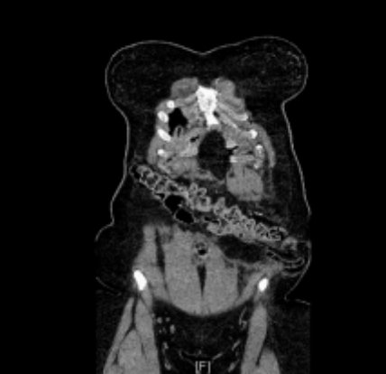

Recent Publications (minimum 5)

1. Makaranka S., Hever P., Cavale N., 2018. A Case of Traumatic Abdominal Wall Hernia Secondary to Seatbelt Injury – Multidisciplinary Management by Delayed Surgical Mesh Repair, Complicated by Intervening Pregnancy. BMJ Case Reports 2018; doi:10.1136/bcr-2018-224880.

Biography (150 word limit)

Stanislau Makaranka is a Foundation Year 2 Doctor working at University College London Hospital in London, UK. He has an interest and aspirations to go into plastic surgery and this year he published a case report on traumatic abdominal wall hernia, the course of which was complicated by pregnancy. It is a rare, albeit a very interesting and important topic, with a very specific message.
Email: stanislau.makaranka@nhs.net

