Title: The effect of polyhedral oligomeric silsesquioxanes supported α-nucleating agent on the properties of isotactic polypropylene
Xian Zhang¹, Zhong Xin*¹
¹Shanghai Key Laboratory of Multiphase Materials Chemical Engineering and Department of Production Engineering, School of Chemical Engineering, East China University of Science and Technology, Shanghai 200237, China.

KEYWORDS: nucleating efficiency; polyhedral oligomeric silsesquioxanes; isotactic polypropylene
I. Abstract Body:
In this paper, the nucleating agent supported on the surface of polyhedral oligomeric silsesquioxanes (POSS) were prepared and its effect on the properties of isotactic polypropylene (iPP) were investigated. The reduced sizes of α-nucleating agent (NA-40) was proved using scanning electron microscopy and energy dispersive X-ray spectroscopy. The nucleating efficiency of NA-40 was investigate via analyzing the mechanical properties and crystallization behavior of polypropylene. It is found that the flexural modulus of iPP increases by 11.6 % with the addition of 0.04 wt.% NA-40 alone and increases by 23.3 % when the same content of NA-40 support on octamethylsilsesquioxane (OMS). Especially, using OMS as the support will not determine the optical properties of polypropylene because of the compatibility between OMS and iPP. Moreover, due to the existence of OMS, the toughness of the system will not decrease compared to add with NA-40 alone. The results of investigation showed that the supported α-nucleating agent prepared by supporting NA-40 on OMS exhibited higher nucleation ability compared to commercial NA-40 powder.
II. Image:
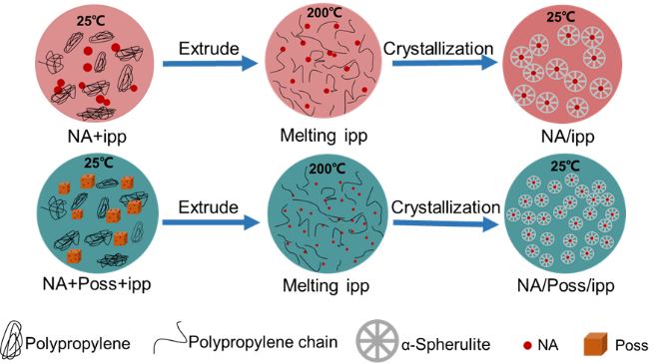
III. Reference:
- Dai. X, Zhang. Z. Wang, C. Ding. Q, Jiang. J, Mai. K, 2013. A novel montmorillonite with β-nucleating surface for enhancing β-crystallization of isotactic polypropylene, Composites Part A 49 1-8.
- Tanaka. K, Chujo. Y, 2012. Advanced functional materials based on polyhedral oligomeric silsesquioxane (POSS), J. Mater. Chem. 22 1733-1746.
- Roy. S, Scionti. V, Jana. S.C, Wesdemiotis. C, Pischera. A.M, Espe. M.P, 2011. Sorbitol–POSS Interactions on Development of Isotactic Polypropylene Composites, Macromolecules 44 8064-8079.
IV. Biography:
Xian Zhang has completed his Bachelor's degree from Qingdao University of science and technology when she was 21 years old. In 2017, she entered East University of science and technology (China) to study for a doctor's degree. Currently, she is engaged in the application of polyhedral oligomeric silsesquioxanes.
V. Presenting author details:
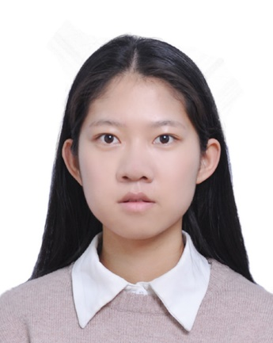
Full Name: Xian Zhang
Twitter account:
Contact number:+8618317179753
Linked In account: xian_z7@163.com
Session name/ number:
Category: Oral presentation
Session name/ number:
Passport Number:

