Title: Star-shaped fluorene-BODIPY oligomers: versatile donor-acceptor systems for luminescent solar concentrators
Nathaniel J. L. K. Davis¹, Rowan W. MacQueen², Saul T. E. Jones³, Rupert Taylor⁴, Dan Credgington³, Peter J. Skabara⁴ and Neil C. Greenham³

¹School of Chemical and Physical Sciences, Victoria University of Wellington, Wellington 6140, New Zealand
² Institute for Nanospectroscopy, Helmholtz-Zentrum Berlin für Materialien und Energie GmbH, Albert-Einstein-Str. 15, 12489 Berlin, Germany
³Cavendish Laboratory, University of Cambridge, J.J. Thomson Avenue, Cambridge, CB3 0HE, UK,
⁴Pure and Applied Chemistry, University of Glasgow, 16 Richmond St, Glasgow G1 1XQ, UK

Keywords: BODIPY, Oligomers, Donor-acceptor systems, Luminescent solar concentrators, Reabsorption

I. Abstract
Luminescent solar concentrators (LSCs) are waveguides doped with luminescent centers that can spectrally and spatially concentrate sunlight. They can reduce the cost of photovoltaic energy production and are attractive prospects for photobioreactors and building-integrated applications¹. Reabsorption, caused by non-zero overlap between the absorption and emission spectra of the light-emitting centers, often limits LSC efficiency². Donor–acceptor energy-transfer complexes are one method to mitigate reabsorption by shifting the emission away from the main absorption peak^{3,4}. Here we introduce versatile star-shaped donor–acceptor molecules based on a central BODIPY energy acceptor with oligofluorene donor side units. Varying the oligofluorene chain length alters the relative oscillator strengths of the donor and acceptor, changing the severity of reabsorption for a given donor density, but also changing the luminescence yield and emission spectrum. We performed comprehensive device measurements and Monte Carlo ray tracing simulations of LSCs containing three oligofluorene–BODIPY donor–acceptor systems with different oligofluorene chain lengths, and then extended the simulation to study hypothetical analogs with higher donor–acceptor ratios and different terminal acceptors. We found that the measured structures permit waveguide propagation lengths on a par with state-of-the-art nanocrystalline emitters, while the proposed structures are viable candidates for photobioreactor and energy production roles and should be synthesized.

II. Image

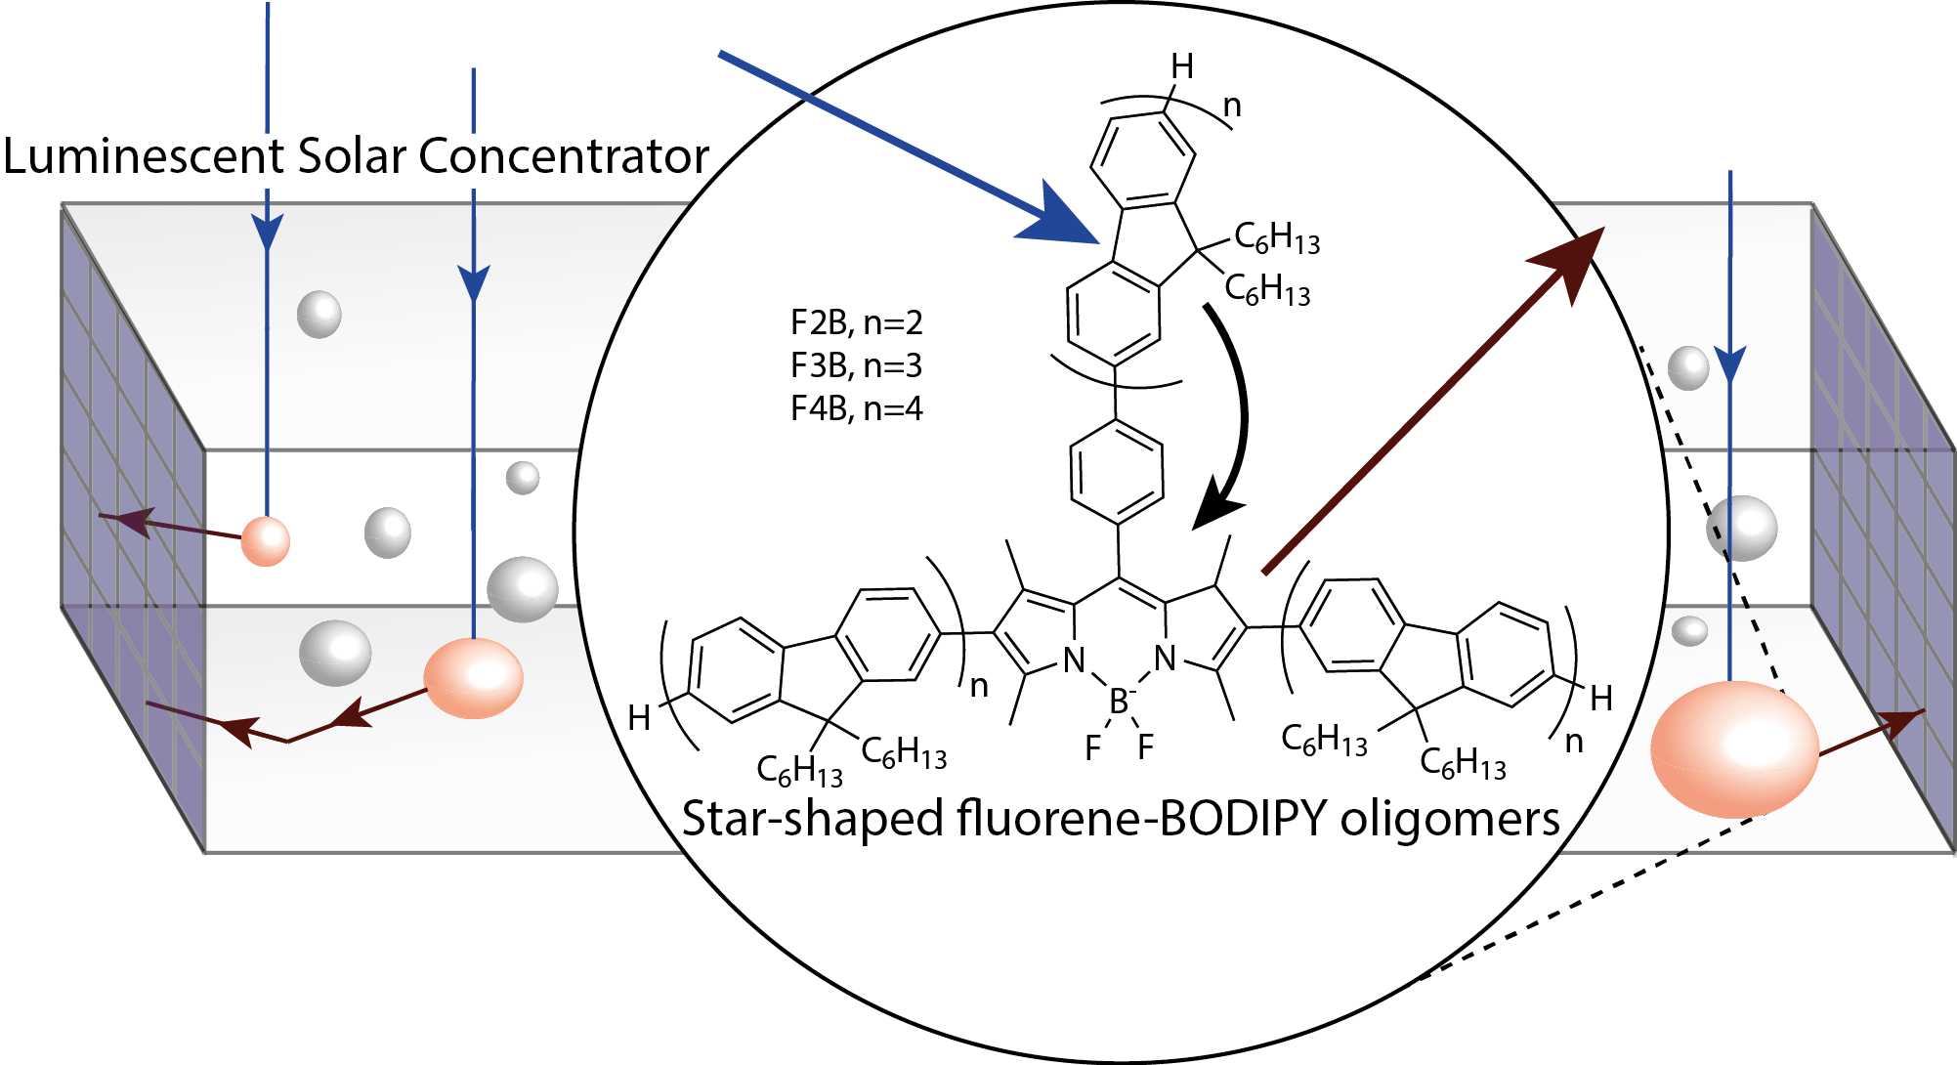

III. References
(1) Debije, M. G.; Verbunt, P. P. C. Thirty Years of Luminescent Solar Concentrator Research: Solar Energy for the Built Environment. Adv. Energy Mater. 2012, 2, 12–35.
(2) Olson, R. W.; Loring, R. F.; Fayer, M. D. Luminescent Solar Concentrators and the Reabsorption Problem. Appl. Opt. 1981, 20 (17), 2934–2940.
(3) Davis, N. J. L. K.; MacQueen, R. W.; Roberts, D. A.; Danos, A.; Dehn, S.; Perrier, S.; Schmidt, T. W. Energy Transfer in Pendant Perylene Diimide Copolymers. J. Mater. Chem. C 2016, 4, 8270–8275.
(4) Giebink, N. C.; Wiederrecht, G. P.; Wasielewski, M. R. Resonance-Shifting to Circumvent Reabsorption Loss in Luminescent Solar Concentrators. Nat. Photonics 2011, 5 (11), 694–701.

IV. Biography
Dr Nathaniel Davis received his Bachelor of Advanced Science from the University of Sydney, Australia, with a double major in advanced chemistry graduating with First Class Honours and the University Medal. He received the Cambridge Australia Bragg Scholarship to carry out his PhD in Physics in the Optoelectronics group at the Cavendish laboratory within the University of Cambridge, United Kingdom. Completing his thesis tittled “Applications of Spectral Management in Optoelectronic devices” in 2016 he was then awarded the Oppenheimer Early Career Research Fellowship in 2017 at the University for Cambridge United Kingdom. Dr Davis has now taken up the Position of Lecturer (Assistant Professor) in Physical Chemistry at Victoria University of Wellington. In 2019 DR Davis was made an Associate investigator of the Dodd Walls Centre for Quantum Technologies.

V. Presenting author details

Full name: Dr Nathaniel J. L. K. Davis
Contact number: +64 4463 9693
Email: nathaniel.davis@vuw.ac.nz

