

Oriented Recrystallization of Carbon-Coated Pre-oriented Ultrathin Polymer Films

Ma L1, Yan S1, 2,
1 State Key Laboratory of Chemical Resource Engineering, Beijing University of Chemical Technology Beijing, 100029, China
2 Key Laboratory of Rubber-Plastics, Qingdao University of Science & Technology, Qingdao 266042, China

Keywords: Polymer, Orientation, Carbon coating, Melting, Recrystallization

- Abstract Body (up to 250 words)
The recrystallization behavior of carbon-coated pre-oriented polymer thin films was studied by means of transmission electron microscopy combined with electron diffraction and spectroscopy. It was found that vacuum evaporated carbon layer can keep the molecular chain orientation of pre-oriented polymer thin films. This demonstrates the existence of strong fixing effect of vacuum evaporated carbon layers on the surface layer of the polymer films, which prevents the relaxation of surface extended macromolecular stems in the crystals or at least from a complete relaxing during high-temperature melting. The fixed surface molecular chains have in turn induced the oriented recrystallization of the thin polymer molten layer. It was further found that the crystal structures and morphologies can be well controlled through regulating the crystallization temperature. For example, the α to β transition of has been achieved by melt recrystallization of carbon-coated highly oriented PVDF ultrathin films at atmospheric pressure. Moreover, through selective carbon-coating with the help of a mask and subsequent recrystallization of the pre-oriented polymer thin film lead to patterned structure control in the coated domains of a polymer thin film. A fully structure control can be fulfilled through a combination of surface carbon coating at desired domains and recrystallization on an oriented substrate with heteroepitaxy.

Image:
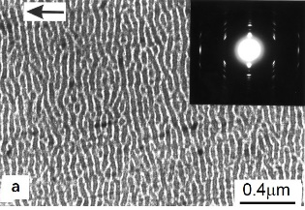 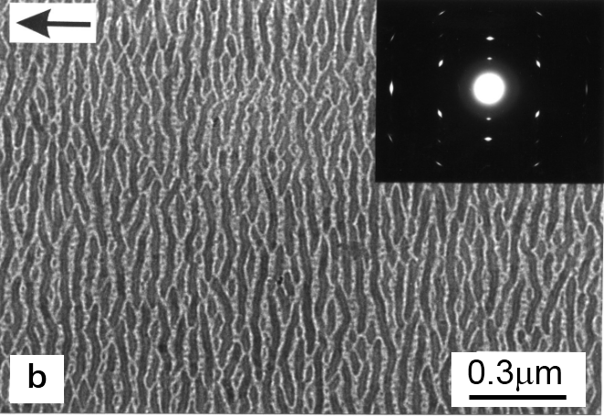TEM images and corresponding electron diffraction patterns of a highly oriented PE ultrathin film before (a) and after (b) melt-recrystallization.
- Reference:

1. Ma, L., Zhou, Z., Zhang, J., Sun, X., Li, H., Zhang, J., Yan, S., 2017. Temperature-Dependent Recrystallization Morphologies of Carbon-Coated Isotactic Polypropylene Highly Oriented Thin Films, Macromolecules, 50; 3582−3589
2. Li, H., Yan, S., 2011. Surface-induced Polymer Crystallization and the Resultant Structures and Morphologies, Macromolecules, 44; 417–428
3. Wang, J., Li, H., Liu, J., Duan, Y., Jiang, S., Yan, S., 2003. On the αβ transition of carbon coated highly oriented PVDF ultra-thin film induced by melt recrystallization, J. Am. Chem. Soc., 125; 1496-1497

Biography:
Shouke Yan completed his M.S. (1988) and Ph.D. (1996) in Polymer Science at the Changchun Institute of Applied Chemistry, Chinese Academy of Sciences (CAS). He then took a position on the research staff at Dortmund University. In 2001, he joined CAS through the Hundred Talents Program and became a full Professor at the Institute of Chemistry, CAS. He has been a Professor in Beijing University of Chemical Technology (BUCT) since 2008 and at Qingdao University of Science & Technology since 2018. His current research involves surface induced polymer crystallization, orientation-induced polymer crystallization, and phase transitions of crystalline polymers.

Presenting author details
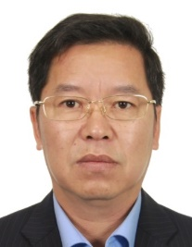
Full Name: Shouke Yan
Contact number: +86-10-13911317103
Session name/ number: Polymer Material Science and Engineering
Category: Oral presentation
Passport Number:



