Jojoba production in arid areas
Abobatta, W, F, PhD, Agriculture Research Center, Egypt

Abstract (300 word limit)
Jojoba, [Simmondsia chinensis (Link) Schneider] tree is considered one of the most practical and scientific solutions for desert plantation in arid areas.
Jojoba is native to the semiarid regions of southern United States of America (Arizona & California (and northwestern Mexico.
Now Jojoba has attracted much attention in recent decades, for Jojoba oil which unique in nature, Jojoba can be grown as an oil-producing cash crop, it’s considered a new oil-producing industrial crop, until now there’s no other plant is known to produce oil like jojoba. It’s used in different industries purposes like cosmetic, medical, pharmaceutical, manufacturing, and automotive industries (as lubricant), also, it is a renewable energy resource.
Now Jojoba is being cultivated in several arid and semi-arid countries all over the world such as Egypt, India, Saudi Arabia, Sudan and MENA region.
Jojoba an evergreen shrub and very drought-resistant, it could be grown on marginal lands without replacing any existing crops.
Fully mature shrubs can reach a height of 15 feet (2-4 meters) with 15 meters long root approximately, with a potential natural life span up to 100 years depending on environmental conditions. For optimum production, the crop needs irrigation, care, and a good cultivar.
It produces a peanut-like seed with a thick brown coat. Jojoba seed can yield 40 up to 50% pure oil chemically classified as liquid wax that gives it a great advantage as natural oil for industrial purposes, which also make it environmentally safe.
Additionally, the meal remaining from seed pressing contains 30% protein that consists of 17 amino acids, 7 of which are essential amino acids. After treatment, the meal becomes suitable for utilization as cattle/fish feed and /or organic fertilizers.

Image
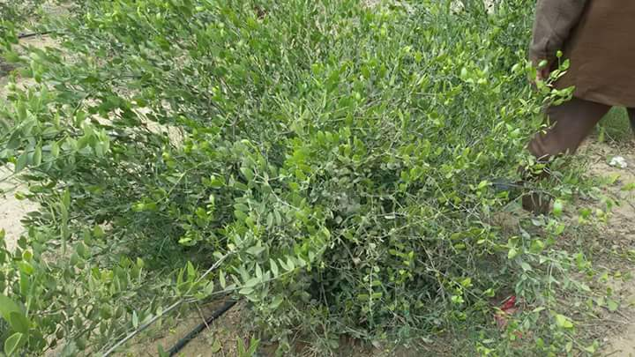
Recent Publications (minimum 5)
- Abdelmoez, W., Tayeb, A. M., Mustafam A. and Abdelhamid, M. 2015. Green Approach for Biodiesel Production from Jojoba Oil Supported by Process Modeling and Simulation. I J C R E, 14 ( 1):185-193.
- Abobatta, W. F. R., El Ghadban, E.A.E. and Mahmud, G. F., 2015. Chemical studies on grown jojoba oils under Egyptian conditions. Glob. J. Agric. Food Safety Sci., Vol.2 (3): pp. 270 – 283.
- Arya, D. and Khan, S. 2016. J. Pharm. Sci. & Res. 8(6), 381-389.
- Bashir, M.A., Anjum, M.A. and Rashid, H. 2007. In vitro root formation in micropropagated shoots of jojoba (Simmondsia chinensis L.). Biotech. 6(3): 465-472.
- Nelson, J.M., and Watson, J. E. 2001. Nitrogen fertilization effects on jojoba seed production. Indust. Crops Products. 13:145-154.
- Waleed Fouad Abobatta, (2016) Simmondsia chinensis الجوجوبا شجرة الذهب الاخضر- - Noor Publishing - Germany.

Biography (150 word limit)
Waleed Abobatta has his expertise in Horticultural science; he’s member of Scientific Committee for Greenhouses Plantation, Abobatta one of International Advisory Board Members of Journal of Harmonized Research, Abobatta one of Jojoba experts in MENA region, He has “Simmondsia chinensis "الجوجوبا_ شجرة الذهب الاخضر book from Noor Publishing- Germany. Also, he’s Head of Judge of Harm El Ebdaa competition 2017, also, judge in Intel BASEF competition and Judge of Egyptian Inventors Syndicate; He’s coordinator of Foundation committee for Arab Federation for Wildlife Protection. He’s consultant of Biodynamic and clean agriculture in Arabian region, Abobatta’s a member of Board of Environment Friends Society, and member of Scientific Society of Flowers and Ornamental Plants. Abobatta’s supervisor of Landscaping Section at Al Ahram Agricultural Magazine, and has many scientific publications.
Email: wabobatta@yahoo.com

Notes/Comments:

