SYNONYMOUS CODON USAGE BIAS IN CHLOROPLAST GENOME OF Vitis vinifera and Two Caucasica Subspecies of Grape Fruit
Farshid Talat ^{1*}, Sayna Shahdparvar ², Jirayer Karapetian²
¹Assistant Professor, Seed and plant improvement Research Department, West Azarbaijan Agricultural and Natural Resources Research and Education Center, AREEO, Urmia, Iran
² Graduate Student of Horticultural Biotechnology, Saba Institute of Education, Urmia, Iran
² Professor, Saba Institute of Education, Urmia, Iran

*Corresponding author: Farshid Talat, Seed and plant improvement Research Department, West Azarbaijan Agricultural and Natural Resources Research and Education Center, AREEO, Urmia, Iran. Tel: +98-4432722197, Fax: +98-4432722221, E-mail: f.talat@areeo.ac.ir

Abstract
Chloroplast research have significant advantage of genomics and genome sequencing, and a new picture is emerging of how the chloroplast functions and communicates with other cellular compartments. Grape (Vitis vinifera) is a genus of trees in the family Vitaceae. Vitis vinifera species belongs to Eurasian grapes. The chloroplast genome is the most comprehensive genome in plants and has many features for evolution analyses due to the unique molecular structure and single-parent inheritance. Sequence and gene annotation was mainly performed by DOGMA. Map of chloroplast genome structure and gene distribution was carried out using OGDRAW V1.1. Relative synonymous codon usage (RSCU) of different codons in each gene sample was calculated by codonW in Mobyle. An online version of REPuter was used to specify the repeat sequence and location. this research was targeted to study and compare the complete chloroplast genome sequences of Saperavi and Meskhuri mtsvane from caucasia subspecies with common grape (Vitis vinifera) and as well genome structure analysis, gene content, organization and repetitive sequences, codon usage and comparison among genomes. The chloroplast (cp) genome of Vitis vinifera is a circular DNA molecule of 160928 base pair (bp) which is longer than chloroplast genome of Saperavi and Meskhuri Mtsvane cultivars. Large and small unique regions are separated by two inverted repeat regions a, b. In all of three genomes, whole genome contains 131 genes which include 79 protein coding genes, 4 rRNA genes and 30 tRNA genes. In other words, there are totally 113 single-copy genes and 18 double-copy genes located in inverted repeat region (IR) in the three studied genomes. The SSRs of the chloroplast genomes were identified and the results indicated that the chloroplast genomes of Vitis vinifera and Saperavi both have 74 and Meskhuri mtsvane has 73 SSRs. The cpSSRs are important and useful for genetic diversity studies. Low GC content is a significant feature of plastid genomes, which is possibly formed after endosymbiosis by DNA replication and repair.
Keywords: Chloroplast genome, complete sequence, Vitis vinifera

Image
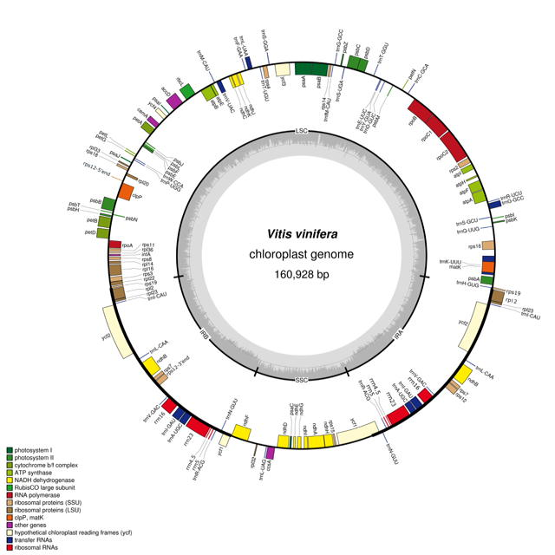

Figure 1. Vitis vinifera chloroplast genome structure and gene organization
Note: genes shown outside of the circle transcribed anticlockwise and shown inside of the circle transcribed clockwise. tRNA genes are shown by 1 letter of the coded amino acid followed by anticodon (genome map was created by using OGDRAW V.1.1, Lohse, 2007)
Recent Publications (minimum 5)
- Talat F, Wang K. Comparative bioanformatics analysis of the chloroplast genome of a wild diploid Gossypium and two cultivated allotetraploid species. Iran J Biotech. 2015; 13(3): 47-56. DOI: 10.15171/ijb.1231
- Lohse M, Drechsel O, Bock R. Organellar Genome DRAW (OGDRAW): a tool for the easy generation of high-quality custom graphical maps of plastid and mitochondrial genomes. Curr Genet. 2007;52(5-6) :267-274. DOI: 10.1007/s00294- 007-0161-y
- Daniell H, Wurdack KG, Kanagaraj A, Lee SB, Saski C, Jansen RK. The complete nucleotide sequence of the cassava (Manihot esculenta) chloroplast genome and the evolution of atpF in Malpighiales: RNA editing and multiple losses of a group II intron. Theor Appl Genet. 2008;116(5):723-737. DOI: 10.1007/s00122-007-0706-y
- Yang M, Zhang X, Liu G, Yin Y, Chen K, Yun Q, Zhao D, Al-Mssallem IS, Yu J. The Complete Chloroplast Genome Sequence of Date Palm (Phoenix dactylifera L.). PLoS One. 2010; 5(9):143-152. DOI:10.1371/journal.pone.0012762
- Freudenberg J, Wang M, Yang Y, Li W. Partial correlation analysis indicates causal relationships between GC-content, exon density and recombination rate in the human genome. BMC Bioinformatics. 2009; 10Suppl 1: S66. DOI: 10.1186/ 1471-2105-10-S1-S66

Biography (150 word limit)

Dr. Farshid Talat is Assistant Professor of Crop genetics and Breeding at Agricultural Research, Education and Extension Organization of Iran. Dr.Talat is deputy director general at West Azerbaijan Agricultural Research Center. He is doing research in the field of crop genetics and biotechnology for 17 years and has been teaching Genetics and Biostatistics in several universities since 1999. He has conducted extensive studies on crop breeding and plant architecture systems in Iran. Dr. Talat served as a coordinator of 40 national projects .He received his B.Sc. degree in Agronomy and Plant Breeding from Urmia University in 1997 and his M.Sc. in Plant Breeding-Biotechnology from University of Tehran in 1999. Dr.Talat received his PhD from Chinese Academy of Agricultural Sciences in Genomics on wild cotton sequencing program. He is the author of 70 national and international published papers.
Email: f.talat@areeo.ac.ir

Notes/Comments:

