ABSTRACT
Title: Traditional medicines used for healthy reproductive life of females from puberty to menopause
V.Dhaarani¹ and A. Rajendran¹
1. Department of Botany, Bharathiar University, Coimbatore, Tamil Nadu, India.

Key words: Phytomedicine, Phytoestrogenic, Documentation, Folklore
I.Abstract body
The usage of medicinal plants for various human ailments started time immemorial. Despite the widespread of allopathic treatments, people still believe in and follow the usage of medicinal herbs for maintaining their health and as first aid for various diseases. The common believes among the people for the usage of medicinal plants is that, they cause no or less side effects. Plants are also refered as phytoprogesteronic and phytoestrogenic, as plant possess molecular structures similar to the female hormones(Ramasubramania raja). As pregnancy and childbirth are considered a part of human existence , females are meant to have healthy reproductive system so that importance is given in the health care and various ailments related to the reproductive system of women( Devi Prasad).
Female become reproductively active at the age of 13, from where they are prone to a number of uterine and ovary related disorders, which drastically affects the healthy reproductive life of an individual. Hence importance is given from the age of 13 and it continues till 45 where the menopause begins. This study involves a brief documentation of various medicinal plants used by the folklore of Tamil Nadu to maintain the reproductive health of women. The study has played a significant role in unearthing many forgotten plant medicines. About 155 plant species belonging to different families were collected and identified to have higher potential in curing various reproductive disorders. Some of the noteworthy plants from the study involves Caesalpinia bonduc (Caesalpiniaceae), Punica granatum (Punicaceae), Psidium gujava (Myrtaceae), Annona squamosa (Annonaceae), Musa paradisiaca (Musaceae) are some of the plant species that plays a major role in treating various ailments like Poly Cystic Ovary Syndrome, Altered menstruation, Pinfull periods, Pelvic pain, Infertility, Uterine fibroids etc. The phytomedicine of various parts of the plants like root, leaf, stem, bark, flowers, fruits and seeds are used. The drugs are prepared and administered in monoherbal or poly herbal combinations.
II. Plant Photo:
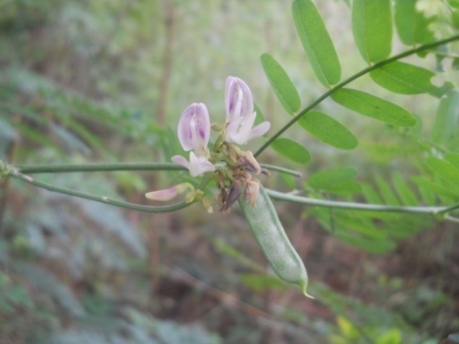
Abrus precatorius L.
III. References:
- World Health Organization (WHO). Guidelines for the Assessment of Herbal Remedies. Traditional Medicine Programme of the world health organization. Geneve 1991.
- Patelanuradha Jitendra, Thakor Akanksha Prawin, Prospective use of Tephrosia purpurea in Remedial Treatment of PCOS: study in Wistar Rat ISCA J. Biological Sci. 2012; 1(3): 1- 6.
- Ayyanar, M and Ignacimuthu , S. Traditional knowledge of Kani tribals in Kouthalai of Tirunelveli hills, Tamil Nadu, India. Journal of Ethnopharmacology 102: 246- 55.
IV. Biography:
Dr. A. Rajendran , Professor and Head, Department of Botany, Bharathiar University, is a Recipient of S. K. Jain award. His field of research interests is Plant Systematics, Ecology, Environmental Science, Ethnobotany and Biodiversity Conservation. He has authored for 10 books, 53 articles in edited books and more than 200 research articles to his credit in various National and International Scientific journals including 18 new species. He has successfully completed 30 PhD and 41 MPhil students. He is an active member of many national and international academic bodies.
V. Dhaarani, Research Scholar , Department of Botany, Bharathiar University is doing her research under the guidance of Prof. Dr. A. Rajendran, in the field of Taxonomy. She has published 5 research articles in various national and international journals.
V. Presenting Author Details:
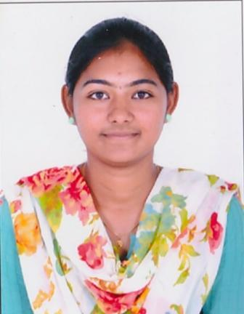
NAME: V.DHAARANI
DESIGNATION: RESEARCH SCHOLAR
CONTACT NUMBER: 8220850635
EMAIL: abiruthi1993@gmail.com
LINKED IN: dhaarani vijayakumar
SESSION NAME/ NUMBER: MEDICINAL PLANT SCIENCES/ 9
PASSPORT NUMBER: R5789448

