High‑level expression of nucleocapsid protein from Canine Distemper Virus in tobacco transplastomic plants

Laguia-Becher M¹, Gallo-Calderón M², Romanutti C², Trentini A¹, Alvarez MA¹; Veramendi J³ and Marconi PL¹.
¹ Departamento de Investigaciones Bioquímicas y Farmacológicas, Laboratorio de Biotecnología Vegetal, CEBBAD-CONICET, Ciudad Autónoma de Buenos Aires, Argentina.
² Instituto de Ciencia y Tecnología Dr. César Milstein-CONICET, Ciudad Autónoma de Buenos Aires, Argentina.
³ Instituto de Agrobiotecnología, Universidad Pública de Navarra-CSIC, Pamplona, España.

Keywords: Tobacco transplastomic plants, Canine Distemper Virus nucleocapsid protein, Plant-based vaccine

- Abstract Body
Canine Distemper Virus (CDV) produces a highly contagious disease in domestic dogs and other wild animals. Although immunization with attenuated CDV vaccines has been shown to be effective, in recent years there has been an increase in the incidence of CDV infection, including vaccinated dogs. Therefore, a more effective vaccine formulation containing updated immunogens is necessary. The use of plants as biofactories for the expression of antigens is an attractive alternative to produce cost-effective subunits vaccines. In particular, chloroplast transplastomic technology offers stable high-level of recombinant protein expression and transgene containment. In this study, we evaluated the production of the nucleocapsid protein (NP) from an Argentinian CDV strain in transplastomic tobacco plants. Protein expression analysis by Western blot showed the presence of two specific bands in total protein extracts. The expected band of 62 kDa for NP represented approximately 60% of the signal in mature leaves. Furthermore, full-length NP was expressed mainly as an insoluble protein. The concentration of NP in young, mature and old leaves was estimated to be 6.2, 4.4 and 6.7 % of total protein, equivalent to 1.2, 0.7 and 0.4 mg/g fresh weight, respectively. We also evaluated the functionality of the plant-derived NP in a murine model. Oral and subcutaneous immunization with transplastomic extracts elicited an increase of NP-specific serum antibodies compared with control mice. Our results show that NP can be efficiently expressed in transplastomic tobacco plants and maintains its immunogenic properties.

- Image:

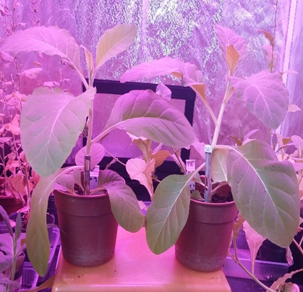
Transplastomic tobacco plants

- Reference:
- Biography:
Marconi has completed his PhD and postdoc from University of Buenos Aires. The actual position is senior researcher at National Research Council CONICET and team-teache at University Maimonides. She has published more than 25 papers in reputed journals.

- Presenting author details



Full Name: Patricia L. Marconi
Contact number: +5491162775290
Session name/ number: Plant Tissue Culture and Biotechnol/3-3
Category: Poster presentation
Passport Number: AAA895806

