Title: Exploring the synergistic effect and mechanism of Spatholobus Suberectus Dunn extract and doxorubicin in breast MCF‐7/ADR cells

Yi WEN¹,
¹School of Chinese Medicine, Li Ka Shing Faculty of Medicine, The University of Hong Kong, Hong Kong, China

Keywords: Pharmacology, cancer, natural plant products, Spatholobus Suberectus Dunn

- Abstract Body (up to 250 words)
Breast cancer is one of the most prevalent cancers in women and the second most common cause of cancer mortality¹. Chemotherapy is the major strategy for treating the breast cancer². The doxorubicin can improve the survive rate of breast cancer patients significantly³. However, the toxicity and drug resistance are the main problem of using the doxorubicin. Grape seed extract (GSE) can reverse the multiple drug resistance by down regulated the NF-kB and YB-1 activity wihich medicatd by MAPK/ERK in A2780/T⁴. We obtained the most active Spatholobus Suberectus Dunn extract (SSP) by optimizing extraction time, the volume of percolation, the concentration of ethanol. The inhibitory effect of SSP and GSE on breast cancer resistant strains (MCF-7/Adr) is similar, but SSP shows a better synergistic effect than GSE when combining doxorubicin. It suggests that there is another pathway working in the MCF-7/Adr regulate by SSP. Thus, we are exploring the active substance of SSP and the potential mechanism of synergistic effect by cell proliferation, adherent, apoptosis, cell cycle and the amount of protein which related in Estrogen receptor. The aim of the project is to illustrate the mechanism of synergistic effect of SSP and doxorubicin. It helps us understand the Spatholobus Suberectus Dunn, traditional Chinse medicine, in a comprehensive way.

- Image:

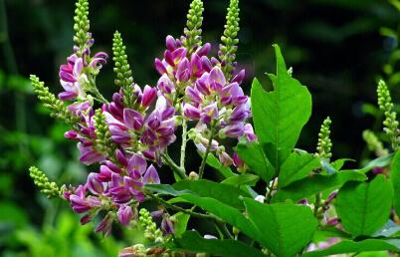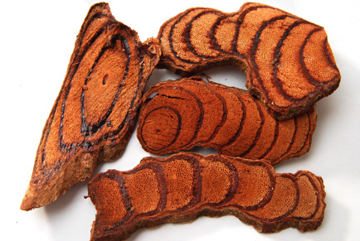

- Reference:
- Kohler, B. A. et al. Annual Report to the Nation on the Status of Cancer, 1975-2011, Featuring Incidence of Breast Cancer Subtypes by Race/Ethnicity, Poverty, and State. J Natl Cancer Inst 107, djv048, doi:10.1093/jnci/djv048 (2015).
- Zuo, W. S., Zheng, M. Z. & Han, C. [Effect of neoadjuvant chemotherapy on the overall treatment strategy in operable breast cancer]. Zhonghua Zhong Liu Za Zhi 39, 952-957, doi:10.3760/cma.j.issn.0253-3766.2017.12.014 (2017).
- Woodward, W. A. et al. African-American race is associated with a poorer overall survival rate for breast cancer patients treated with mastectomy and doxorubicin-based chemotherapy. Cancer 107, 2662-2668, doi:10.1002/cncr.22281 (2006).
- Zhao, B. X. et al. Grape seed procyanidin reversal of p-glycoprotein associated multi-drug resistance via down-regulation of NF-kappaB and MAPK/ERK mediated YB-1 activity in A2780/T cells. PLoS One 8, e71071, doi:10.1371/journal.pone.0071071 (2013).

- Biography:
Ms. WEN Yi is a Ph.D student of The University of Hong Kong. She obtained her Master’s degree of Traditional Chinese Medicine in Jiangsu University and Shanghai Institute of Materia Medica. And gained the Bachelor of Pharmacy in Jiangsu University. Ms. WEN Yi was granted the Dragon Culture Traditional Chinese Medicine Scholarship in 2017. And won the Best Paper Award in 17th Tri-University International Joint Seminar & symposium in Thailand. She won the first-class scholarship twice, the second-class scholarship once and also the National Motivational Scholarships during the Bachelor’s degree. Ms. WEN Yi discovered the first novel inhibitor of NAD(P)⁺-dependent malic enzyme by high-throughput screening and studied the mechanism of inhibitor

- Presenting author details


Full Name: WEN Yi
Contact number:852-56109025
Email: u3004630@connect.hku.hk & 1417070046@qq.com:
Category: Poster presentation
Passport Number: G40589609

