Abstract

Title: Role of AMF in ameliorating detrimental effect of drought stress on PSI and PSII photochemistry in Wheat plants

Dr. Sonal Mathur¹ and Dr. Anjana Jajoo¹
¹School of Life Science, Devi Ahilya University, Indore, India

Keywords: Arbuscular Mycorrhizal Fungi (AMF), Drought stress, Photosynthesis, Photosystem I (PSI), Photosystem II (PSII) , Wheat

- Abstract Body (up to 250 words)
Water scarcity is becoming a major problem. Drought stress (DS) is amongst one of the most alarming abiotic factors limiting crop productivity. Common symptoms observed for DS are stunted growth, reduced photosynthesis rate, and accelerated leaf senescence. Arbuscular mycorrhizal fungi (AMF) makes symbiotic interactions with ~ 80% land plants. The present work represent role of AMF in protecting photosynthetic apparatus of wheat (Triticum aestivum) from detrimental effect of DS. Wheat (Triticum aestivum; Purna cultivar HI-1544) and AMF culture (mainly comprised of Rhizophagus intraradices; Funneliformis mosseae; F. geosporum) were used for the experiment. DS plants had minimum RWC (Relative water content) for both leaf and soil while AMF plants showed increased RWC indicating that AMF hyphae penetrated deep into the soil and provided moisture to the plants. AMF protected oxygen evolving complex followed by enhanced primary photochemistry of PSII. A down regulation in quantum yields of PSI and PSII, electron transport rate was observed in DS stressed plants. Small PSII antenna size can efficiently restrict PSI photochemistry via donor side limitation which was evident in DS plants (Zivcak et al. 2013). In DS plants, decrease in the quantum yield of PSII and PSI occurred mainly due to an increase in the non regulated energy dissipation and donor-side limitation of PSI. AMF plants had a greater ability for high photosynthetic capacity and prevented the photosynthetic apparatus from being damaged under DS (Mathur et al. 2018). AMF colonization thus helps the plant to maintain integrity and stability of PSI and PSII under drought stress.

- Image:

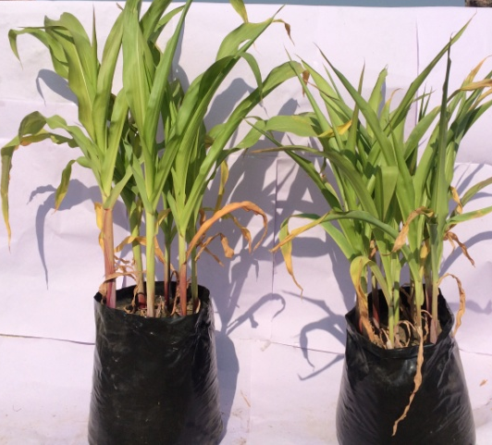

- Reference:

- Zivcak, M., M. Brestic, Z. Balatova, P. Drevenakova, K. Olsovska, H.M. Kalaji, X. Yang and S.I. Allakhverdiev, 2013. Photosynthetic electron transport and specific photoprotective responses in wheat leaves under drought stress. Photosynth. Res., 117; 529–546

- Mathur S, R.S. Tomar, and A. Jajoo, 2018 Arbuscular Mycorrhizal fungi (AMF) protects photosynthetic apparatus of wheat under drought stress. Photosynth. Res., DOI: 10.1007/s11120-018-0538-4.

- Biography:
Dr Sonal Mathur completed her PhD at the age of 34 years from Devi Ahilya University, India and is continuing Postdoctoral Studies as UGC-PDF-SA-II (for Women), from School of Life Science, Devi Ahilya University, India. She was awarded Young Talent Award in 2016 (Russia), and Young Scientist Award in 2014 from Madhya Pradesh Council of Science and Technology, Bhopal, India. She has published 21 papers in reputed journals, with cumulative impact factor of ~ 46.76. She has been serving as a reviewer of few journals.
- Presenting author details


Full Name: Dr. Sonal Mathur Contact number:+91-9926073316
Twitter account: NA
Linked In account:mathurksonal@gmail.com
Session name/ number: Track7; Track 7-5
Category: (Oral presentation) Oral Presentation
Passport Number: P9927413

Control
AMFMMF

