INTERACTIVE EFFECTS OF CADIMIUM STRESS AND PROLINE ON PHYSIOLOGICAL AND BIOCHEMICAL PARAMETERS OF FABA BEAN PLANT

Assia Amri*, Naima Layachi

Departement of Bioloy, Faculty of Sciences, University of Cherif Messadia Soukahras, 41000 - Soukahras, Algeria.
E-mail :amri.assia@yahoo.fr

Keywords: growth, metal stress, cadimium chloride, Vicia faba,
proline
I Abstract
Heavy metal stress is one of the major abiotic stresses that cause environmental pollution in recent decades (Castro et al., 2011). Under stress, Proline accumulated in many plants and acts as a signaling molecule and trigger specific gene expression, which can be essential for plant recovery from stress (Szabados & Savouré, 2009).Therefore, the present experiment was aimed to study the effect of proline on the performance of faba bean under cadmium stress condition. The effect of exogenous application of proline with different concentrations (0, 25 or 50mg / l) on faba bean (Vicia faba L.) plant grown at cadimium levels (0 or 150µM/l.).Under Metal stress condition, all parameters [plant height and root length, root fresh weight, shoot fresh weight, root dry weight, shoot dry weight, total soluble carbohydrates (TSC), chlorophyll (Chl) a and b, and activity of peroxidase (POD), and catalase (CAT)] of faba beans were strongly depressed, except malondialdehyde (MDA) contents. From these results, proline traitement alleviated the adverse effects of metal stress through increased the photosynthetic pigments, polysaccharides, total carbohydrates, plant height, leaves number, fresh and dry weights of shoot, and seed yield as well as, total soluble sugars, total free amino acids and proline, compared with those of the corresponding cadimium levels, while decreased lipid peroxidation product as malondialdehyde (MDA) and the oxidative enzymes.These results indicate that application of proline was effective, and helped the plant to restore the altered physiological process induced by cadimium stress.
II Image:
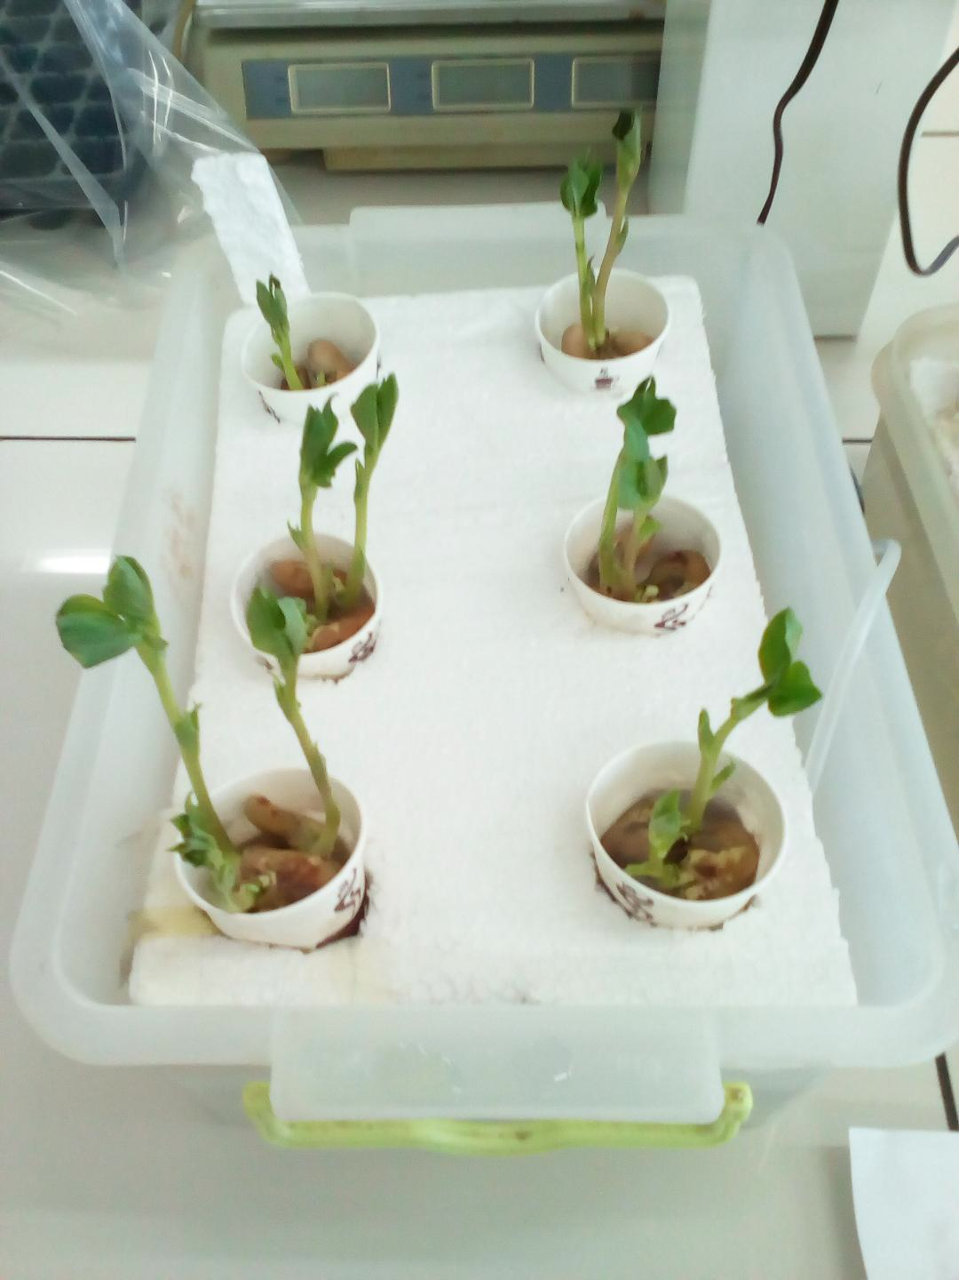

III Reference:
- Szabados, L. and A. Savouré, 2009. Proline: A multifunctional amino acid. Trends Plant Sci.., 15: 89-97.

-Castro, R., L.Caetano., G .Ferreira., P .Padilha., M .Saeki., L .Zara., M. Martines and G .Castro ,2011. Banana peel applied to the solid phase extraction of copper and lead from river water. Chem. Res., 50(6): 3446-3451
IV Biography:
AMRI ASSIA has completed her PhD at the age of 25 years from Annaba university, Algeria. She is researcher and a teacher at university. She has published 4 articls in reputed journals.
V Presenting author details


Full Name:Amri Assia
Contact number:+213555673495
Linked In account:Amri Assia
Session name/ number:
Category: (Poster presentation)
Passport Number:177065293

