International Conference on Plant Science and Molecular Biology June 18-20, 2018 Paris-France

Title: Plant science and molecular biology are the major industries for the development of
Health, daily use of life, reduces financial crises, poverty and hunger in the world.

Theme: Explore Plant Science & Molecular Biology
Abstract:
References
- "Polymerase Chain Reaction (PCR)". www.ncbi.nlm.nih.gov. Retrieved 31 December 2016.
- Jump up^ "Polymerase Chain Reaction (PCR) Fact Sheet". National Human Genome Research Institute (NHGRI). Retrieved 31 December 2016.
- Jump up^ Lee, Pei Yun; Costumbrado, John; Hsu, Chih-Yuan; Kim, Yong Hoon (20 April 2012). "Agarose Gel Electrophoresis for the Separation of DNA Fragments". Journal of Visualized Experiments (62). doi:10.3791/3923. ISSN 1940-087X. PMC 4846332 . PMID 22546956.

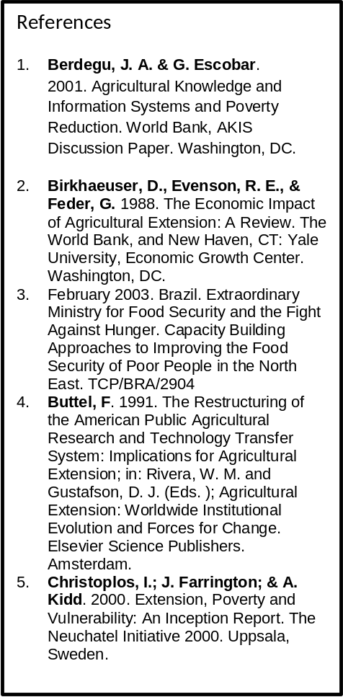

The aim of presentation consist of plant science, molecular biology, health , life , financial crises, poverty and hunger were studied and reported that plant science and molecular biology are the major industries for the development of health, daily use of life, reduce financial crises, poverty and hunger in the world.
Plant science is the study of plant growth, reproduction, evaluation and adaptation as well as the use of plant for food, fiber and ornamental purposes. In simple words, plant science is the study of plant life of a particular region or time. It is the biological characteristics of a particular group of plant. The science of plant is the branch of biology that deals with plant life. In simple words the science of plants means the branch of biology that deals with the plant life. Molecular biology is the branch of biology that deals with the physical and chemical interaction of molecules involved in life function. By using chemical knowledge and techniques, biochemists and molecular biologists can understand and solve biological problems. In the light of the above study, it is proposed that plant science and molecular biology should be commercialized as it is the major industries for the development of health, daily use of life, reduces financial crises, poverty and hunger in the world.



Muhammad Usman, Moderator of Biochemistry 2017 Felicitate Prof. Jaleel K Ahmed with Keynote Certificate on Sept, 29 at Dubai


Biography: Mr. Muhammad Usman, Former Director General of Agricultural Research System, Government of Pakistan who retired from service after a spotless career of about 35 years with senior level experience on research and development of integrated agricultural production, industries, Plant science and Molecular biology on a sustainable way.

Presenting paper in FCF, Geneva,
Switzerland on 31st Oct, 2012

Mr. Usman is basically an agricultural scientist with specialization of agricultural working on the yield and quality of various products.

Mr. Usman is consider as the senior most scientist in the world, always participated in the international conferences as a keynote speech, organizing committee member, moderator of the conferences around the world.

