Pre-sowing magnetic treatment on germination, growth and yield of Okra (Abelmoschus esculentus) and Chilli (capsicum annum L.) seeds

R. D. Vaidya¹, P. K. Patel² , K. R. Patel³, Dipak Bokha⁴
¹ Department of Physics, Sheth P. T. Arts & Science College, Godhra, Panchmahals, Gujarat, India
² Department of Botany, Sheth P. T. Arts & Science College, Godhra, Panchmahals, Gujarat, India
³ Department of Physics, Biogas Research Centre, Gujarat Vidyapith, Sadara, Gandhinagar, Gujarat, India
⁴ Department of Integrated Biotechnology, ARIBAS, New V. V. Nagar, Anand, Gujarat, India

Keywords: Magnetic treatment, seed germination, plant growth, Okra (Abelmoschus esculentus) and Chilli (capsicum annum L.) seeds
- Abstract :
An attempt has been made to study the effect of magnetic field on germination, growth and yield of Okra (Abelmoschus esculentus) and Chilli (Capsicum annum L.) seeds. The genetically uniform dry seeds were exposed to magnetic field induced by an electromagnet. The seeds were exposed to 50 mT, 100 mT and 200 mT magnetic field for 5, 10 and 30 minute period. The seeds with no magnetic field treatment were considered as control. Both treated and non-treated seeds were sown in similar conditions. Several growth parameters were measured, including germination rate, root length, stem height and numbers of secondary roots. The results showed that magnetism had a significant positive effect on plant growth. Plant seeds under the influence of the magnetic field had a higher germination rate compare to the control. No adverse effects of magnetism on plant growth were noticed.
- Image:
The comparative data of root length (in cm) and stem height (in cm) of Chilli seeds germinated under magnetic treatment.

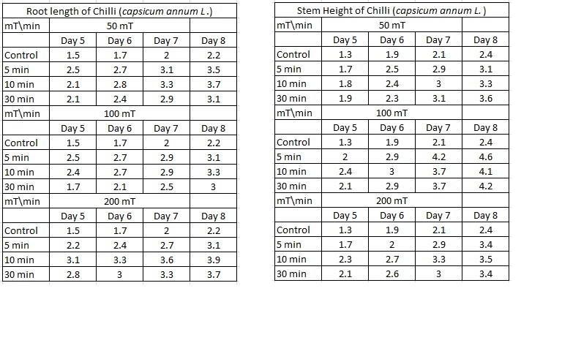
- Reference:
[1] Ananta Vashistha, C. author, & Nagarajanb, S. (n.d.). Effect
on germination and early growth characteristics in
sunflower (Helianthus annuus) seeds exposed to static
magnetic field. Journal of Plant Physiology, 167(2), 149–
156.
[2] Balouchi, H., & Sanavy, S. (2009). Electromagnetic field
impact on annual medics and dodder seed germination. Int.
Agrophysics, 111–115. Retrieved from

http://www.old.international-
agrophysics.org/artykuly/international_agrophysics/
IntAgr_2009_23_2_111.pdf
[3] Burt, J. (2005). Growing capsicums and chillies, (64).
Retrieved from
http://www.agric.wa.gov.au/content/hort/veg/cp/
capsicums/f06499.pdf
- Biography:
Dr. R. D. Vaidya has completed his PhD from Sardar Patel University, Vallalbh Vidyanagar, Gujarat, India. His partial research work has been carried out at HPPD, BARC, Mumbai.. He has published more than 30 papers in reputed journals and attended more than 25 conferences or seminar at national and international level. He was awarded best research paper award for consecutive 3 years by university during Ph. D. He has also contributed in the field of biophysics and working on effect of magnetic field as well as music (sound) on growth of plants. He possesses 15 years of teaching and 22 years of research experience. He has been serving as an Assistant Professor at SPT science college at present.
- Presenting author details


Full Name: Dr. Rajiv Devendra Vaidya
Contact number:+91-9099175995
E-mail:rajivdvaidya@gmail.com
Session name/ number: Plant Sciences
Category: Oral presentation

