EFFECTIVE MUTATION ON PLANTS
Mahdi Tajalifar, MSc in Plant Genetics and Plant Breeding qazvin Address:Iran.qazvin. End of the padegan street of Shahid babaee Alley.tell: 00982833367725. Email: madi.tajalifar@yahoo.com
Dr Valyollah Rasouli, Ph.D. in Plant Breeding. Address: Iran.Qazvin. Agricultural and Natural Resources Research Center of Qazvin Province Phone: 00989124812955 email:spiiqv@gmail.com
Dr Tina Barsby, phd. Plant genetics.member niab. Address: University
Cambridge. Tell:00441223342280. Email:tina.barsby@niab.com
Abstract:
Plant breeding is started of 9000-11000 years ago and mutation breeding is just new design in breeder toolkit.mutation breeding has been started since the 1930s. It’s a mean of speed up the process of development traits for choice, Example disease resistance, tolerance to fast growing condition, and other value agronomic traits. It does not contain gene improvement, also known as gene splicing. Mutation breeding using on plant’s gene pool on the method of selfing mutation.
Seeds, cutting, or the shredded leaf of a plant(texture) are radiated. The radiated matter is either grew or tilled in a strile furrow average and individual plants segregated and controlled for their traits.
General breeding initiates cross breeding, within the parents, toward a several generation step that may devest 4 or 5 years to delete an unwanted genome and extend the sought-since traits before pioneer crops are experienced, increasing more manifester in the civilized mutant races.
Mutation breeding is based on selfing mutants until the induction character has a stable expressing in the adventagous mutant generation.
Mutation breeding has many comparative advances. It is cost effective, quick, proven and robust, mutation breeding is transferable. There are more than 3200 mutant varieties that use in more than 210 plant species from more than 70 countries.
Key word: Mutation,Value, Gene pool, Species and Expressing.

Introduction:
The first process in plant breeding is to find normal genotypes including.
The desirable gene between existing varieties, or to make one that is not in nature. In nature variation occurs more than a result of mutation and non-mutation. Plant breeding would be imposible. The main target in mutation in mutation based is to develop and modify well-adapted plant varieties by breeding one or two important traits to access efficiency or quality. Both physical and chemical mutagenesis have application in containing mutations in seeds and other planting materials.
Therefore, choice for agronomy traits is out and out in the first slip, whereby most mutant lines may be rejected. The agronomy traits are support in the second and third foster because obvious phenotypic register,when another valuation are carried out in the aftermath fosters.finaly, just the mutant lines with suitable traits are choiced as a new variety or similar a parent line for cross breeding.
It is famous that transmutation and feasible breeding belong to genetic diversion. The variations that are found in navigate do not display the basic spectra of naturally mutations. Rather, they are the sequent of genotypes recombining within people and their attached interplay with environmental factors.
Mutagenesis the step where by abrupt inheritable conversions happen the genetic data of an organism not caused by genetic separation or genetic recombination, but contained by chemical, physical biological.
Agent of synthesic mutation are called mutagenes. Mutagenes are commonly grouped into two wide categories namely chemical mutagens and physical mutagens.
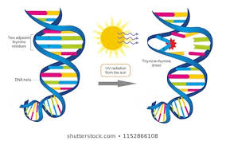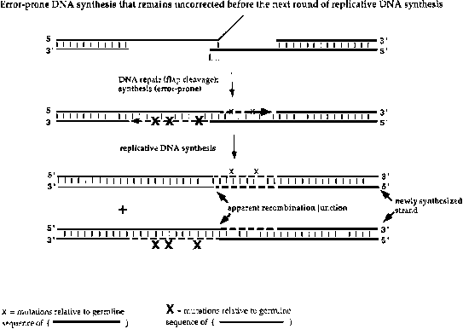
Figure1: mutagen Figure2: synthesic mutations
Material and method:
- Mutation breeding:
Mutation breeding using by three kinds of mutagenesis.
In which mutation happen as success of radiation( gamma rays, x-ray, ion beam, etc) or manner with chemical mutagens; place-directed mutagenesis,
That is step of making a mutation at a certain place in a DNA moulecule;
And adjuntion, tward genetic transformation and adjuntion of T-DNA or
Activation of transposable elements.
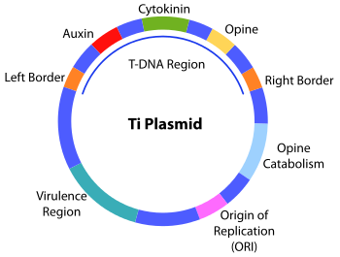
Figure2: T-DNA
Plant mutagenesis in crop modified :primary times and applied.
Although manifold mutant alleles are the mines genetic variety for crop breeding as well as functional analyzation of the aimed gene in multitude coverages. The point in mutation breeding is the steps of cognizancing individuals with a aim mutation, that indirects two basic processes: mutant harping and mutant verification.
Mutant harping is step indirecting choice of individuals of a great mutated people that meet specially choice criteria, e.g. shortly flowering, disease resistance as collected to the parent. Although , these choices are frequently noticed as given mutants or pseudo mutants.
Mutant verification, one of the another hand, is the step of reappraising the given mutants below a governed and repeated environment using great modules. Although this step ,very given mutants are located to be psedue mutant. Commonly, the mutation that are principal in crop breeding ordinarly queer alone bases and may or may not effect protein synthesis.

- Mutagenice organs:
Primaries of plant genetics and plant breeding. Implanted mutagenesis in plants using physical and chemical organs.
Traditionally , to actuate mutations in crops, implant material are subject physical and chemical mutagenic organs.
Mutagenesis can be administrated with all kind of implant materials, e.g.all plant, usually bud and invitro breed cells.
Yet, the most customarily used plant matter is seed. Varius kinds multipliable, like bulbs, tubers, corns and rhizomes.
Mutation breeding: a modern materiel for genetics modification of beat crops especially chickpea(cicerarietinum l.)
The infuse of mutations in herbally diffused plant is becoming more effective whereas scientists assume profit of totipotency(ability of a particular cell to sector and generate all of the diversed cells in an organ to reformed into all plants) using particular cells and another tailles of in vitro cultured plant tissue.
The starting matter for infuse of mutations are vegetative cutting, scions, or in vitrocultured tissues as leaf and stem explants, anthers, calli, cell cultures, microspores, ovules, protoplasts, etc. gametes. Ordinarily interior the inflorescences, are as well as aimed for mutagenic manner although soak of spikes, tassels, etc.
The function of infused mutations in universe food safety.
Significantly that abundance and kinds of mutations are upstanding results of the dose and scale exposure or execution of the mutagen rapider than its kind. In the terminal, the selection of a mutation will be based more often than not on the special researcher’s conditions, like health of mode, easiness of use, access of mutagens, affection in infusing definite genetic convertions, suitable tissue, value and accessible texture among another agents.

- Physical mutagenesis:
The history 80 years, physical mutagens, mainly ionizing irradiations,have been used vastly for infused heritable aberrance and more than 70% mutant
Diversities were expanded using physical mutagenesis.
Mutagenic irradiations: x-rays, ionizing quantums and ultraviolet.
Irradiation is praised as energy travelling although a interval in the shape
Cockles or quantums. These are sort of vast-energy planes of electromagnetic(EM) spectrum that are able of dislodging electron of the
Nuclear orbits of the motes that the reception upon. The seried atoms,
Therefore behove ions. Since , the term ionizing irradiation.
These ionizing component of the EM contain cosmic, gamma(y)and x-rays.
Infused mutations drop the agents of plant genetic means for farming.
Since then varied subatomic quantoms(neutrons, protons, beta particles
And alpha particles) have been generated using nuclear reactors.Though it has been stabled to be an affective mutagen, especially for producing great DNA fragment delitions. The application of neutrons in infused mutagenesis is limiting.
Physical mutagens like express neutron and gamma rays make broad arrive genetic mutability and have played a important pattern in plant genetics researchs. Physical mutagens containing irradiation similar gamma rays and ionization with neutrons are often applied for mutagenesis. Morphological mutant lines and brix mutants that can be consumed brix-setting genes in plants.
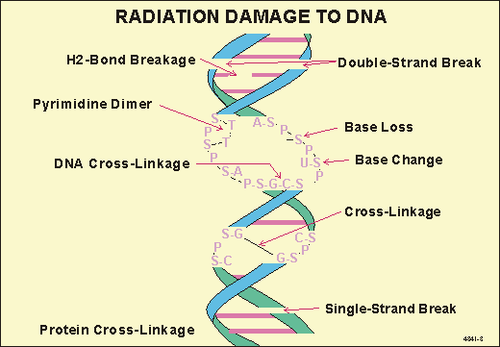
Figure4: gamma rays
- Chemical mutagenesis:
Chemical mutagenesis is one of the most valid and suitable accesses applied in variety plant species. EX: EMS and Sodium azide have been consumed as chemical mutagens.
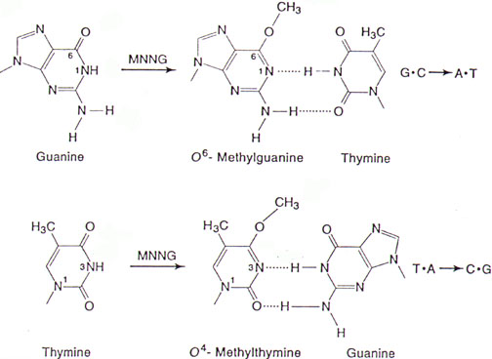
Figure5: chemical mutagenesis
Although , chemical mutagens are universally carcinogenic and therefore, excess notice must be taken for safety keep in course the device. Matter and health information pages for the particular chemical mutagen designee should be carefully reading and the organ should be appropriately disabled before consumption. In spite of the adult number of mutagenic composed, just a few number has been examined in plant.
EMS: ethyle methan sulphonate, 1-methyl-1-nitrosoura and 1-ethyl-1-nitrosourea, that score for 64% these diversity.
The EMS is the most vast applied chemical mutagen in plants because of EMS great affect at point mutation and delitions the chromosomal separation. EMS mutagenesis found valid on other customary plant breeding verge are not possible.
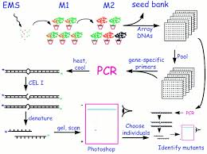
Figure6: EMS
Conclution:
Mutation breeding using by three kinds of mutagenesis.
Mutant harping is step indirecting choice of individuals of a great mutated people that meet specially choice criteria, e.g. shortly flowering, disease resistance as collected to the parent. Although , these choices are frequently noticed as given mutants or pseudo mutants.
Mutagenesis is step of making a mutation at a certain place in DNA molecule; and adjunction mutagenesis.
The starting matter for infuse of mutations are vegetative cutting, scions, or in vitrocultured tissues as leaf and stem explants, anthers, calli, cell cultures, microspores, ovules, protoplasts, etc. gametes. Ordinarily interior the inflorescences, are as well as aimed for mutagenic manner although Therefore behove ions. Since , the term ionizing irradiation.
These ionizing component of the EM contain cosmic, gamma(y)and x-rays.
Infused mutations drop the agents of plant genetic means for farming.
soak of spikes, tassels, etc.
Physical mutagens like express neutron and gamma rays make broad arrive genetics mutability and have played a important pattern in plant genetics research.
Chemical mutagenesis is one of the most valid and suitable accesses applied in variety plant species.
EMS: ethyle methan sulphonate, 1-methyl-1-nitrosoura and 1-ethyl-1-nitrosourea, that score for 64% these diversity.
EMS is chemical mutagens. EMS have great affect at point mutation.

References:
- Oladosu, Y; Y. Rafii, M; Abdullah, N, and et al; 2015; Principle and application of plant mutagenesis in crop improvement: a review; Journal of biotechnology& biotechnological equipment; p 1-6
- Yamaguchi, H; 2018; Mutation breeding of ornamental plants using ion beams; JSB; 1: 71-78
- Ulukapi, K and Nasircilar, A. G; 2018; Inducted mutation: Creating genetics diversity in plants; Journal of intech open; P1-17
- Rafiq wani, M; 2017; Inducted cholophyll mutation, comparative mutagenic effectiveness and efficiency of chemical mutagens in lentils; Asian journal of plant science; p 221-226
- Guo, H; Yan, Z; Li, X and et al; 2017; Development of a high-efficient mutation resource with phenotypic variation in hexaploid winter wheat and identification of novel alleles in the the TaAGP.B1Gene; Front. Plant sci; p 1-9
- Jankowicz- Cieslak, J; Mba, C and J.Till, B; 2016; Mutagenesis for crop breeding functional genomics; Journal of biotechnologies for plant mutation breeding; p3-18
- Guo, J; Li, K; Jin, L and et al; 2018; A simple and cost- effective method for screening of crispry/ cas-induced homozygous/ biallelic mutant; plant method; 14:1-10
- Chaudhary, J; Alisha, A; Bhatt, V and et al; 2019; Mutation breeding in tomato: advance, applicability and challenges; Journal of mdpi;8:3-17
- Edition, T; 2018; Manual on mutation breeding; plant breeding and genetics subprogram
- www.naweb.iaea.org

