Abstract
Title: An Analysis on Change of Agriculture Pattern in Southern Shan State in Myanmar

Dr Aye Aye Khine¹, Dr Saw Yu May²

¹ Department of Geography, Taunggyi University, Shan State, Myanmar

²Department of Geography, Yangon University, Yangon, Myanmar

Key Word - Agriculture pattern, Vegetable, Crops, GIS, Crop combination
- ABSTRACT
Agriculture is the main economy of Myanmar. In 2017-18, about 77% of state population has inhabited in rural area sustaining their livelihood mainly on Agriculture. Similarly with other regions of Myanmar, the main occupation of Southern Shan State is agriculture. In fact, Southern Shan State is the one of the main agricultural area of Myanmar especially for it unique cereal crop, oil seed, vegetables, kitchen crops and orchard gardening. From Southern Shan State, vegetable have supplied to the Yangon Region, Central Myanmar until neighboring countries. This region is known as one of vegetable supply area of Myanmar. Various kinds of crops can be grown due to favorable natural conditions. Southern Shan State Located Shan State in Myanmar. It is lies between latitudes 19˚ 18’ 00” N and 22˚ 16’ 00” N and between longitudes 96˚ 13’ 00” E and 97˚ 28’ 34” E. It is constituted of 21 townships. It comprises 1671 village tracts (3002 villages). The total area of Southern Shan State is 57697.71 square kilometers (22277.21 square miles.. This paper are depicted the distribution patterns of agriculture by using GIS Software in study area. The geo-database for Southern Shan State was systematically established for the analysis of agriculture. In Southern Shan State, the total sown acreage was 1,276,307 acres in 2010 and it increased to 1,431,122 acres and currently it is about 1,501,790 acres. Therefore total sown acreage was gradually increased from 2010 to 2018 which estimated about 225483 acres during 8 years in Southern Shan State. For this study, it only based on the secondary data; therefore, it is explore how agriculture pattern has changed by using crop combination method in Southern Shan State and what are the advantages and disadvantages of this situation in further study.
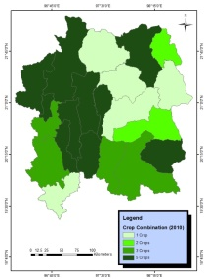
II. Image
III. Reference:
Hla Tun Aung, U, (2002)The Study of Process and Pattern, National Centre for Human Resource Development, Ministry of Education, Myanmar
Mar Lar Thein (2010) A Geographical Analysis on Soybean Cultivation of Taunggyi District.
Ministry of Commerce, Taunggyi (2010), (2014) , (2018)

IV. Biography:
Dr.Aye Aye Khine has completed her PhD (Environmental Geography ) at the age of 45 years from Yangon University and also she got again Diploma in computer Science since in 2002 and got again Diploma in Geographic Information System since n 2004. She studied GIS and RS about two months at CDAC Institute, Noida India in 2017. Now she is studying the Education, Health and Agriculture Geography within Southern Shan State in Myanmar. She has published more than 6 papers in reputed journals and also has published 2 papers in international.
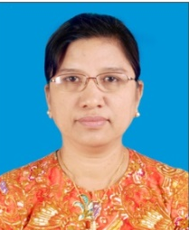
Full Name: Dr Aye Aye Khine
Contact number: 095 5186573
Twitter account:
Linked In account: aak13366@gmail.com
Session name/ number:
Category: (Oral presentation)
Passport Number:

