Abstract

Title: Isolation and identification of a novel strain of Lactic Acid Bacteria from fermented common lime (Citrus aurantifolia) and analysis of exopolymeric substances produced by the strain.

Arindam Barman¹
¹Department of Horticulture, North Eastern Hill University, Tura, Meghalaya, India

Keywords: Common Lime, Lactic Acid Bacteria, 16s rRNA, Probiotic, Exopolysaccheride

- Abstract
Gram positive, rod shaped and catalase negative strain of Lactic Acid Bacteria was isolated from traditionally fermented common lime (Citrus aurantifolia) of Assam, North-East India. Bacterial identification was done by using conventional morphological and biochemical methods as well as advanced molecular technique. Isolated bacteria were identified up to species level by using ribosomal RNA (rRNA) gene sequencing technique. Based on nucleotide homology and phylogenetic analysis the isolate was found to be a strain of Lactobacillus delbrueckii. This is the first report of finding this sub species of Lactic Acid Bacteria in citrus fruit product. The bacterial isolate also produced exopolysaccharide (EPS) when grown in chemically defined medium. Fourier Transform Infrared and Nuclear Magnetic Resonance Spectroscopy was done for chemical and compositional characterization of partially purified exopolysaccharide. The plant origin Lactic acid bacteria are of great interest for the biotechnologists and the findings of the present study will encourage the consumption of fermented Citrus aurantifolia juices as a probiotic food and EPS produced could have several applications in health and food industry. The quest for lactic acid bacteria in traditional food and their capability of producing exopolysaccharide will enhance sustainable bioprospecting and may open new doors of research in the field of food microbiology and may give answers on their interaction with living environment

- Image:

FTIR of partially purified EPS

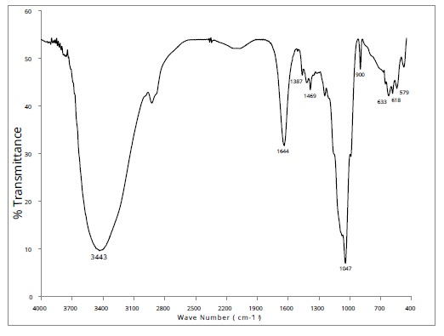
- Biography:
Arindam Barman has completed his PhD from Indian Institute of Technology, Dhanbad. He is now working as an assistant professor in the Department of Horticulture, North Eastern Hill University, Tura, India. Dr. Barman has a wide array of laboratory management skills with 7+ years of experience in plant genomic works. Research is primarily focused on coordinating complex projects related with genetic diversity assessment of indigenous plants found in North Eastern states of India and its implications in plant breeding and agronomics . At present, his lab has four ongoing research projects which are being funded by the Department of Science & Technology and Department of Biotechnology, Govt. of India.
- Presenting author details


Full Name: Dr. Arindam Barman
Contact number: +91-8794703810
Twitter account:
Linked In account:
Session name/ number:
Category: (Oral presentation/ Poster presentation): Poster
Passport Number:

